

Online Shopping(Clothing) System

Submitted by

[Amarjeet Awadhesh Singh]

Seat no - _______

March - 2018

Under the guidance of

Mrs. Sumedha Barve

Submitted in partial fulfillment of the requirements for qualifying

B.Sc.-(I.T.), Semester – VI Examination

PTVA’S SATHAYE COLLEGE Dixit Road,

Vileparle(E), Mumbai-400 057

2017-18



**Parle Tilak Vidyalaya Association’s**

**SATHAYE COLLEGE**

**Vile-Parle (East), Mumbai – 400 057.**

This is to certify that the project entitled

______________________________________________________

undertaken at the_______________________________________

by Mr./Ms. ________________________________Seat No._____

in partial fulfillment of B.Sc. IT degree (Semester- VI) Examination, had not been submitted for any other examination and does not form part of any other course undergone by the candidate.

It is further certified that he/she has completed all required phases of the project.

Internal Guide External Guide Coordinator B.Sc. [I.T.]

College seal

18th April 2018

**TO WHOMSOEVER IT MAY CONCERN**

This is to certify that the project titled ‘**Tenali Clothing**’ developed by Mr. Amarjeet Awadhesh Singh is completed and according to our requirements.

This certificate is issued on their request for submission of the project to the college in partial fulfilment of B.Sc. I.T. (Semester VI) examination. We take this opportunity to wish Amarjeet a bright future.

Yours sincerely,

For and on behalf of

**Tenali Clothing**

**(Authorized Signatory)**

**Synopsis**

This is a small-scale project for Online Shopping(Clothing) System. The basic idea is that customers can buy products online. It consists of product details, security system, status and exits. The administrator can enter the name and password and can perform operations like add, search and delete the products in the database.

This Online Shopping System enables customers to buy products online, customers to browse through different products and a system administrator to add or remove products for customers and maintain list of categories. Also, on the agenda is designing an Online Shopping site to manage the items in the shop and also helps customers purchase them online without having to visit the shop physically. Our Online Shopping site will use the internet as sole method for selling wearables i.e. clothing and footwear to its customers. Shopping will be highly personalized and the mall will provide lower prices than most competitors.

**Preface**

The purpose of the project entitled as "ONLINE SHOPPING SYSTEM" is to provide buying cloths and footwear online services to everyone.

It hardly matters whether the users live in metro or remotely located villages, users can connect through their home via internet or approach any nearby kiosk to get this online service.

The main function of this system is that it can be used by any customers to buy the product they want, they can also view product detail, etc.

The users can register and buy products as they required in 2 to 3 days.

**INDEX**

|  |  |  |
| --- | --- | --- |
| Sr. No | Topic | Page No. |
| 1 | Analysis Phase |  |
| 1.1 | Requirement Gathering Phase | 1 |
| 1.1.1 | Problem Statement |  |
| 1.1.2 | Fact Finding Techniques |  |
| 1.1.3 | Project Objective and Scope of Project |  |
| 1.1.4 | Problem with Existing System |  |
| 1.1.5 | Advantages of Proposed System |  |
| 1.2 | Feasibility Study |  |
| 1.2.1 | Operartional Feasibility |  |
| 1.2.2 | Technical Feasibility |  |
| 1.2.3 | COCOMO Model1 |  |
| 1.2.4 | Function Point |  |
| 1.2.5 | Gantt Chart |  |
| 1.3 | Requirement Specification |  |
| 1.3.1 | Functional Requirement |  |
| 1.3.2 | Technical Requirement |  |
| 1.3.3 | Software Requirement Specification |  |
| 1.4 | Tools and Technology |  |
| 2 | Design Phase |  |
| 2.1 | Detailed Life Cycle of Project |  |
| 2.1.1 | Event Table |  |
| 2.1.2 | E-R Diagram |  |
| 2.1.3 | Use Case Diagram |  |
| 2.1.4 | Class Diagram |  |
| 2.1.5 | Activity Diagram |  |
| 2.1.6 | Deployment Chart |  |
| 2.1.7 | Menu Tree |  |
| 2.2 | Physical Design |  |
| 2.2.1 | System Flow Chart |  |
| 3 | Implementation Phase |  |
| 3.1 | Building |  |
| 3.1.1 | Screen Layout |  |
| 3.1.2 | Coding |  |
| 3.2 | Testing Techniques |  |
| 3.2.1 | Test Cases |  |
| 4 | Maintenance and Evaluation |  |
| 4.1 | System Maintenance and Future Enhancement |  |
| 4.2 | User Manual |  |
| 5 | Annexure |  |
| 5.1 | References |  |
| 5.2 | Bibliography |  |
| 5.3 | Acknowledgment |  |

**1.ANALYSIS PHASE**

* 1. **REQUIREMENT GATERING PHASE**
     1. **Problem Statement**
* If a customer (potential stake holder) has a query related to the product or need suggestion toward best brands or price need to find a trusted source and get information from that source.
* Currently everything is performed by one to one communicating with the customer to whom the product is shown.
* Communicating the same thing over to each and every customer who happen to have a similar choice for product, and total amount related query, etc. is a tedious and repetitive thing. Sometime doing thing repetitive can affect performance.
* To overcome this issue, a solution of developing a website which to directly optimizing the performance and repetitive work.
* LIMITATION OF THE SYSTEM IN USE

1. The customer need to be present and he/she should be trust worthy.
2. No single point of information gathering.
3. Repetitive work done for each query.
4. Untrusted Source.
   * 1. **Fact Finding Techniques**

We interviewed our owner **Mr. Avinash Khair** about the current system and what the proposed system should have so as that would help the owner as well as the customer. We prepared certain key question for the owner to find out about the need and expectation of the owner.

We had put the following questions in front of the owner of the “**TENALI CLOTHING**” and his response to these questions were as follows:

**INTERVIEWER:** What are the things that normally customers mostly have query about?

**INTERVIEWEE:** The customer mostly want to know about new and latest designs colours and size of the product.

**INTERVIEWER:** What do you do when such query arrive to you?

**INTERVIEWEE:** I have to solve this query for each and everyone who comes to me.

**INTERVIEWER:** Do you solve this query for only your customers or for every customers who approaches you?

**INTERVIEWEE:** Yes, I solve the doubt of each one of them whether it be our customers or outsider.

**INTERVIEWER:** Do you collect information about the customer?

**INTERVIEWEE:** Yes, we collect information about the customers so that we can be touch with them and inform about our facilities.

**INTERVIEWER:** Do you want outsider to sign up to the system?

**INTERVIEWEE:** Yes, we want them to know about us.

**INTERVIEWER:** What kind of information do you want during the sign up process?

**INTERVIEWEE:** I will need Name, Contact number, Email Address, Address, pincode and password are primary things that I would prefer.

**INTERVIEWER:** Do you want to provide Online Payment module to your register customers?

**INTERVIEWEE:** No, we will first go through our website response and if its satisfied then we will come soon with the Online Payment Module.

* + 1. **Project Objective and Scope of Project**

**Project Objectives**

The objective is to deliver innovative approaches to buy and sale product that can be more suitable and beneficial for the customers. It provides the products having latest trend in the market. It will also provide the availability of the products.

The software will meet the following need that the customers need and client wants:

* Putting information at single point and making it accessible for every one
* Repetitive task are avoided
* Owner can promote his organization
* Customer has no need to visit factory to place an order.

**Scope of the Project**

* Online stores are usually available 24 hours a day, and many customers have Internet access both at work and at home.
* Other establishments such as internet cafes provide access as well. A visit to a conventional wholesale store requires travel and must take place during business hours.
* Searching or browsing an online catalog can be faster than browsing the aisles of a physical store.
* One can avoid crowded malls resulting in long lines, and no parking.
* Some customers prefer interacting with people rather than computers because they find computers hard to use.
* Not all online wholesalers have succeeded in making their sites easy to use or reliable. On the other hand, a majority of stores have made it easy to find the style one is looking for, as well as the price range that is acceptable making the shopping experience quick and efficient.
* The internet has made shopping an almost effortless task.
  + 1. **Problem with Existing System**
* The current system of “**Tenali Clothing**” is totally paper based and done manually.
* The data is maintained in paper file system.
* It is also time-consuming system.
  + 1. **Advantages of Proposed System**
* It is more efficient and accurate in compare to current system.
* The product details will more accurate and error free.
* No unauthorized access to the system will not be allowed.
* Validation would lead to the correctness of the information’s.
* The system will be more user friendly and easy to operate on.
  1. **FEASIBILITY STUDY**
     1. **Operational Feasibility**
* Operational feasibility is to gain an understanding of whether the proposed system will likely solve the business problem or take advantage of the opportunities or not. It is important to understand how the new system will fit the current day to day operations of the organization.
* We have also conducted an operational feasibility of our software to identify whether our software is able to satisfy the goal of developing the software.
* Before the existence of the software the owner had to sit in his office for their customer and customer had to come to the owner for their query or incase if customer is unable to visit he/she could refer to the call the owner that would be available on the software from any place.
* Major requirement of the owner was to reduce the repetitive work and create a platform for selling and buying products.
  + 1. **Technical Feasibility**
* Assessing technical feasibility is to evaluate whether the new system will perform adequately and whether an organization has ability to construct a proposed system or not. The technical assessment help answer the question such as whether the technology needed for the system exists, how difficult it will be to build, and whether the firm has enough experience using that technology.
* In case of technical feasibility we have made a system that match accord to the requirements of the owner.
* We have made the project in a language in which we are familiar. The entire website is made in C# and SQL Server. We have chosen these to as the project is small and also we are familiar with the technologies.
* The next area to be concentrated is the operating system architecture. At presently the client is using Windows 8.1 64 bit and very soon he is planning to update Windows 10 64bit. But this will not have a great impact on the performance as it is a web application. So in order to solve this problem we have made the software operating system and architecture friendly and as well also considered the minimum hardware requirement that it need to run this web application.
  + 1. **COCOMO MODEL1**

COCOMO'81 models depends on the two main equations.

1. Development effort: MM = a * KDSI b based on MM - man-month / person month / staff-month is one month of effort by one person. In COCOMO'81, there are 152 hours per Person month. According to organization this values may differ from the standard by 10% to 20%.
2. Effort and development time (TDEV): TDEV = 2.5 * MMc .

The coefficients a, b and c depend on the mode of the development. There are three modes of development:

|  |  |  |  |  |
| --- | --- | --- | --- | --- |
| Development Mode | Project Characteristics | | | |
|  | Size | Innovation | Deadline/Constraint | Dev.Environment |
| Organic | Small | Little | Not Light | Stable |
| Semi-Detached | Medium | Medium | Medium | Medium |
| Embedded | Large | Greater | Tight | Complex Hardware |

BASIC COCOMO

The basic COCOMO applies the parameterized equation without much detailed consideration of project characteristics.

|  |  |  |  |  |
| --- | --- | --- | --- | --- |
| BasicCOCOMO | A | B | C | D |
| Organic | 2.4 | 1.05 | 2.5 | 0.38 |
| Semi-Detached | 3.0 | 1.12 | 2.5 | 0.35 |
| Embeded | 3.6 | 1.20 | 2.5 | 0.32 |

MM = a * KDSI b

TDEV = 2.5 * MMc

Calculation:

MM=2.4*2.6071.05

MM=2.4*2.734

MM=6.5616

Assuming man months as 7, we will calculate effort and development (TDEV)

TDEV= 2.5 * MMc

= 2.5 * 6.56160.38

= 2.5 * 2.043

= 5.1075

Total 5 months required for completion.

* + 1. **Function Point**

|  |  |  |  |  |  |  |  |  |  |  |
| --- | --- | --- | --- | --- | --- | --- | --- | --- | --- | --- |
| Software System Components | Complexity Level | | | | | | | | | Total CFP |
| Simple | | | Average | | | Complex | | |  |
|  | Count A | Weight Factor B | Point C= A*B | Count D | Weight Factor E | Point F= D*E | CountG | Weight Factor H | Point I= G*H |  |
| User Inputs | 2 | 3 | 6 | 2 | 4 | 8 | 0 | 6 | 0 | 14 |
| User Outputs | 3 | 4 | 12 | 2 | 5 | 10 | 0 | 7 | 0 | 22 |
| User Online Queries | 1 | 3 | 3 | 1 | 4 | 4 | 0 | 6 | 0 | 7 |
| Logical Files | 3 | 7 | 21 | 2 | 10 | 20 | 0 | 15 | 0 | 41 |
| External Files | 0 | 5 | 0 | 0 | 7 | 0 | 0 | 10 | 0 | 0 |
| Total CFP |  |  | 42 |  |  | 42 |  |  | 0 | 84 |

**CALCULATION OF RCAF:**

* Summarizes the complexity characteristics of the software system Assign grades (0 to 5) to the 4 subjects that substantially affect the development effort RCAF=∑ 𝑆𝑖 14 𝑖=1.
* The RCAF determines the technical complexity factor TCF=0.65+0.01*RCAF.
* FP = CFP*TCF

|  |  |  |
| --- | --- | --- |
| Sr.No. | Subject | Grade |
| 1 | Requirement for reliable backup and recovery | 3 |
| 2 | Requirement for data communication | 4 |
| 3 | Extent of distributed processing | 2 |
| 4 | Performance requirements | 2 |
| 5 | Expected operational environment | 3 |
| 6 | Extent of online data entries | 3 |
| 7 | Extent of multi-screen or multi-operation online data input | 4 |
| 8 | Extent of online updating of master files | 0 |
| 9 | Extent of complex inputs, outputs, online queries and files | 4 |
| 10 | Extent of complex data processing | 0 |
| 11 | Extent that currently developed code can be designed for reuse | 5 |
| 12 | Extent of conversion and installation included in the design | 0 |
| 13 | Extent of multiple installation in an organization and variety of customer organizations | 0 |
| 14 | Extent of change and focus on ease of use | 4 |
|  | Total = RCAF | 34 |

Calculating FP

FP = CFP*TCF

TCF = 0.065+0.01*RCAF

TCF= 0.65+0.01+*34

TCF=0.99

FP=CFP*TCF

FP=84*0.99

FP=83.16

* + 1. **Gantt Chart**

A Gantt Chart is a horizontal bar chart developed as a production control tool in 1917 by Henry L. Gantt, an American engineer and social scientist. Frequently used in project management, a Gantt chart provides a graphical illustration of a schedule that helps to plan, coordinate and track specific tasks in project. Gantt chart may be simple versions created on graph paper or complex automated version created using project management application such as Microsoft Project or Excel.

A Gantt chart, commonly used in project management, is one of the most popular and useful ways of showing activities (tasks or events) displayed against time.

This allows you to see at a glance:

* What the various activities are
* When each activity begins and ends
* How long each activity is scheduled to last
* Where activities overlap with other activities, and by how much
* The start and end date of the whole project

To summarize, a Gantt chart shows you what has to be done (the activities) and when (the schedule) the activities need to be done.

|  |  |  |  |  |  |  |  |  |  |  |  |  |  |  |  |  |
| --- | --- | --- | --- | --- | --- | --- | --- | --- | --- | --- | --- | --- | --- | --- | --- | --- |
|  | DECEMBER | | | | JANUARY | | | | FEBRUARY | | | | MARCH | | | |
| 1W | 2W | 3W | 4W | 1W | 2W | 3W | 4W | 1W | 2W | 3W | 4W | 1W | 2W | 3W | 4W |
| Requirements |  |  |  |  |  |  |  |  |  |  |  |  |  |  |  |  |
|  |  |  |  |  |  |  |  |  |  |  |  |  |  |  |  |
| Analysis |  |  |  |  |  |  |  |  |  |  |  |  |  |  |  |  |
|  |  |  |  |  |  |  |  |  |  |  |  |  |  |  |  |
| Design |  |  |  |  |  |  |  |  |  |  |  |  |  |  |  |  |
|  |  |  |  |  |  |  |  |  |  |  |  |  |  |  |  |
| Coding |  |  |  |  |  |  |  |  |  |  |  |  |  |  |  |  |
|  |  |  |  |  |  |  |  |  |  |  |  |  |  |  |  |
| Testing |  |  |  |  |  |  |  |  |  |  |  |  |  |  |  |  |
|  |  |  |  |  |  |  |  |  |  |  |  |  |  |  |  |
| Deployment |  |  |  |  |  |  |  |  |  |  |  |  |  |  |  |  |
|  |  |  |  |  |  |  |  |  |  |  |  |  |  |  |  |

|  |  |
| --- | --- |
|  | ESTIMATED TIME |
|  | ACTUAL TIME |

* 1. **REQUIREMENT SPECIFICATION**
     1. **Functional Requirement**

The Software we are developing will have the following functional requirement:

Function of the Software:

* Show Product, Category and Product Image.
* Allow viewing of Product, Category and Product Image.
* Allow user to add product to cart.
* Allow users send mail through contact us or can call.

Admin Functionality:

* Add, Edit and Remove Product.
* Add, edit and remove Category.
* Add, edit and remove Security.
* Add, edit and maintain User.

User Functionality:

* View Category and select Product.
* View product and buy product.
  + 1. **Technical Requirement**

For running software there are some specification and only if it satisfies the specified requirement it will get installed and works as it is designed for.

* A technical requirement pertains to the technical aspects that your system must fulfil, such as performance-related issues, reliability issues, and availability issues. These types of requirements are often called quality of service (QoS) requirements, service level requirements or non-functional requirements.
* For our software also there are some specification there are as follows:

1. Minimum space required in HDD is 200MB.
2. RAM required is 1GB.
3. Screen resolution should be 1024x768 or more.
4. Internet Connection
5. Web Browser with latest version
6. Pen Drive or External HDD for safe backup
7. Windows 7,8,10
8. Works with both 32 bit or 64 bit Operating System.
9. Microsoft .Net 4.0 and above.

The software will work properly as intended and smoothly only if the requirements are met or else the software will work but it may lag.

* + 1. **Software Requirement Specification**

“**Tenali Clothing**” website allows owner to sell product online, customers to browse through the website, and allows admin to add, update and delete products, categories from website and also he/she can maintain customers. It allows customer to purchase products online using internet without visiting the shop physically. The online shopping system will use the internet as the sole method for selling products to its customers.

The system work on internet server, so it will operated by any end user for the buying purpose.

**Requirements**

We interviewed our owner **Mr. Avinash Khair** about the current system and what the proposed system should have so as that would help the owner as well as the customer. We prepared certain key question for the owner to find out about the need and expectation of the owner.

* 1. **TOOLS AND TECHNOLOGY**

The tools that we are using for this software are:

* Microsoft Visual Studio 2013
* Sql Server

Microsoft Visual Studio 2013:

* Microsoft Visual Studio is an integrated development environment (IDE) from Microsoft. It is used to develop computer programs for Microsoft Windows, as well as web sites, web applications and web services. Visual Studio uses Microsoft software development platforms such as Windows API, Windows Forms, Windows Presentation Foundation, Windows Store and Microsoft Silverlight. It can produce both native code and managed code.
* We have used this application to make both standalone as well as website.
* It is one of the effective tool for making applications for windows.

Sql Server:

* SQL Server is a relational database management system developed by Microsoft. As a database, it is a software product whose primary function is to store and retrieve data as requested by other software applications, be it those on the same computer or those running on another computer across a network (including the Internet).
* SQL is playing an extremely important part in storing data.

Technologies that we have used in our project are as follows:

* Sql
* C#
* HTML
* Bootstrap

Sql:

* SQL (Structured Query Language) is a special-purpose programming language designed for managing data held in a relational database management system (RDBMS), or for stream processing in a relational data stream management system (RDSMS).
* SQL plays an important role in saving retrieving and performing many other operation for retrieving data from Microsoft SQL Server.

C#:

* C# (pronounced as see sharp) is a multi-paradigm programming language encompassing strong typing, imperative, declarative, functional, generic, object oriented, and component-oriented programming disciplines. It was developed by Microsoft within its .NET. C# is intended to be a simple, modern, and general purpose, object-oriented programming language.
* We have coded the entire project in C# both standalone as well as website.

HTML:

* Hyper Text Markup Language, commonly referred to as HTML, is the standard markup language used to create web pages. It is written in the form of HTML elements consisting of tags enclosed in angle brackets.
* For creating any website or web application we have the basic thing required is HTML.

Bootstrap:

* Bootstrap is a combination of jquery and CSS classes using which one can develop more interactive websites and web application.
* We have used bootstrap classes to make out website look more user attractive, better component stabilization and using this our web application can be viewed in any mobiles or tab.

**2.DESIGN PHASE**

**2.1 DETAILED LIFE CYCLE OF PROJECT**

**2.1.1 Event Table**

|  |  |  |  |  |  |  |
| --- | --- | --- | --- | --- | --- | --- |
| Sr. No. | Event | Trigger | Source | Activity | Response | Destination |
| 1 | Registration | User Registration | User | Entering user details | User registered or not | Details added to database |
| 2 | Login | Enters to System Feature | Admin or User | Entering username and password | Valid or invalid | Accessing System |
| 3 | Select Product | Product Selected | User | Selecting Products | Adding to Cart | Cart |
| 4 | Order Placement | Order Placed | User | Entering Product Details | Receives order details | Details added to database |
| 5 | Add Product | Enter Product Details | Admin | Adding new Product | New Products gets added | Products added to database |
| 6 | Delete Product | Deleting Product | Admin | Deleting Product | Product gets deleted | Product deleted from database |
| 7 | Logout | Logout | Admin or User | Logs out of website | Redirect to another page | Successfully Logged out |

**2.1.2 E-R Diagram**

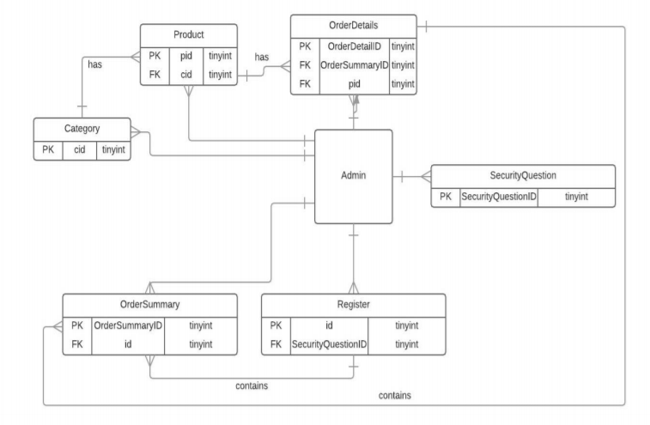

**2.1.3 Use Case Diagram**

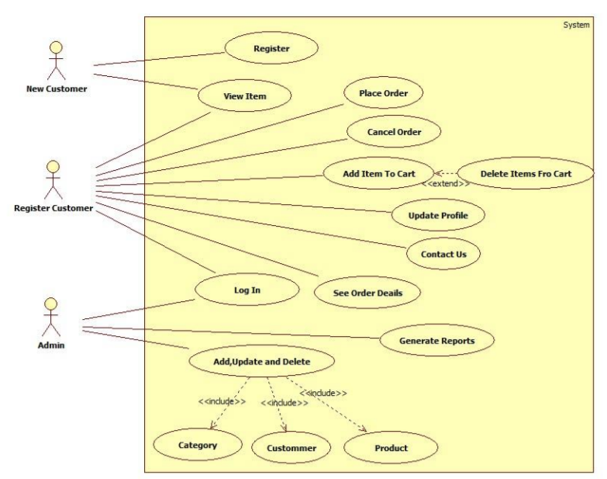

**2.1.4 Class Diagram**

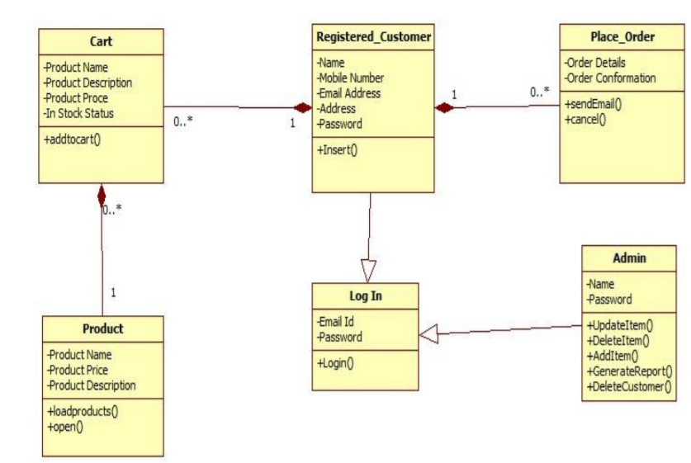

* + 1. **Activity Diagram**

**Admin**

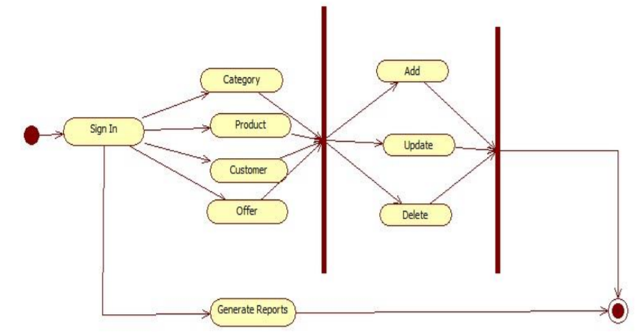

**Customer**

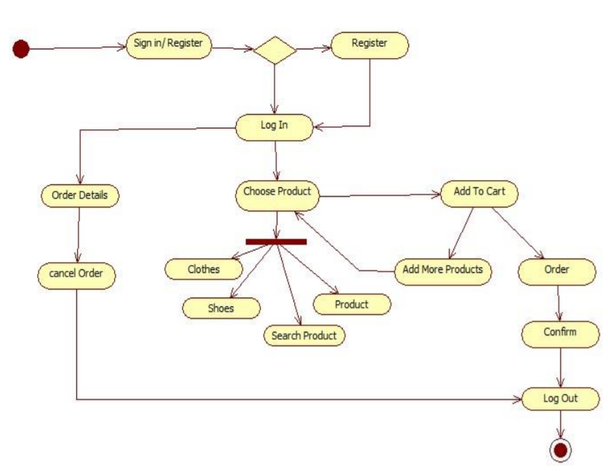

* + 1. **Deployment Chart**

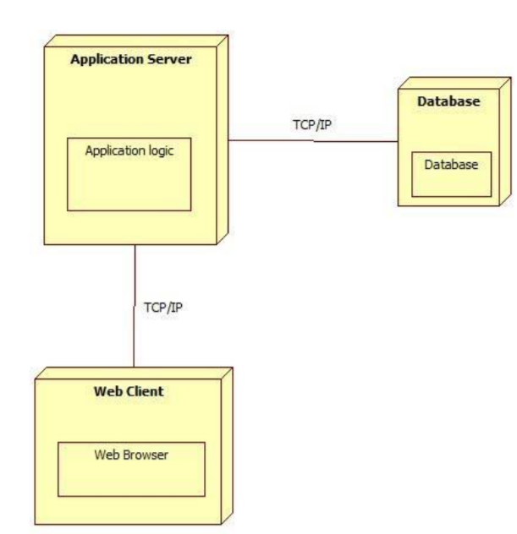

* + 1. **Menu Tree**

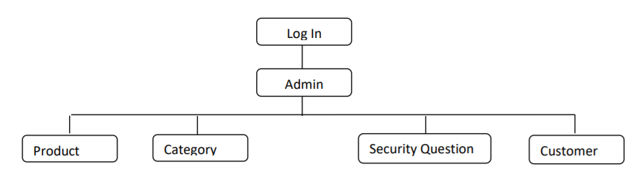

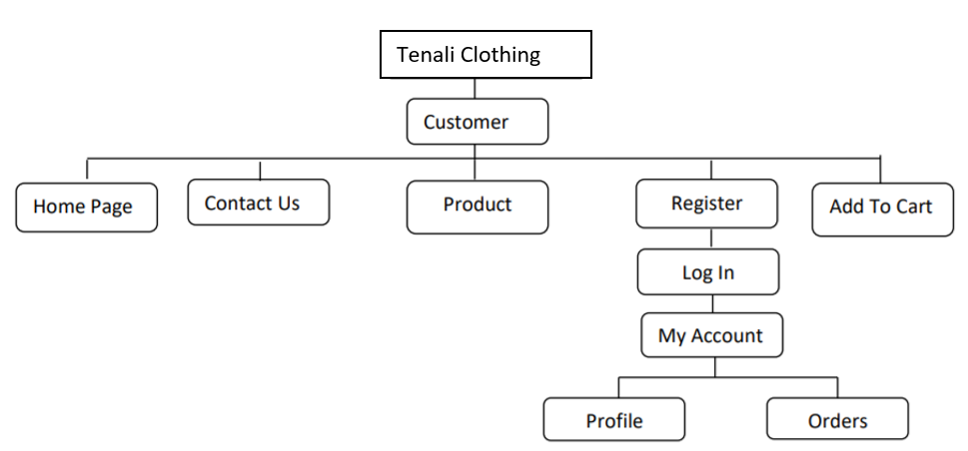

* 1. **PHYSICAL DESIGN**

**2.2.1 System Flow Chart**

**Admin**

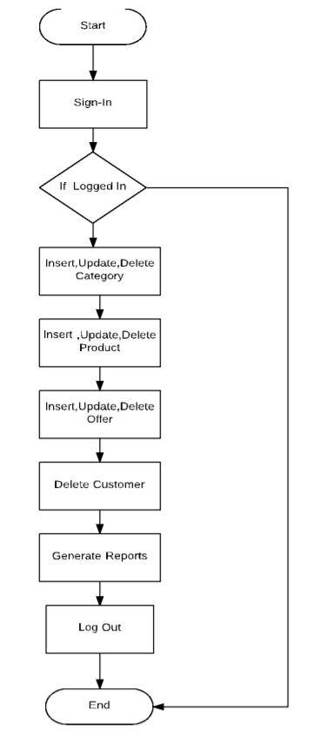

**Customer**

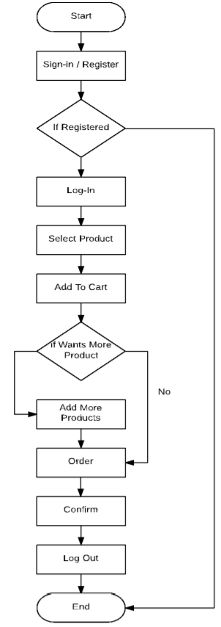

**3.IMPLEMENTATION PHASE**

**3.1 BUILDING**

**3.1.1 Screen Layout**

**Admin**

**SignIn Page**

This is signin page for both admin and user

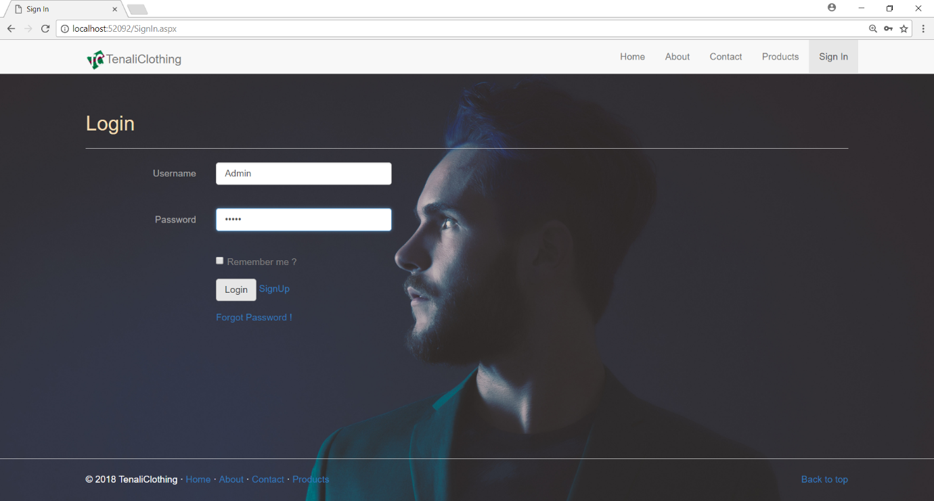

**Customer**

**3.1.2 Coding**

**AdminHome Page**

This is to show that the admin has logged in and can began the work.

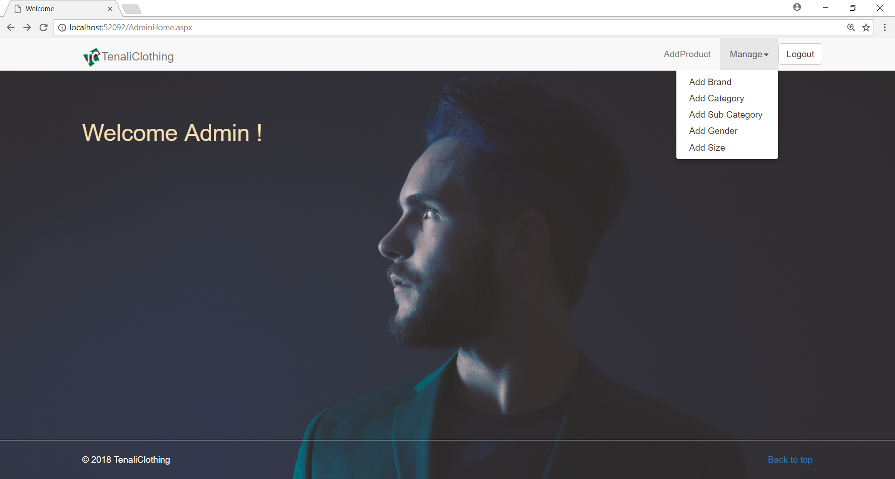

**AddBrand Page**

This is to show how admin Add Brand for the Product

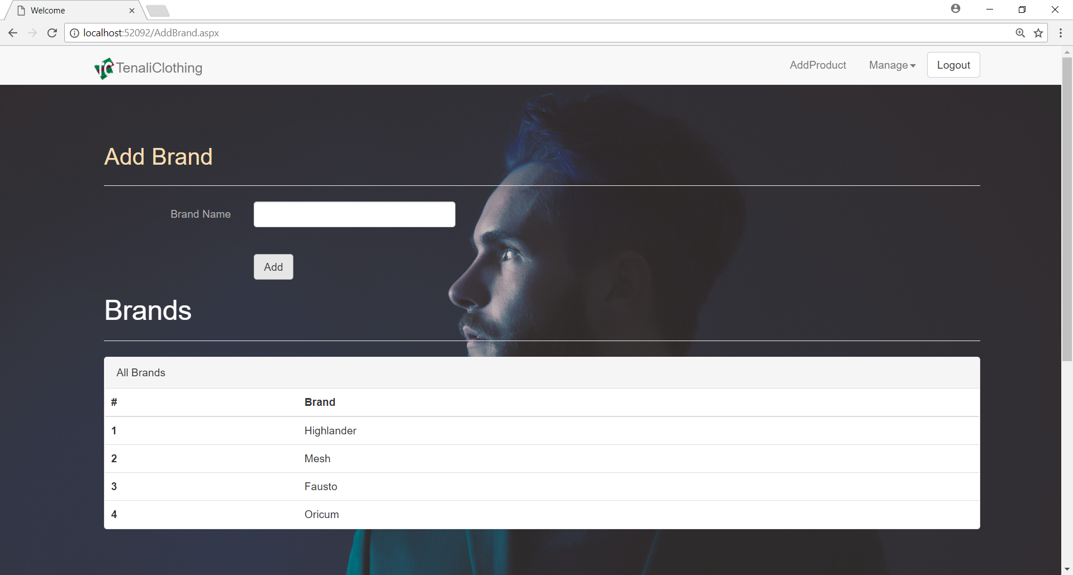

**AddCategory Page**

This is to show how admin Add Category for the Product

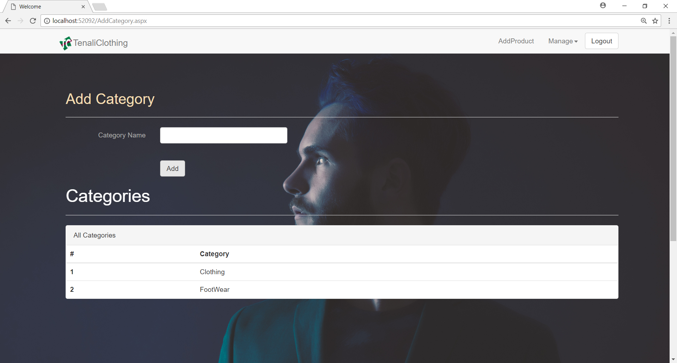

**AddSubCategory Page**

This is to show how admin Add SubCategory for the Product

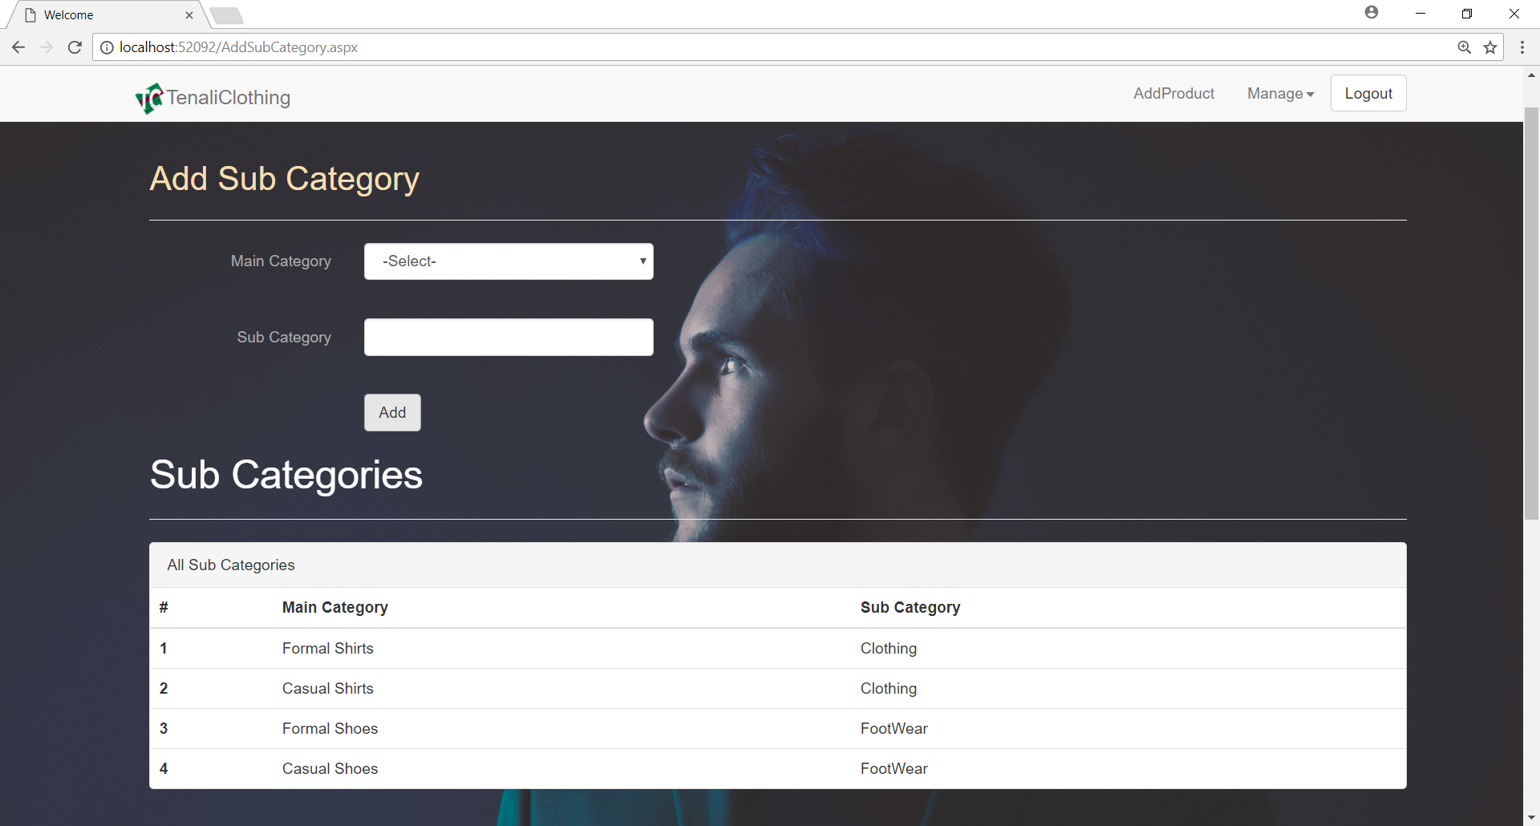

**AddGender Page**

This is to show how admin Add Gender for the Product

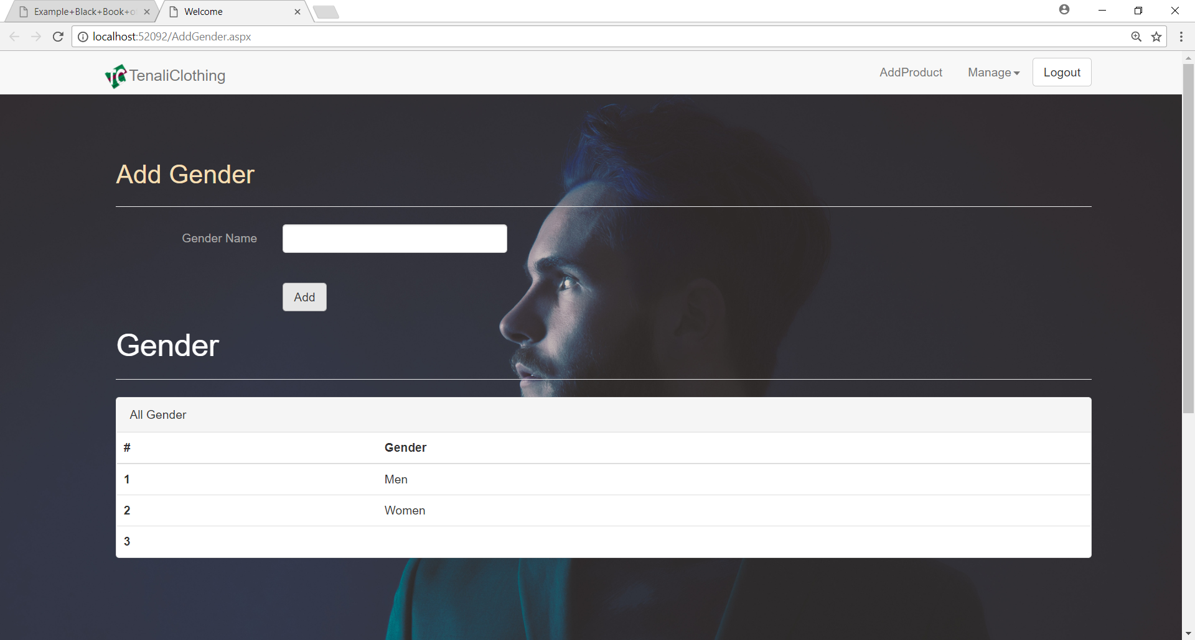

**AddSize Page**

This is to show how admin Add Size for the Product

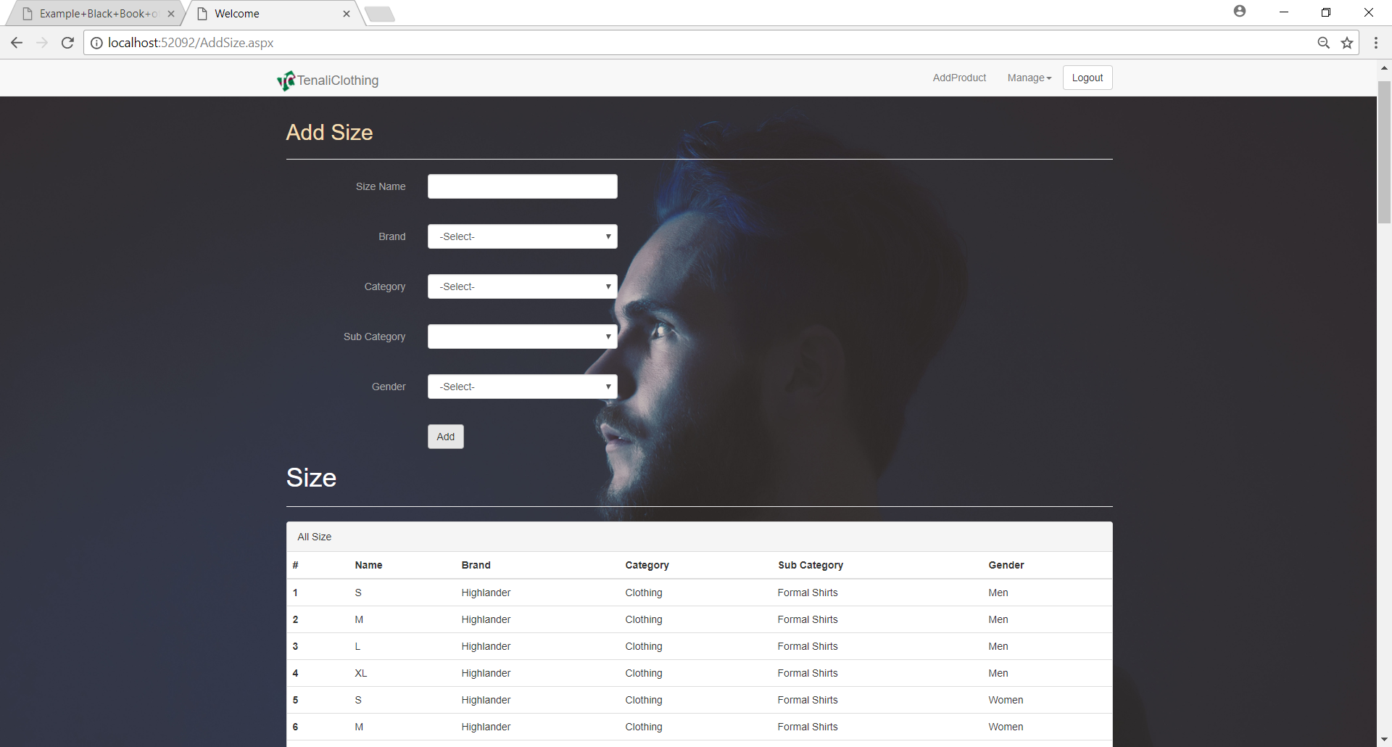

**AddProduct Page**

This is to show how admin Add Product

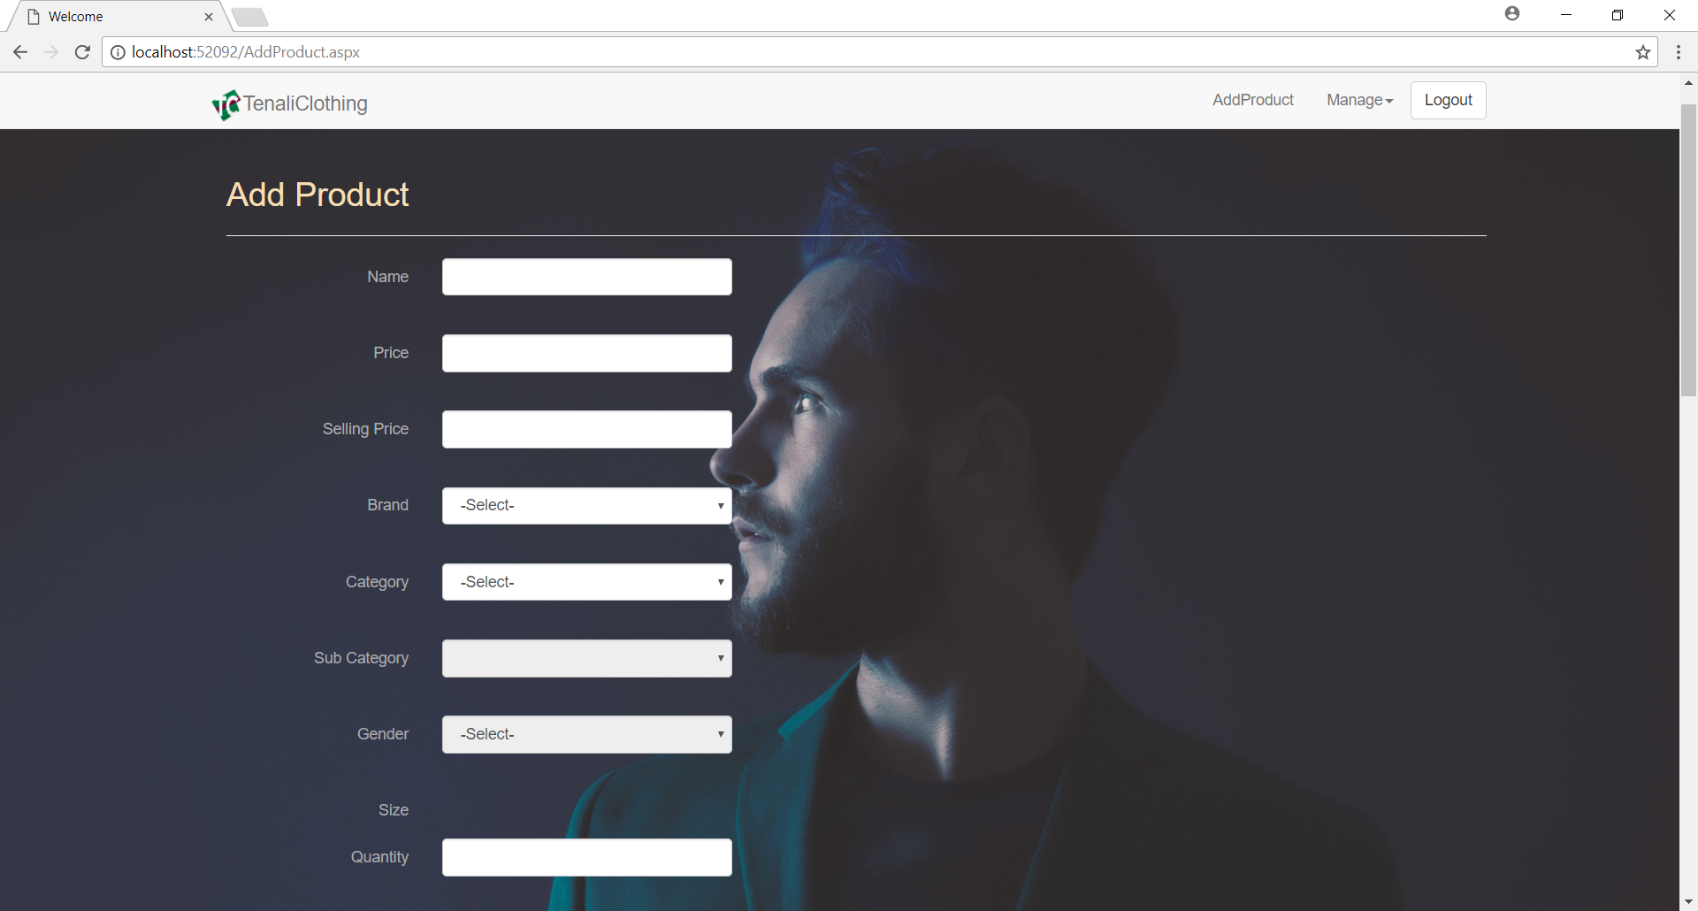

**Customer**

**SignUp Page**

This page is for registering user.

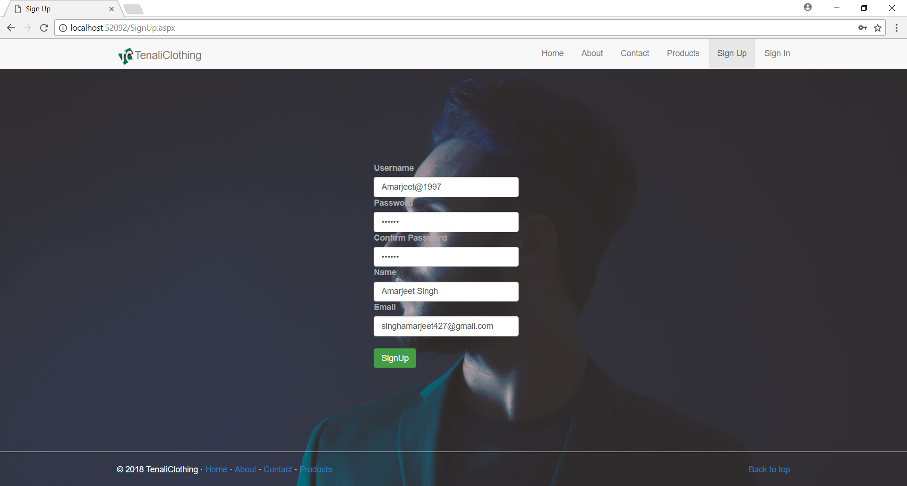

**SignIn Page**

This is signin page for both admin and user

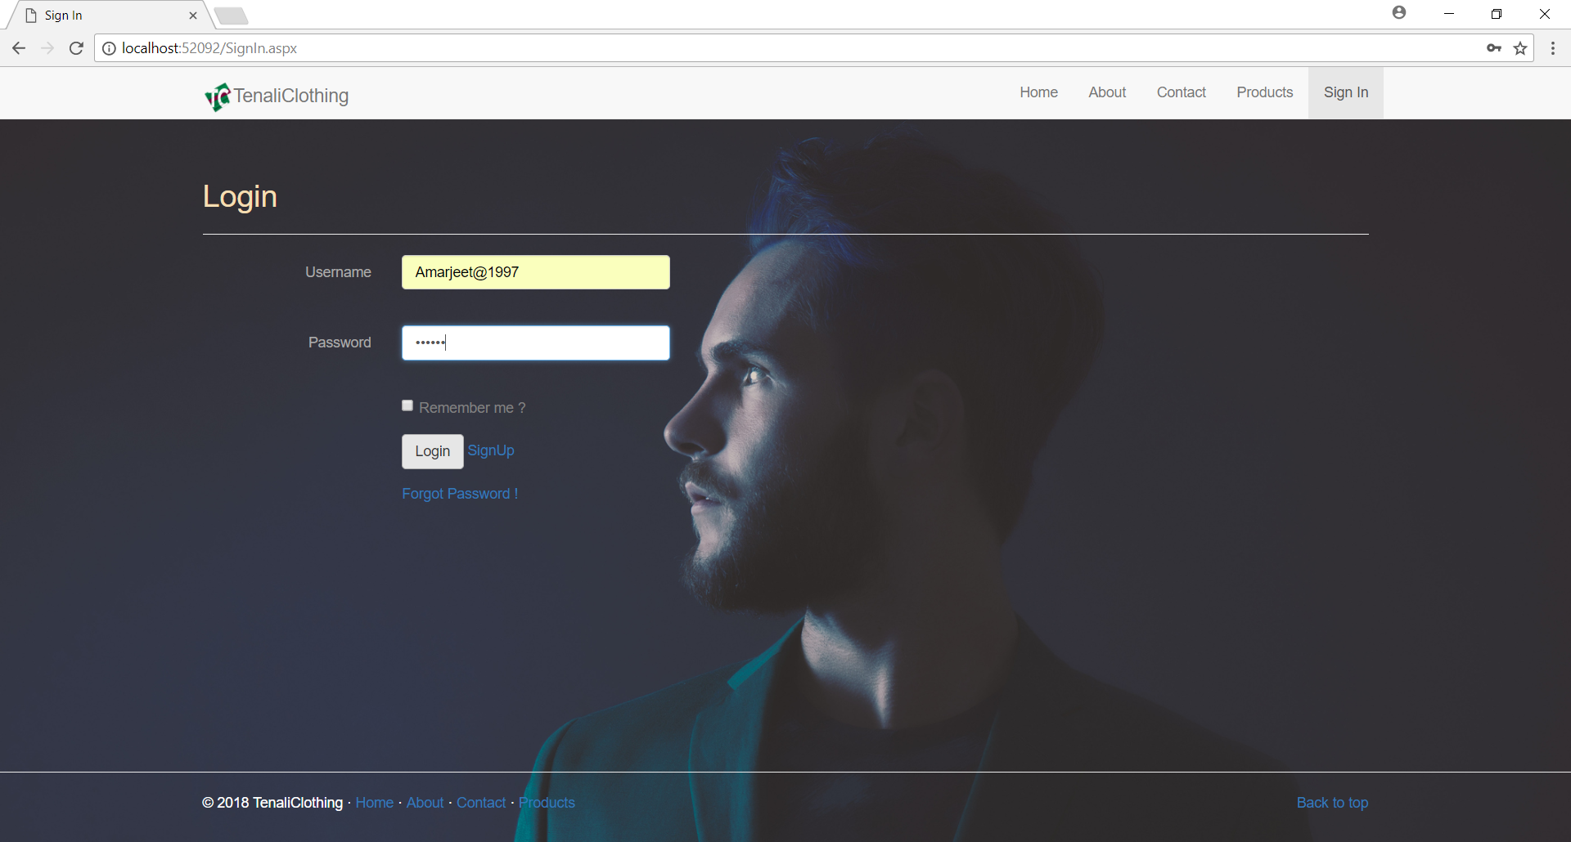

**ForgotPassword Page**

If user forget the password he can click on forgot password and enter his registered email id and press send then he have to log in into his gmail account and have to click on the reset password link and enter the new password after clicking on reset password link ypu clicked it again then it will show that the link has expired.

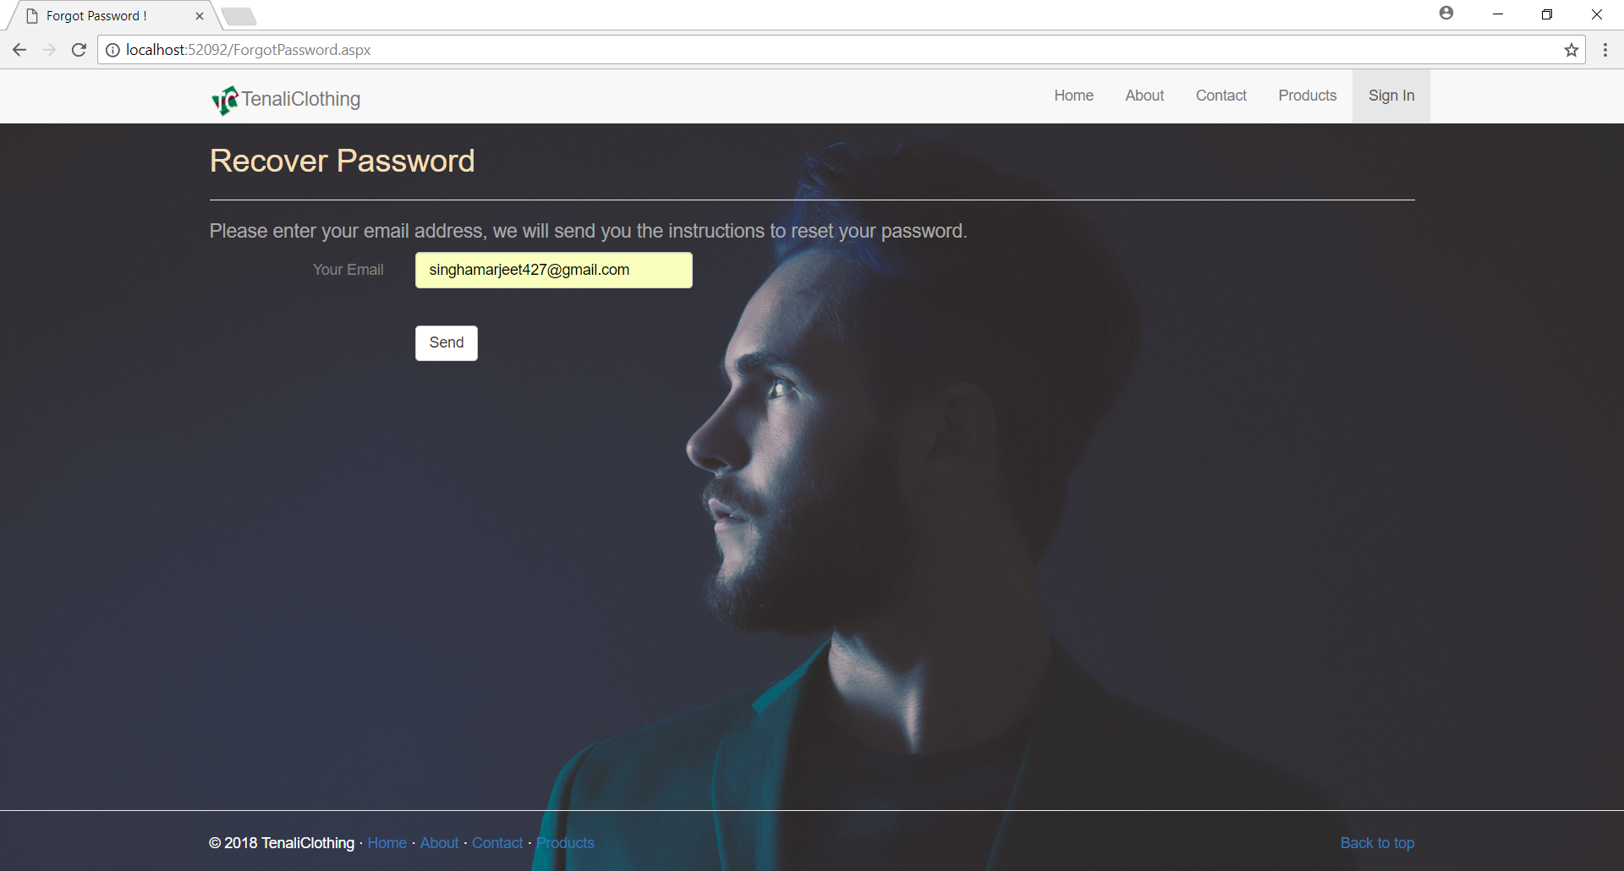

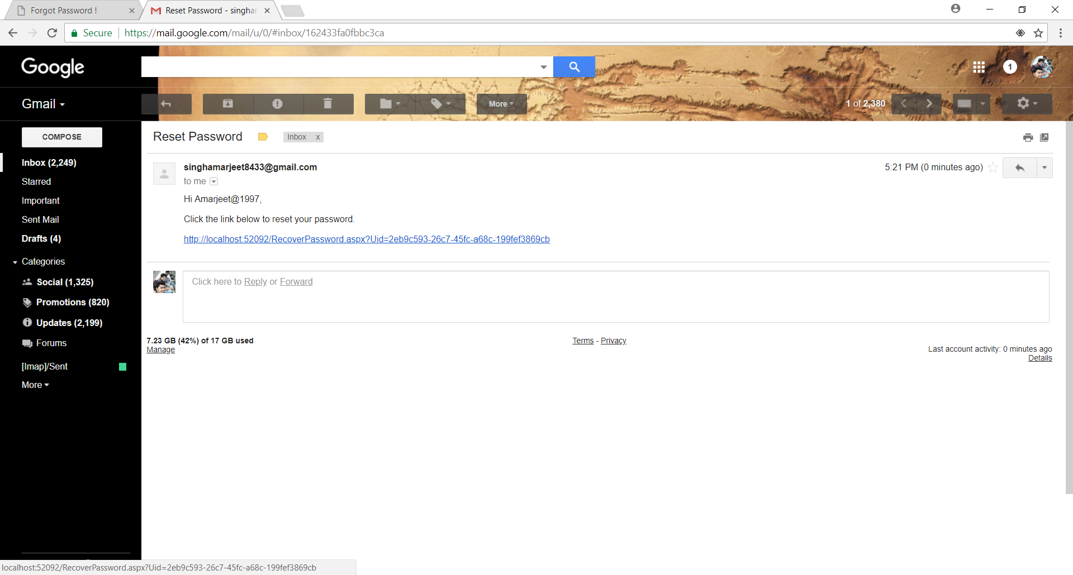

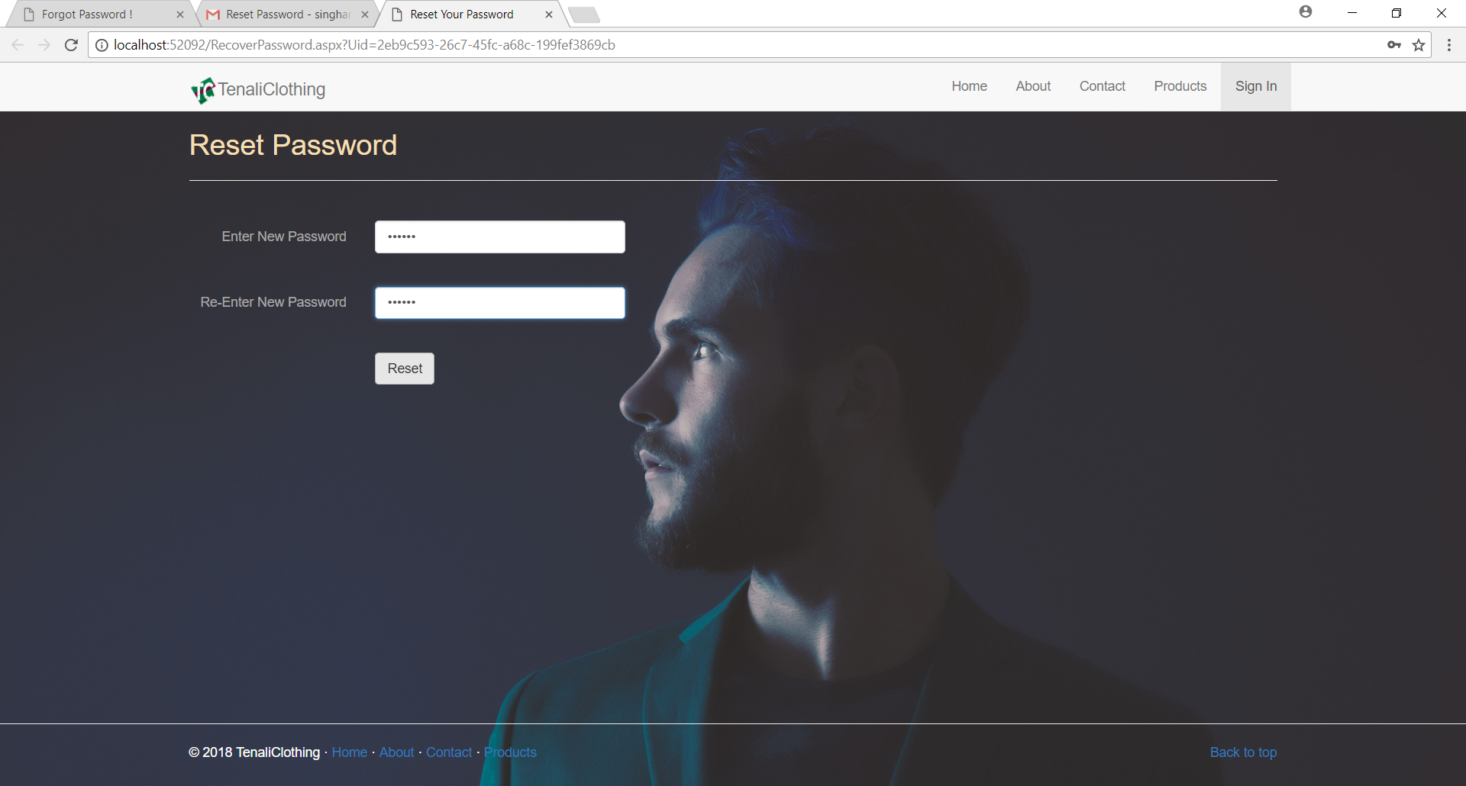

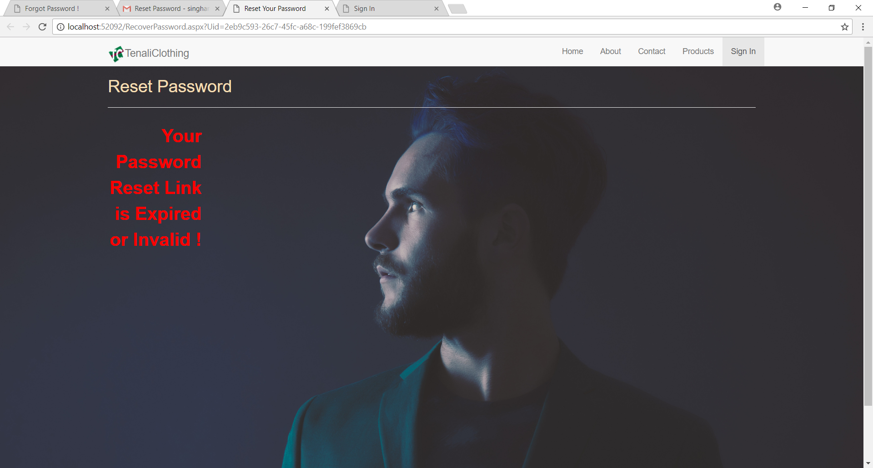

**Home Page**

When user will successfully logged in he will be redirected in home page

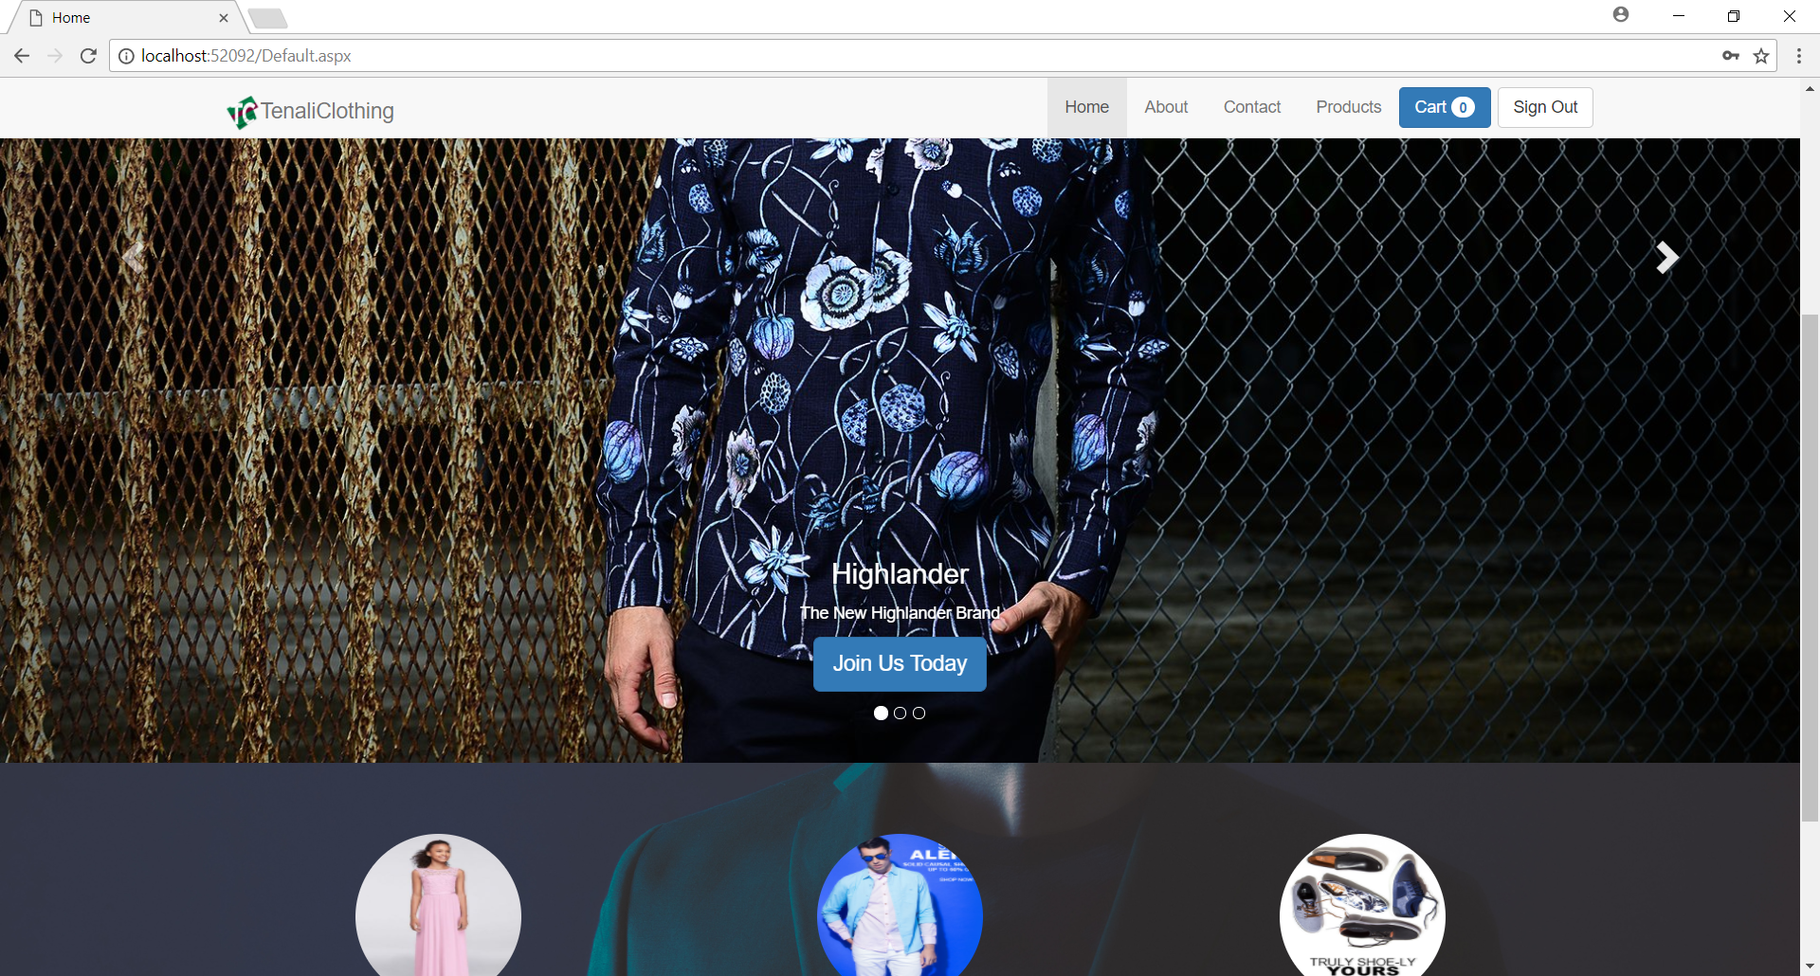

**Product Page**

This page is for user to see list of products

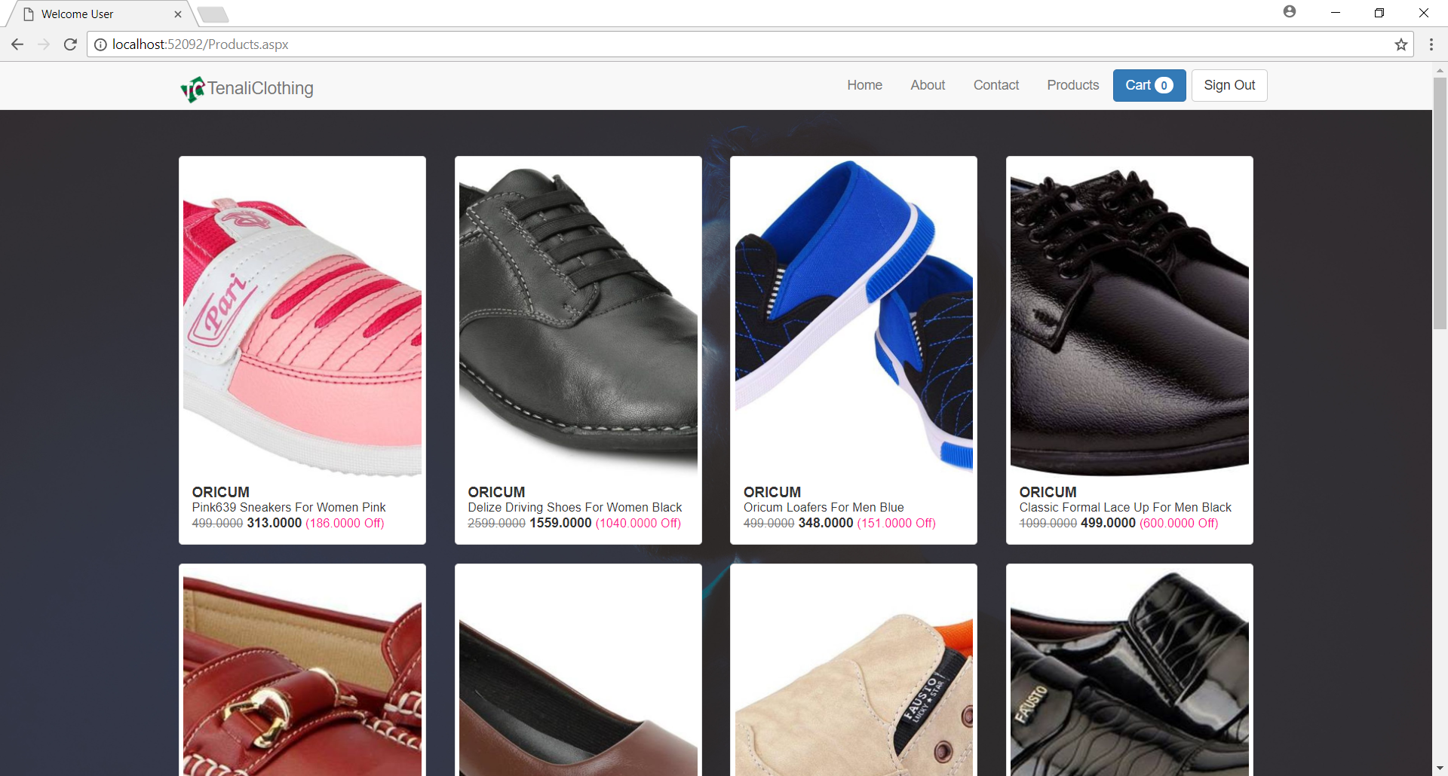

**ProductView Page**

If user select any product it’s description will appear.

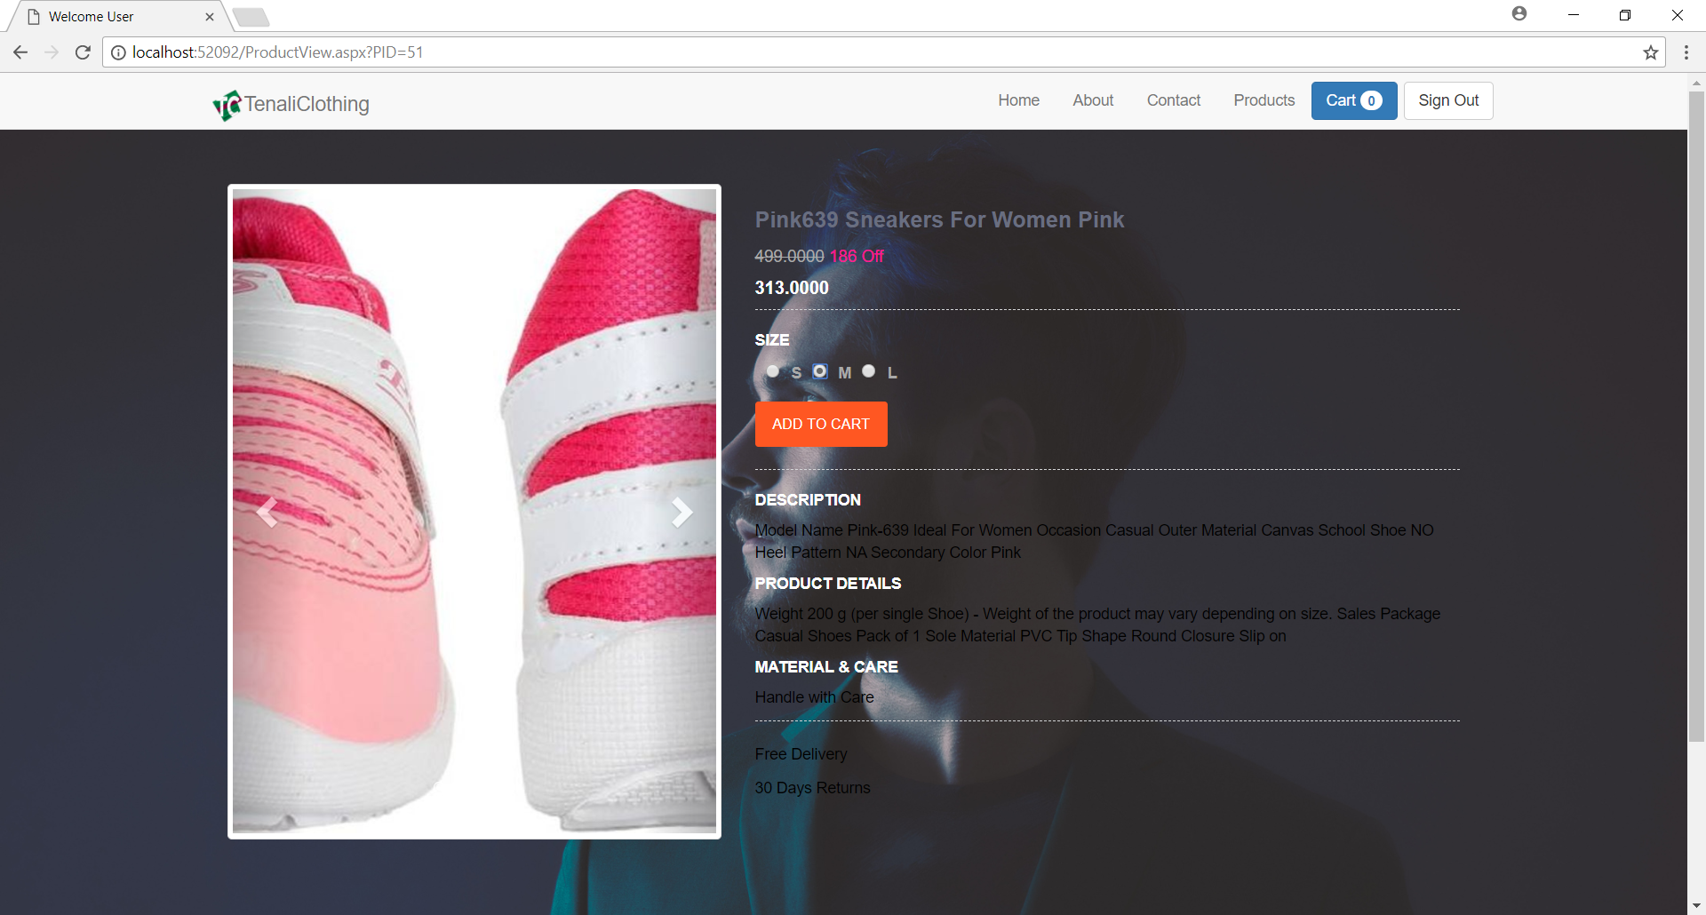

**Cart Page**

In this page after clicking add to cart button every product will be shown to the user if user want he can remove the product by clicking on remove button.

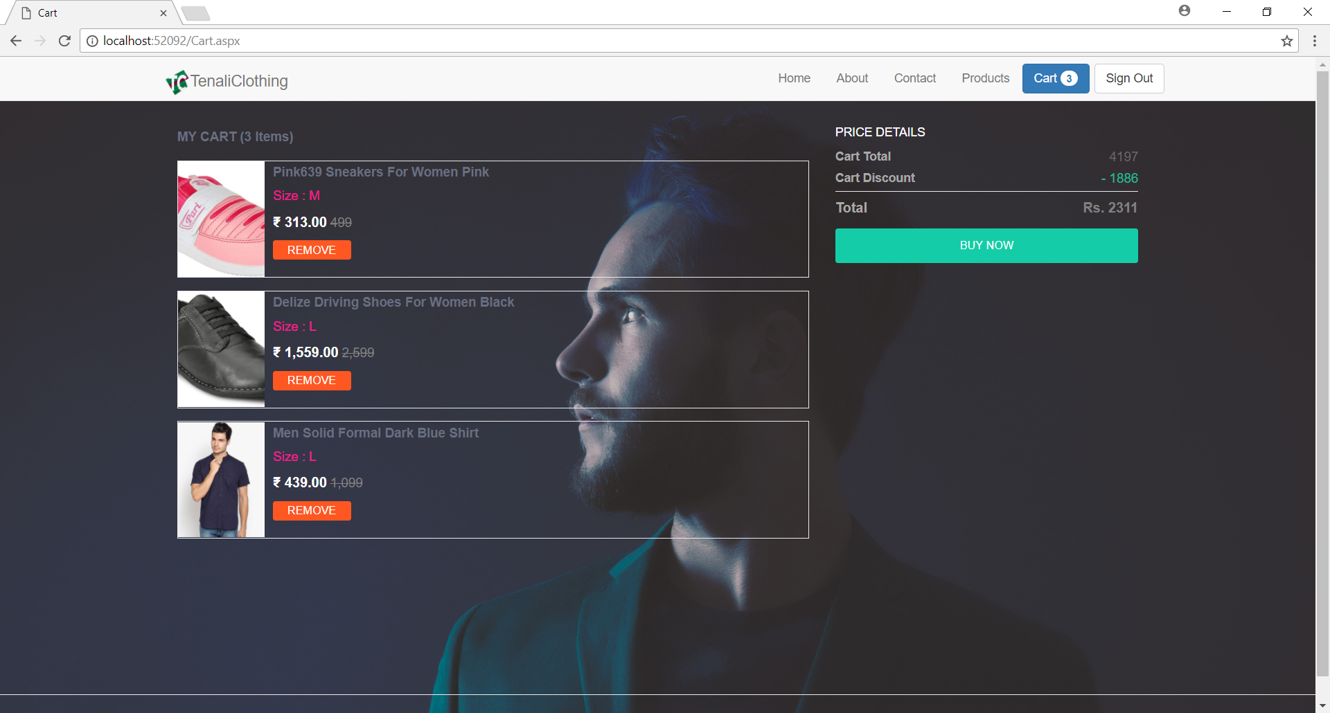

**DeliveryAddress Page**

After clicking on buy now user has to enter the delivery address

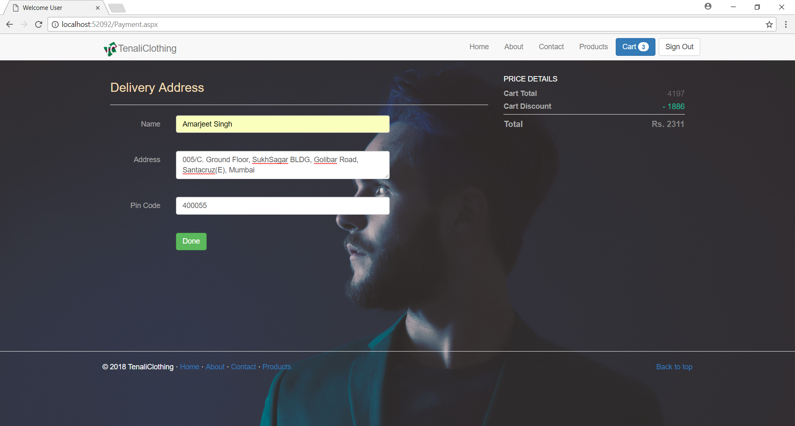

**List of Tables**

Users.sql

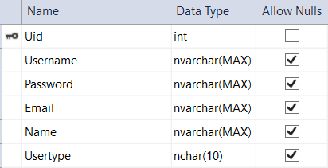

ForgotPassRequests.sql

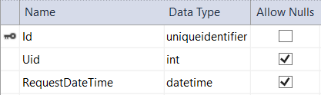

tblBrands.sql

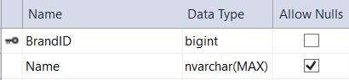

tblCategories.sql

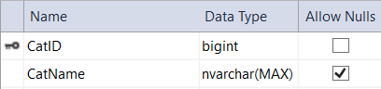

tblSubCategories.sql

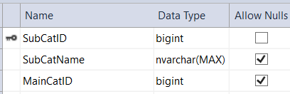

tblGender.sql

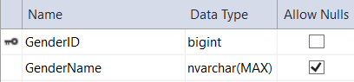

tblSizes.sql

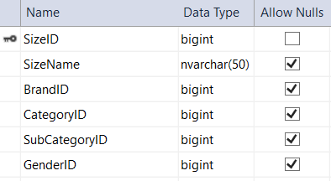

tblProducts.sql

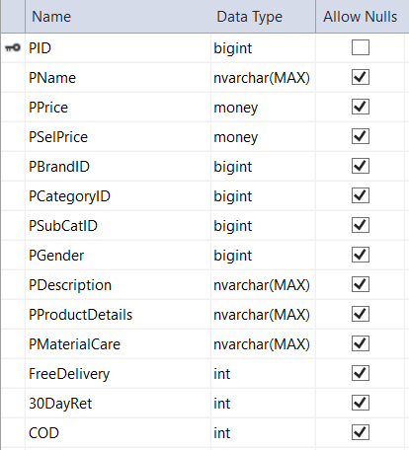

tblProductSizeQuantity.sql

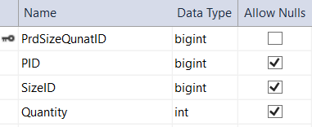

TblProductImages.sql

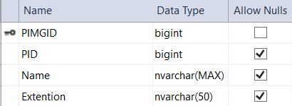

**3.1.1 Coding**

SignUp.aspx:

<%@ Page Language="C#" AutoEventWireup="true" CodeFile="SignUp.aspx.cs" Inherits="SignUp" %>

<!DOCTYPE html>

<html xmlns="http://www.w3.org/1999/xhtml">

<head runat="server">

<meta charset="utf-8" />

<meta http-equiv="X-UA-Compatible" content="IE=edge" />

<meta name="viewport" content="width=device-width, initial-scale=1" />

<!-- The above 3 meta tags *must* come first in the head; any other head content must come *after* these tags -->

<title>Sign Up</title>

<!-- Bootstrap -->

<link href="css/bootstrap.min.css" rel="stylesheet" />

<link href="css/Custom-Cs.css" rel="stylesheet" />

<!-- HTML5 shim and Respond.js for IE8 support of HTML5 elements and media queries -->

<!-- WARNING: Respond.js doesn't work if you view the page via file:// -->

<!--[if lt IE 9]>

<script src="https://oss.maxcdn.com/html5shiv/3.7.2/html5shiv.min.js"></script>

<script src="https://oss.maxcdn.com/respond/1.4.2/respond.min.js"></script>

<![endif]-->

</head>

<body>

<form id="form1" runat="server">

<div>

<div class="navbar navbar-default navbar-fixed-top" role="navigation">

<div class="container">

<div class="navbar-header">

<button type="button" class="navbar-toggle" data-toggle="collapse" data-target=".navbar-collapse">

<span class="sr-only">Toogle navigation</span>

<span class="icon-bar"></span>

<span class="icon-bar"></span>

<span class="icon-bar"></span>

</button>

<a class="navbar-brand" href="Default.aspx"><span>

<img src="Images/tc only 512.png" alt="Logo" height="30" /></span>TenaliClothing</a>

</div>

<div class="navbar-collapse collapse">

<ul class="nav navbar-nav navbar-right">

<li><a href="Default.aspx">Home</a></li>

<li><a href="About.aspx">About</a></li>

<li><a href="Contact.aspx">Contact</a></li>

<li><a href="Products.aspx">Products</a></li>

<li class="active"><a href="SignUp.aspx">Sign Up</a></li>

<li><a href="SignIn.aspx">Sign In</a></li>

</ul>

</div>

</div>

</div>

</div>

<!-- Sign Up -->

<div class="center-page">

<label class="col-xs-11" style="color: darkgray">Username</label>

<div class="col-xs-11">

<asp:TextBox ID="tbUname" runat="server" Class="form-control" placeholder="Username"></asp:TextBox>

</div>

<label class="col-xs-11" style="color: darkgray">Password</label>

<div class="col-xs-11">

<asp:TextBox ID="tbPass" runat="server" Class="form-control" placeholder="Password" TextMode="Password"></asp:TextBox>

</div>

<label class="col-xs-11" style="color: darkgray">Confirm Password</label>

<div class="col-xs-11">

<asp:TextBox ID="tbCPass" runat="server" Class="form-control" placeholder="Confirm Password" TextMode="Password"></asp:TextBox>

</div>

<label class="col-xs-11" style="color: darkgray">Name</label>

<div class="col-xs-11">

<asp:TextBox ID="tbName" runat="server" Class="form-control" placeholder="Name"></asp:TextBox>

</div>

<label class="col-xs-11" style="color: darkgray">Email</label>

<div class="col-xs-11">

<asp:TextBox ID="tbEmail" runat="server" Class="form-control" placeholder="Email" TextMode="Email"></asp:TextBox>

</div>

<div class="col-xs-11 space-vert">

<asp:Button ID="btnSignUp" runat="server" Class="btn btn-success" Text="SignUp" OnClick="btnSignUp_Click" />

<asp:Label ID="lblMsg" runat="server"></asp:Label>

</div>

</div>

<!-- Sign Up -->

</form>

<!-- Footer -->

<div style="padding-top: 630px">

<hr />

<footer>

<div class="container">

<p class="pull-right"><a href="#">Back to top</a></p>

<p style="color: white">&copy; 2018 TenaliClothing &middot; <a href="Default.aspx">Home</a> &middot; <a href="About.aspx">About</a> &middot; <a href="Contact.aspx">Contact</a> &middot; <a href="Products.aspx">Products</a></p>

</div>

</footer>

</div>

<!-- Footer -->

<!-- jQuery (necessary for Bootstrap's JavaScript plugins) -->

<script src="js/jquery-3.2.1.min.js"></script>

<!-- Include all compiled plugins (below), or include individual files as needed -->

<script src="js/bootstrap.min.js"></script>

</body>

</html>

SignUp.aspx.cs

using System;

using System.Collections.Generic;

using System.Linq;

using System.Web;

using System.Web.UI;

using System.Web.UI.WebControls;

using System.Data.SqlClient;

using System.Configuration;

using System.Drawing;

public partial class SignUp : System.Web.UI.Page

{

protected void Page_Load(object sender, EventArgs e)

{

}

protected void btnSignUp_Click(object sender, EventArgs e)

{

if (tbUname.Text != "" & tbPass.Text != "" && tbName.Text != "" && tbEmail.Text != "" && tbCPass.Text != "")

{

if (tbPass.Text == tbCPass.Text)

{

String CS = ConfigurationManager.ConnectionStrings["MyDatabaseConnectionString1"].ConnectionString;

using (SqlConnection con = new SqlConnection(CS))

{

SqlCommand cmd = new SqlCommand("insert into Users values('" + tbUname.Text + "','" + tbPass.Text + "','" + tbEmail.Text + "','" + tbName.Text + "','U')", con);

con.Open();

cmd.ExecuteNonQuery();

lblMsg.Text = "Registration Succesfull";

lblMsg.ForeColor = Color.Green;

Response.Redirect("SignIn.aspx");

}

}

else

{

lblMsg.ForeColor = Color.Red;

lblMsg.Text = "Passwords do not match";

}

}

else

{

lblMsg.ForeColor = Color.Red;

lblMsg.Text = "All fields are Mandatory";

}

}

}

SignIn.aspx:

<%@ Page Language="C#" AutoEventWireup="true" CodeFile="SignIn.aspx.cs" Inherits="SignIn" %>

<!DOCTYPE html>

<html xmlns="http://www.w3.org/1999/xhtml">

<head runat="server">

<meta charset="utf-8" />

<meta http-equiv="X-UA-Compatible" content="IE=edge" />

<meta name="viewport" content="width=device-width, initial-scale=1" />

<!-- The above 3 meta tags *must* come first in the head; any other head content must come *after* these tags -->

<title>Sign In</title>

<!-- Bootstrap -->

<link href="css/bootstrap.min.css" rel="stylesheet" />

<link href="css/Custom-Cs.css" rel="stylesheet" />

<!-- HTML5 shim and Respond.js for IE8 support of HTML5 elements and media queries -->

<!-- WARNING: Respond.js doesn't work if you view the page via file:// -->

<!--[if lt IE 9]>

<script src="https://oss.maxcdn.com/html5shiv/3.7.2/html5shiv.min.js"></script>

<script src="https://oss.maxcdn.com/respond/1.4.2/respond.min.js"></script>

<![endif]-->

</head>

<body>

<form id="form1" runat="server">

<div>

<div class="navbar navbar-default navbar-fixed-top" role="navigation">

<div class="container">

<div class="navbar-header">

<button type="button" class="navbar-toggle" data-toggle="collapse" data-target=".navbar-collapse">

<span class="sr-only">Toogle navigation</span>

<span class="icon-bar"></span>

<span class="icon-bar"></span>

<span class="icon-bar"></span>

</button>

<a class="navbar-brand" href="Default.aspx"><span>

<img src="Images/tc only 512.png" alt="Logo" height="30" /></span>TenaliClothing</a>

</div>

<div class="navbar-collapse collapse">

<ul class="nav navbar-nav navbar-right">

<li><a href="Default.aspx">Home</a></li>

<li><a href="About.aspx">About</a></li>

<li><a href="Contact.aspx">Contact</a></li>

<li><a href="Products.aspx">Products</a></li>

<li class="active"><a href="SignIn.aspx">Sign In</a></li>

</ul>

</div>

</div>

</div>

</div>

<!-- Sign In start -->

<br />

<br />

<div class="container">

<div class="form-horizontal">

<h2 style="color: wheat">Login</h2>

<hr />

<div class="form-group">

<asp:Label ID="Label1" runat="server" ForeColor="DarkGray" CssClass="col-md-2 control-label" Text="Username"></asp:Label>

<div class="col-md-3">

<asp:TextBox ID="UserName" CssClass="form-control" runat="server"></asp:TextBox>

<asp:RequiredFieldValidator ID="RequiredFieldValidatorUsername" CssClass="text-danger" runat="server" ErrorMessage="This field is required !" ControlToValidate="UserName"></asp:RequiredFieldValidator>

</div>

</div>

<div class="form-group">

<asp:Label ID="Label2" runat="server" ForeColor="DarkGray" CssClass="col-md-2 control-label" Text="Password"></asp:Label>

<div class="col-md-3">

<asp:TextBox ID="Password" CssClass="form-control" runat="server" TextMode="Password"></asp:TextBox>

<asp:RequiredFieldValidator ID="RequiredFieldValidatorPassword" CssClass="text-danger" runat="server" ErrorMessage="This field is required !" ControlToValidate="Password"></asp:RequiredFieldValidator>

</div>

</div>

<div class="form-group">

<div class="col-md-2"></div>

<div class="col-md-6">

<asp:CheckBox ID="CheckBox1" runat="server" />

<asp:Label ID="Label3" runat="server" ForeColor="Gray" CssClass="control-label" Text="Remember me ?"></asp:Label>

</div>

</div>

<div class="form-group">

<div class="col-md-2"></div>

<div class="col-md-6">

<asp:Button ID="Button1" runat="server" Text="Login" CssClass="btn btn-default" OnClick="Button1_Click" />

<asp:LinkButton ID="LinkButton1" runat="server" PostBackUrl="~/SignUp.aspx">SignUp</asp:LinkButton>

</div>

</div>

<div class="form-group">

<div class="col-md-2"></div>

<div class="col-md-6">

<asp:LinkButton ID="lbForgotPass" runat="server" PostBackUrl="~/ForgotPassword.aspx">Forgot Password !</asp:LinkButton>

</div>

</div>

<div class="form-group">

<div class="col-md-2"></div>

<div class="col-md-6">

<asp:Label ID="lblError" CssClass="text-danger" runat="server"></asp:Label>

</div>

</div>

</div>

</div>

<!-- Sign In end -->

</form>

<!-- Footer -->

<div style="padding-top:210px">

<hr />

<footer>

<div class="container">

<p class="pull-right"><a href="#">Back to top</a></p>

<p style="color: white">&copy; 2018 TenaliClothing &middot; <a href="Default.aspx">Home</a> &middot; <a href="About.aspx">About</a> &middot; <a href="Contact.aspx">Contact</a> &middot; <a href="Products.aspx">Products</a></p>

</div>

</footer>

</div>

<!-- Footer -->

<!-- jQuery (necessary for Bootstrap's JavaScript plugins) -->

<script src="js/jquery-3.2.1.min.js"></script>

<!-- Include all compiled plugins (below), or include individual files as needed -->

<script src="js/bootstrap.min.js"></script>

</body>

</html>

SignIn.aspx.xs:

using System;

using System.Collections.Generic;

using System.Linq;

using System.Web;

using System.Web.UI;

using System.Web.UI.WebControls;

using System.Data.SqlClient;

using System.Configuration;

using System.Data;

public partial class SignIn : System.Web.UI.Page

{

protected void Page_Load(object sender, EventArgs e)

{

if (!IsPostBack)

{

if (Request.Cookies["UNAME"] != null && Request.Cookies["PWD"] != null)

{

UserName.Text = Request.Cookies["UNAME"].Value;

Password.Attributes["value"] = Request.Cookies["PWD"].Value;

CheckBox1.Checked = true;

}

}

}

protected void Button1_Click(object sender, EventArgs e)

{

String CS = ConfigurationManager.ConnectionStrings["MyDatabaseConnectionString1"].ConnectionString;

using (SqlConnection con = new SqlConnection(CS))

{

SqlCommand cmd = new SqlCommand("select * from Users where Username='" + UserName.Text + "' and Password='" + Password.Text + "'", con);

con.Open();

SqlDataAdapter sda = new SqlDataAdapter(cmd);

DataTable dt = new DataTable();

sda.Fill(dt);

if (dt.Rows.Count != 0)

{

Session["USERID"] = dt.Rows[0]["Uid"].ToString();

Session["USEREMAIL"] = dt.Rows[0]["Email"].ToString();

if (CheckBox1.Checked)

{

Response.Cookies["UNAME"].Value = UserName.Text;

Response.Cookies["PWD"].Value = Password.Text;

Response.Cookies["UNAME"].Expires = DateTime.Now.AddDays(15);

Response.Cookies["PWD"].Expires = DateTime.Now.AddDays(15);

Session["USERNAME"] = UserName.Text;

Response.Redirect("UserHome.aspx");

}

else

{

Response.Cookies["UNAME"].Expires = DateTime.Now.AddDays(-1);

Response.Cookies["PWD"].Expires = DateTime.Now.AddDays(-1);

}

string Utype;

Utype = dt.Rows[0][5].ToString().Trim();

if (Utype == "U")

{

Session["USERNAME"] = UserName.Text;

if (Request.QueryString["rurl"] != null)

{

if (Request.QueryString["rurl"] == "cart")

{

Response.Redirect("Cart.aspx");

}

}

else

{

Response.Redirect("UserHome.aspx");

}

}

if (Utype == "A")

{

Session["USERNAME"] = UserName.Text;

Response.Redirect("AdminHome.aspx");

}

}

else

{

lblError.Text = "Invalid Username or Password";

}

}

}

}

ForgotPassword.aspx:

<%@ Page Language="C#" AutoEventWireup="true" CodeFile="ForgotPassword.aspx.cs" Inherits="ForgotPassword" %>

<!DOCTYPE html>

<html xmlns="http://www.w3.org/1999/xhtml">

<head runat="server">

<title>Forgot Password !</title>

<!-- Bootstrap -->

<link href="css/bootstrap.min.css" rel="stylesheet" />

<link href="css/Custom-Cs.css" rel="stylesheet" />

<!-- HTML5 shim and Respond.js for IE8 support of HTML5 elements and media queries -->

<!-- WARNING: Respond.js doesn't work if you view the page via file:// -->

<!--[if lt IE 9]>

<script src="https://oss.maxcdn.com/html5shiv/3.7.2/html5shiv.min.js"></script>

<script src="https://oss.maxcdn.com/respond/1.4.2/respond.min.js"></script>

<![endif]-->

</head>

<body>

<form id="form1" runat="server">

<div>

<div class="navbar navbar-default navbar-fixed-top" role="navigation">

<div class="container">

<div class="navbar-header">

<button type="button" class="navbar-toggle" data-toggle="collapse" data-target=".navbar-collapse">

<span class="sr-only">Toogle navigation</span>

<span class="icon-bar"></span>

<span class="icon-bar"></span>

<span class="icon-bar"></span>

</button>

<a class="navbar-brand" href="Default.aspx"><span>

<img src="Images/tc only 512.png" alt="Logo" height="30" /></span>TenaliClothing</a>

</div>

<div class="navbar-collapse collapse">

<ul class="nav navbar-nav navbar-right">

<li><a href="Default.aspx">Home</a></li>

<li><a href="About.aspx">About</a></li>

<li><a href="Contact.aspx">Contact</a></li>

<li><a href="Products.aspx">Products</a></li>

<li class="active"><a href="SignIn.aspx">Sign In</a></li>

</ul>

</div>

</div>

</div>

</div>

<div class="container">

<div class="form-horizontal">

<h2 style="color: wheat">Recover Password</h2>

<hr />

<h4 style="color: darkgray">Please enter your email address, we will send you the instructions to reset your password.</h4>

<div class="form-group">

<asp:Label ID="lblEmail" runat="server" ForeColor="Gray" CssClass="col-md-2 control-label" Text="Your Email"></asp:Label>

<div class="col-md-3">

<asp:TextBox ID="tbEmailId" CssClass="form-control" runat="server"></asp:TextBox>

<asp:RequiredFieldValidator ID="RequiredFieldValidatorEmail" CssClass="text-danger" runat="server" ErrorMessage="Please enter your Email ID" ControlToValidate="tbEmailId"></asp:RequiredFieldValidator>

</div>

</div>

<div class="form-group">

<div class="col-md-2"></div>

<div class="col-md-6">

<asp:Button ID="btPassRec" runat="server" CssClass="btn btn-default" Text="Send" OnClick="btPassRec_Click" />

<asp:Label ID="lblPassRec" runat="server"></asp:Label>

</div>

</div>

</div>

</div>

</form>

<!-- Footer -->

<div style="padding-top: 390px">

<hr />

<footer>

<div class="container">

<p class="pull-right"><a href="#">Back to top</a></p>

<p style="color: white">&copy; 2018 TenaliClothing &middot; <a href="Default.aspx">Home</a> &middot; <a href="About.aspx">About</a> &middot; <a href="Contact.aspx">Contact</a> &middot; <a href="Products.aspx">Products</a></p>

</div>

</footer>

</div>

<!-- Footer -->

<!-- jQuery (necessary for Bootstrap's JavaScript plugins) -->

<script src="js/jquery-3.2.1.min.js"></script>

<!-- Include all compiled plugins (below), or include individual files as needed -->

<script src="js/bootstrap.min.js"></script>

</body>

</html>

ForgotPassword.aspx.cs

using System;

using System.Collections.Generic;

using System.Linq;

using System.Web;

using System.Web.UI;

using System.Web.UI.WebControls;

using System.Data;

using System.Data.SqlClient;

using System.Configuration;

using System.Drawing;

using System.Net;

using System.Net.Mail;

public partial class ForgotPassword : System.Web.UI.Page

{

protected void Page_Load(object sender, EventArgs e)

{

}

protected void btPassRec_Click(object sender, EventArgs e)

{

String CS = ConfigurationManager.ConnectionStrings["MyDatabaseConnectionString1"].ConnectionString;

using (SqlConnection con = new SqlConnection(CS))

{

SqlCommand cmd = new SqlCommand("select * from users where Email='" + tbEmailId.Text + "'", con);

con.Open();

SqlDataAdapter sda = new SqlDataAdapter(cmd);

DataTable dt = new DataTable();

sda.Fill(dt);

if (dt.Rows.Count != 0)

{

String myGUID = Guid.NewGuid().ToString();

int Uid = Convert.ToInt32(dt.Rows[0][0]);

SqlCommand cmd1 = new SqlCommand("insert into ForgotPassRequests values('" + myGUID + "','" + Uid + "',getdate())", con);

cmd1.ExecuteNonQuery();

//send email

String ToEmailAddress = dt.Rows[0][3].ToString();

String Username = dt.Rows[0][1].ToString();

String EmailBody = "Hi " + Username + ",<br/><br/> Click the link below to reset your password. <br/><br/> http://localhost:52092/RecoverPassword.aspx?Uid=" + myGUID;

MailMessage PassRecMail = new MailMessage("singhamarjeet8433@gmail.com", ToEmailAddress);

PassRecMail.Body = EmailBody;

PassRecMail.IsBodyHtml = true;

PassRecMail.Subject = "Reset Password";

SmtpClient SMTP = new SmtpClient("smtp.gmail.com", 587);

SMTP.Credentials = new NetworkCredential()

{

UserName = "singhamarjeet8433@gmail.com",

Password = "8433570965"

};

SMTP.EnableSsl = true;

SMTP.Send(PassRecMail);

lblPassRec.Text = "Check your email to reset your Password.";

lblPassRec.ForeColor = Color.Green;

}

else

{

lblPassRec.Text = "OOps This Email id DOES NOT Exist in our database !";

lblPassRec.ForeColor = Color.Red;

}

}

}

}

RecoverPassword.aspx:

<%@ Page Language="C#" AutoEventWireup="true" CodeFile="RecoverPassword.aspx.cs" Inherits="RecoverPassword" %>

<!DOCTYPE html>

<html xmlns="http://www.w3.org/1999/xhtml">

<head runat="server">

<title>Reset Your Password</title>

<!-- Bootstrap -->

<link href="css/bootstrap.min.css" rel="stylesheet" />

<link href="css/Custom-Cs.css" rel="stylesheet" />

<!-- HTML5 shim and Respond.js for IE8 support of HTML5 elements and media queries -->

<!-- WARNING: Respond.js doesn't work if you view the page via file:// -->

<!--[if lt IE 9]>

<script src="https://oss.maxcdn.com/html5shiv/3.7.2/html5shiv.min.js"></script>

<script src="https://oss.maxcdn.com/respond/1.4.2/respond.min.js"></script>

<![endif]-->

</head>

<body>

<form id="form1" runat="server">

<div>

<div class="navbar navbar-default navbar-fixed-top" role="navigation">

<div class="container">

<div class="navbar-header">

<button type="button" class="navbar-toggle" data-toggle="collapse" data-target=".navbar-collapse">

<span class="sr-only">Toogle navigation</span>

<span class="icon-bar"></span>

<span class="icon-bar"></span>

<span class="icon-bar"></span>

</button>

<a class="navbar-brand" href="Default.aspx"><span>

<img src="Images/tc only 512.png" alt="Logo" height="30" /></span>TenaliClothing</a>

</div>

<div class="navbar-collapse collapse">

<ul class="nav navbar-nav navbar-right">

<li><a href="Default.aspx">Home</a></li>

<li><a href="About.aspx">About</a></li>

<li><a href="Contact.aspx">Contact</a></li>

<li><a href="Products.aspx">Products</a></li>

<li class="active"><a href="SignIn.aspx">Sign In</a></li>

</ul>

</div>

</div>

</div>

</div>

<div class="container">

<div class="form-horizontal">

<h2 style="color: wheat">Reset Password</h2>

<hr />

<div class="form-group">

<asp:Label ID="lblMsg" runat="server" CssClass="col-md-2 control-label" Font-Size="XX-Large" Font-Bold="true"></asp:Label>

</div>

<div class="form-group">

<asp:Label ID="lblPassword" runat="server" ForeColor="DarkGray" CssClass="col-md-2 control-label" Text="Enter New Password" Visible="False"></asp:Label>

<div class="col-md-3">

<asp:TextBox ID="tbNewPass" CssClass="form-control" TextMode="Password" runat="server" Visible="False"></asp:TextBox>

<asp:RequiredFieldValidator ID="RequiredFieldValidatorNewPass" CssClass="text-danger" runat="server" ErrorMessage="Please Enter your new Password !" ControlToValidate="tbNewPass"></asp:RequiredFieldValidator>

</div>

</div>

<div class="form-group">

<asp:Label ID="lblRetypePass" runat="server" ForeColor="DarkGray" CssClass="col-md-2 control-label" Text="Re-Enter New Password" Visible="False"></asp:Label>

<div class="col-md-3">

<asp:TextBox ID="tbConfirmPass" CssClass="form-control" TextMode="Password" runat="server" Visible="False"></asp:TextBox>

<asp:CompareValidator ID="CompareValidatorPass" CssClass="text-danger" runat="server" ErrorMessage="Both Password must be same !" ControlToCompare="tbConfirmPass" ControlToValidate="tbNewPass"></asp:CompareValidator>

</div>

</div>

<div class="form-group">

<div class="col-md-2"></div>

<div class="col-md-6">

<asp:Button ID="btRecPass" runat="server" CssClass="btn btn-default" Text="Reset" Visible="False" OnClick="btRecPass_Click" />

</div>

</div>

</div>

</div>

</form>

<!-- Footer -->

<div style="padding-top: 320px">

<hr />

<footer>

<div class="container">

<p class="pull-right"><a href="#">Back to top</a></p>

<p style="color: white">&copy; 2018 TenaliClothing &middot; <a href="Default.aspx">Home</a> &middot; <a href="About.aspx">About</a> &middot; <a href="Contact.aspx">Contact</a> &middot; <a href="Products.aspx">Products</a></p>

</div>

</footer>

</div>

<!-- Footer -->

<!-- jQuery (necessary for Bootstrap's JavaScript plugins) -->

<script src="js/jquery-3.2.1.min.js"></script>

<!-- Include all compiled plugins (below), or include individual files as needed -->

<script src="js/bootstrap.min.js"></script>

</body>

</html>

RecoverPassword.aspx.cs:

using System;

using System.Collections.Generic;

using System.Linq;

using System.Web;

using System.Web.UI;

using System.Web.UI.WebControls;

using System.Data;

using System.Data.SqlClient;

using System.Configuration;

using System.Drawing;

public partial class RecoverPassword : System.Web.UI.Page

{

String CS = ConfigurationManager.ConnectionStrings["MyDatabaseConnectionString1"].ConnectionString;

String GUIDvalue;

DataTable dt = new DataTable();

int Uid;

protected void Page_Load(object sender, EventArgs e)

{

using (SqlConnection con = new SqlConnection(CS))

{

GUIDvalue = Request.QueryString["Uid"];

if (GUIDvalue != null)

{

SqlCommand cmd = new SqlCommand("select * from ForgotPassRequests where id='" + GUIDvalue + "'", con);

con.Open();

SqlDataAdapter sda = new SqlDataAdapter(cmd);

sda.Fill(dt);

if (dt.Rows.Count != 0)

{

Uid = Convert.ToInt32(dt.Rows[0][1]);

}

else

{

lblMsg.Text = "Your Password Reset Link is Expired or Invalid !";

lblMsg.ForeColor = Color.Red;

}

}

else

{

Response.Redirect("Default.aspx");

}

}

if (!IsPostBack)

{

if (dt.Rows.Count != 0)

{

tbNewPass.Visible = true;

tbConfirmPass.Visible = true;

lblPassword.Visible = true;

lblRetypePass.Visible = true;

btRecPass.Visible = true;

}

else

{

lblMsg.Text = "Your Password Reset Link is Expired or Invalid !";

lblMsg.ForeColor = Color.Red;

}

}

}

protected void btRecPass_Click(object sender, EventArgs e)

{

using (SqlConnection con = new SqlConnection(CS))

{

if (tbNewPass.Text != "" && tbConfirmPass.Text != "" && tbNewPass.Text == tbConfirmPass.Text)

{

SqlCommand cmd = new SqlCommand("update users set Password='" + tbNewPass.Text + "' where Uid='" + Uid + "'", con);

con.Open();

cmd.ExecuteNonQuery();

SqlCommand cmd2 = new SqlCommand("delete from ForgotPassRequests where Uid='" + Uid + "'", con);

cmd2.ExecuteNonQuery();

Response.Redirect("SignIn.aspx");

}

}

}

}

Default.aspx:

<%@ Page Language="C#" AutoEventWireup="true" CodeFile="Default.aspx.cs" Inherits="_Default" %>

<!DOCTYPE html>

<html xmlns="http://www.w3.org/1999/xhtml">

<head runat="server">

<meta charset="utf-8" />

<meta http-equiv="X-UA-Compatible" content="IE=edge" />

<meta name="viewport" content="width=device-width, initial-scale=1" />

<!-- The above 3 meta tags *must* come first in the head; any other head content must come *after* these tags -->

<title>Home</title>

<script src="js/jquery-3.2.1.min.js"></script>

<!-- Bootstrap -->

<link href="css/bootstrap.min.css" rel="stylesheet" />

<link href="css/Custom-Cs.css" rel="stylesheet" />

<!-- HTML5 shim and Respond.js for IE8 support of HTML5 elements and media queries -->

<!-- WARNING: Respond.js doesn't work if you view the page via file:// -->

<!--[if lt IE 9]>

<script src="https://oss.maxcdn.com/html5shiv/3.7.2/html5shiv.min.js"></script>

<script src="https://oss.maxcdn.com/respond/1.4.2/respond.min.js"></script>

<![endif]-->

<script>

$(document).ready(function myfunction() {

$("#btnCart").click(function myfunction() {

window.location.href = "/Cart.aspx";

});

});

</script>

</head>

<body>

<form id="form1" runat="server">

<div>

<div class="navbar navbar-default navbar-fixed-top" role="navigation">

<div class="container">

<div class="navbar-header">

<button type="button" class="navbar-toggle" data-toggle="collapse" data-target=".navbar-collapse">

<span class="sr-only">Toogle navigation</span>

<span class="icon-bar"></span>

<span class="icon-bar"></span>

<span class="icon-bar"></span>

</button>

<a class="navbar-brand" href="Default.aspx"><span>

<img src="Images/tc only 512.png" alt="Logo" height="30" /></span>TenaliClothing</a>

</div>

<div class="navbar-collapse collapse">

<ul class="nav navbar-nav navbar-right">

<li class="active"><a href="Default.aspx">Home</a></li>

<li><a href="About.aspx">About</a></li>

<li><a href="Contact.aspx">Contact</a></li>

<li><a href="Products.aspx">Products</a></li>

<li>

<button id="btnCart" class="btn btn-primary navbar-btn" type="button">

Cart <span class="badge" id="pCount" runat="server"></span>

</button>

</li>

<li id="btnSignUp" runat="server"><a href="SignUp.aspx">Sign Up</a></li>

<li id="btnSignIn" runat="server"><a href="SignIn.aspx">Sign In</a></li>

<li>

<asp:Button ID="btnSignOut" runat="server" Class="btn btn-default navbar-btn" Text="Sign Out" OnClick="btnSignOut_Click" />

</li>

</ul>

</div>

</div>

</div>

<!-- Carousel -->

<div id="carousel-example-generic" class="carousel slide" data-ride="carousel">

<!-- Indicators -->

<ol class="carousel-indicators">

<li data-target="#carousel-example-generic" data-slide-to="0" class="active"></li>

<li data-target="#carousel-example-generic" data-slide-to="1"></li>

<li data-target="#carousel-example-generic" data-slide-to="2"></li>

</ol>

<!-- Wrapper for slides -->

<div class="carousel-inner" role="listbox">

<div class="item active">

<img src="Images/Banner1.jpg" alt="..." />

<div class="carousel-caption">

<h3>Highlander</h3>

<p>The New Highlander Brand</p>

<p><a class="btn btn-lg btn-primary" href="SignUp.aspx" role="button">Join Us Today</a></p>

</div>

</div>

<div class="item">

<img src="Images/Banner2.jpg" alt="..." />

<div class="carousel-caption">

<h3 style="color: black">Mesh</h3>

<p style="color: black">So Beautiful...</p>

</div>

</div>

<div class="item">

<img src="Images/Banner3.jpg" alt="..." />

<div class="carousel-caption">

<h3>Addidas</h3>

<p>Run for it..</p>

</div>

</div>

</div>

<!-- Controls -->

<a class="left carousel-control" href="#carousel-example-generic" role="button" data-slide="prev">

<span class="glyphicon glyphicon-chevron-left" aria-hidden="true"></span>

<span class="sr-only">Previous</span>

</a>

<a class="right carousel-control" href="#carousel-example-generic" role="button" data-slide="next">

<span class="glyphicon glyphicon-chevron-right" aria-hidden="true"></span>

<span class="sr-only">Next</span>

</a>

</div>

<!-- Carousel -->

</div>

<!-- Middle Contents -->

<br />

<br />

<br />

<div class="container center">

<div class="row">

<div class="col-lg-4">

<img class="img-circle" src="Images/Thumb1.jpg" alt="thumb01" width="140" height="140" />

<h2 style="color: white">Women</h2>

<p style="color: gray">A women is always beautiful but our clothing style can make them more beautiful.</p>

</div>

<div class="col-lg-4">

<img class="img-circle" src="Images/Thumb02.jpg" alt="thumb02" width="140" height="140" />

<h2 style="color: white">Men</h2>

<p style="color: gray">A man is known by it's clothing style and here we take care of that.</p>

</div>

<div class="col-lg-4">

<img class="img-circle" src="Images/Thumb03.jpg" alt="thumb03" width="140" height="140" />

<h2 style="color: white">FootWear</h2>

<p style="color: gray">A pair of Shoes decides where your journey will take you, so why not buy the best one. You need it, We have it.</p>

</div>

</div>

</div>

<!-- Middle Contents -->

<!-- Footer -->

<hr />

<footer>

<div class="container">

<p class="pull-right"><a href="#">Back to top</a></p>

<p style="color: white">&copy; 2018 TenaliClothing &middot; <a href="Default.aspx">Home</a> &middot; <a href="About.aspx">About</a> &middot; <a href="Contact.aspx">Contact</a> &middot; <a href="Products.aspx">Products</a></p>

</div>

</footer>

<!-- Footer -->

</form>

<!-- Include all compiled plugins (below), or include individual files as needed -->

<script src="js/bootstrap.min.js"></script>

</body>

</html>

Default.aspx.cs:

using System;

using System.Collections.Generic;

using System.Linq;

using System.Web;

using System.Web.UI;

using System.Web.UI.WebControls;

public partial class _Default : System.Web.UI.Page

{

protected void Page_Load(object sender, EventArgs e)

{

BindCartNumber();

if (Session["USERNAME"] != null)

{

btnSignUp.Visible = false;

btnSignIn.Visible = false;

btnSignOut.Visible = true;

}

else

{

btnSignUp.Visible = true;

btnSignIn.Visible = true;

btnSignOut.Visible = false;

}

}

public void BindCartNumber()

{

if (Request.Cookies["CartPID"] != null)

{

string CookiePID = Request.Cookies["CartPID"].Value.Split('=')[1];

string[] ProductArray = CookiePID.Split(',');

int ProductCount = ProductArray.Length;

pCount.InnerText = ProductCount.ToString();

}

else

{

pCount.InnerText = 0.ToString();

}

}

protected void btnSignOut_Click(object sender, EventArgs e)

{

Session["USERNAME"] = null;

Response.Redirect("Default.aspx");

}

}

User.master:

<%@ Master Language="C#" AutoEventWireup="true" CodeFile="User.master.cs" Inherits="User" %>

<!DOCTYPE html>

<html xmlns="http://www.w3.org/1999/xhtml">

<head runat="server">

<meta charset="utf-8" />

<meta http-equiv="X-UA-Compatible" content="IE=edge" />

<meta name="viewport" content="width=device-width, initial-scale=1" />

<!-- The above 3 meta tags *must* come first in the head; any other head content must come *after* these tags -->

<title>Welcome User</title>

<script src="js/jquery-3.2.1.min.js"></script>

<!-- Bootstrap -->

<link href="css/bootstrap.min.css" rel="stylesheet" />

<link href="css/Custom-Cs.css" rel="stylesheet" />

<!-- HTML5 shim and Respond.js for IE8 support of HTML5 elements and media queries -->

<!-- WARNING: Respond.js doesn't work if you view the page via file:// -->

<!--[if lt IE 9]>

<script src="https://oss.maxcdn.com/html5shiv/3.7.2/html5shiv.min.js"></script>

<script src="https://oss.maxcdn.com/respond/1.4.2/respond.min.js"></script>

<![endif]-->

<script>

$(document).ready(function myfunction() {

$("#btnCart").click(function myfunction() {

window.location.href = "/Cart.aspx";

});

});

</script>

<asp:ContentPlaceHolder ID="head" runat="server">

</asp:ContentPlaceHolder>

</head>

<body>

<form id="form1" runat="server">

<div>

<!-- Navbar -->

<div class="navbar navbar-default navbar-fixed-top" role="navigation">

<div class="container">

<div class="navbar-header">

<button type="button" class="navbar-toggle" data-toggle="collapse" data-target=".navbar-collapse">

<span class="sr-only">Toogle navigation</span>

<span class="icon-bar"></span>

<span class="icon-bar"></span>

<span class="icon-bar"></span>

</button>

<a class="navbar-brand" href="Default.aspx"><span>

<img src="Images/tc only 512.png" alt="Logo" height="30" /></span>TenaliClothing</a>

</div>

<div class="navbar-collapse collapse">

<ul class="nav navbar-nav navbar-right">

<li><a href="Default.aspx">Home</a></li>

<li><a href="About.aspx">About</a></li>

<li><a href="Contact.aspx">Contact</a></li>

<li><a href="Products.aspx">Products</a></li>

<li>

<button id="btnCart" class="btn btn-primary navbar-btn" type="button">

Cart <span class="badge" id="pCount" runat="server"></span>

</button>

</li>

<li id="btnSignIn" runat="server"><a href="SignIn.aspx">Sign In</a></li>

<li>

<asp:Button ID="btnSignOut" runat="server" Class="btn btn-default navbar-btn" Text="Sign Out" OnClick="btnSignOut_Click" />

</li>

</ul>

</div>

</div>

</div>

<!-- Navbar -->

<div class="container">

<asp:ContentPlaceHolder ID="ContentPlaceHolder1" runat="server">

</asp:ContentPlaceHolder>

</div>

</div>

</form>

<!-- Footer -->

<div style="padding-top: 160px">

<hr />

<footer>

<div class="container">

<p class="pull-right"><a href="#">Back to top</a></p>

<p style="color: white">&copy; 2018 TenaliClothing &middot; <a href="Default.aspx">Home</a> &middot; <a href="About.aspx">About</a> &middot; <a href="Contact.aspx">Contact</a> &middot; <a href="Products.aspx">Products</a></p>

</div>

</footer>

</div>

<!-- Footer -->

<!-- Include all compiled plugins (below), or include individual files as needed -->

<script src="js/bootstrap.min.js"></script>

</body>

</html>

User.master.cs:

using System;

using System.Collections.Generic;

using System.Linq;

using System.Web;

using System.Web.UI;

using System.Web.UI.WebControls;

public partial class User : System.Web.UI.MasterPage

{

protected void Page_Load(object sender, EventArgs e)

{

BindCartNumber();

if (Session["USERNAME"] != null)

{

btnSignOut.Visible = true;

btnSignIn.Visible = false;

}

else

{

btnSignOut.Visible = false;

btnSignIn.Visible = true;

}

}

private void BindCartNumber()

{

if (Request.Cookies["CartPID"] != null)

{

string CookiePID = Request.Cookies["CartPID"].Value.Split('=')[1];

string[] ProductArray = CookiePID.Split(',');

int ProductCount = ProductArray.Length;

pCount.InnerText = ProductCount.ToString();

}

else

{

pCount.InnerText = 0.ToString();

}

}

protected void btnSignOut_Click(object sender, EventArgs e)

{

Session["USERNAME"] = null;

Response.Redirect("Default.aspx");

}

}

UserHome.aspx:

<%@ Page Language="C#" AutoEventWireup="true" CodeFile="UserHome.aspx.cs" Inherits="UserHome" %>

<!DOCTYPE html>

<html xmlns="http://www.w3.org/1999/xhtml">

<head runat="server">

<meta charset="utf-8" />

<meta http-equiv="X-UA-Compatible" content="IE=edge" />

<meta name="viewport" content="width=device-width, initial-scale=1" />

<!-- The above 3 meta tags *must* come first in the head; any other head content must come *after* these tags -->

<title>Welcome !</title>

<script src="js/jquery-3.2.1.min.js"></script>

<!-- Bootstrap -->

<link href="css/bootstrap.min.css" rel="stylesheet" />

<link href="css/Custom-Cs.css" rel="stylesheet" />

<!-- HTML5 shim and Respond.js for IE8 support of HTML5 elements and media queries -->

<!-- WARNING: Respond.js doesn't work if you view the page via file:// -->

<!--[if lt IE 9]>

<script src="https://oss.maxcdn.com/html5shiv/3.7.2/html5shiv.min.js"></script>

<script src="https://oss.maxcdn.com/respond/1.4.2/respond.min.js"></script>

<![endif]-->

<script>

$(document).ready(function myfunction() {

$("#btnCart").click(function myfunction() {

window.location.href = "/Cart.aspx";

});

});

</script>

</head>

<body>

<form id="form1" runat="server">

<div>

<div class="navbar navbar-default navbar-fixed-top" role="navigation">

<div class="container">

<div class="navbar-header">

<button type="button" class="navbar-toggle" data-toggle="collapse" data-target=".navbar-collapse">

<span class="sr-only">Toogle navigation</span>

<span class="icon-bar"></span>

<span class="icon-bar"></span>

<span class="icon-bar"></span>

</button>

<a class="navbar-brand" href="Default.aspx"><span>

<img src="Images/tc only 512.png" alt="Logo" height="30" /></span>TenaliClothing</a>

</div>

<div class="navbar-collapse collapse">

<ul class="nav navbar-nav navbar-right">

<li><a href="Default.aspx">Home</a></li>

<li><a href="About.aspx">About</a></li>

<li><a href="Contact.aspx">Contact</a></li>

<li><a href="Products.aspx">Products</a></li>

<li>

<button id="btnCart" class="btn btn-primary navbar-btn" type="button">

Cart <span class="badge" id="pCount" runat="server"></span>

</button>

</li>

<li>

<asp:Button ID="btnSignIn" runat="server" Class="btn btn-default navbar-btn" Text="Sign In" OnClick="btnSignIn_Click" />

<asp:Button ID="btnSignOut" runat="server" Class="btn btn-default navbar-btn" Text="Sign Out" OnClick="btnSignOut_Click" />

</li>

</ul>

</div>

</div>

</div>

</div>

<asp:Label ID="lblSuccess" runat="server" CssClass="text-success"></asp:Label>

</form>

<!-- Footer -->

<hr />

<footer>

<div class="container">

<p class="pull-right"><a href="#">Back to top</a></p>

<p>&copy; 2018 TenaliClothing &middot; <a href="Default.aspx">Home</a> &middot; <a href="#">About</a> &middot; <a href="#">Contact</a> &middot; <a href="Products.aspx">Products</a></p>

</div>

</footer>

<!-- Footer -->

<!-- Include all compiled plugins (below), or include individual files as needed -->

<script src="js/bootstrap.min.js"></script>

</body>

</html>

UserHome.aspx.cs:

using System;

using System.Collections.Generic;

using System.Linq;

using System.Web;

using System.Web.UI;

using System.Web.UI.WebControls;

public partial class UserHome : System.Web.UI.Page

{

protected void Page_Load(object sender, EventArgs e)

{

BindCartNumber();

if (Session["USERNAME"] != null)

{

btnSignOut.Visible = true;

btnSignIn.Visible = false;

Response.Redirect("Default.aspx");

//lblSuccess.Text = "Login Success, Welcome " + Session["USERNAME"].ToString() + "";

}

else

{

btnSignOut.Visible = false;

btnSignIn.Visible = true;

}

}

private void BindCartNumber()

{

if (Request.Cookies["CartPID"] != null)

{

string CookiePID = Request.Cookies["CartPID"].Value.Split('=')[1];

string[] ProductArray = CookiePID.Split(',');

int ProductCount = ProductArray.Length;

pCount.InnerText = ProductCount.ToString();

}

else

{

pCount.InnerText = 0.ToString();

}

}

protected void btnSignOut_Click(object sender, EventArgs e)

{

Session["USERNAME"] = null;

Response.Redirect("Default.aspx");

}

protected void btnSignIn_Click(object sender, EventArgs e)

{

Response.Redirect("SignIn.aspx");

}

}

ProductView.aspx:

<%@ Page Title="" Language="C#" MasterPageFile="~/User.master" AutoEventWireup="true" CodeFile="ProductView.aspx.cs" Inherits="ProductView" %>

<asp:Content ID="Content1" ContentPlaceHolderID="head" runat="Server">

</asp:Content>

<asp:Content ID="Content2" ContentPlaceHolderID="ContentPlaceHolder1" runat="Server">

<div style="padding-top: 50px">

<div class="col-md-5">

<div style="max-width: 480px" class="thumbnail">

<!-- Carousel -->

<div id="carousel-example-generic" class="carousel slide" data-ride="carousel">

<!-- Indicators -->

<ol class="carousel-indicators">

<li data-target="#carousel-example-generic" data-slide-to="0" class="active"></li>

<li data-target="#carousel-example-generic" data-slide-to="1"></li>

<li data-target="#carousel-example-generic" data-slide-to="2"></li>

<li data-target="#carousel-example-generic" data-slide-to="3"></li>

<li data-target="#carousel-example-generic" data-slide-to="4"></li>

</ol>

<!-- Wrapper for slides -->

<div class="carousel-inner" role="listbox">

<asp:Repeater ID="rptrImages" runat="server">

<ItemTemplate>

<div class="item <%# GetActiveClass(Container.ItemIndex) %>">

<img src="Images/ProductImages/<%#Eval("PID") %>/<%#Eval("Name") %><%#Eval("Extention") %>" alt="<%#Eval("Name") %>" onerror="this.src='Images/noimage.jpg'" />

</div>

</ItemTemplate>

</asp:Repeater>

</div>

<!-- Controls -->

<a class="left carousel-control" href="#carousel-example-generic" role="button" data-slide="prev">

<span class="glyphicon glyphicon-chevron-left" aria-hidden="true"></span>

<span class="sr-only">Previous</span>

</a>

<a class="right carousel-control" href="#carousel-example-generic" role="button" data-slide="next">

<span class="glyphicon glyphicon-chevron-right" aria-hidden="true"></span>

<span class="sr-only">Next</span>

</a>

</div>

<!-- Carousel -->

</div>

</div>

<div class="col-md-7">

<asp:Repeater ID="rptrProductDetails" OnItemDataBound="rptrProductDetails_ItemDataBound" runat="server">

<ItemTemplate>

<div class="divDet1">

<h1 class="proNameView"><%#Eval("PName") %></h1>

<span style="color:darkgray" class="proOgPriceView"><%#Eval("PPrice") %></span><span class="proPriceDiscountView"> <%# string.Format("{0}",Convert.ToInt64(Eval("PPrice"))-Convert.ToInt64(Eval("PSelPrice"))) %> Off</span>

<p style="color:white" class="proPriceView"><%#Eval("PSelPrice") %></p>

</div>

<div>

<h5 style="color:white" class="h5Size">SIZE</h5>

<div style="color:darkgray">

<asp:RadioButtonList ID="rblSize" runat="server" RepeatDirection="Horizontal" RepeatLayout="Flow">

</asp:RadioButtonList>

</div>

</div>

<div class="divDet1">

<asp:Button ID="btnAddToCart" OnClick="btnAddToCart_Click" CssClass="mainButton" runat="server" Text="ADD TO CART" />

<asp:Label ID="lblError" runat="server" CssClass="text-danger"></asp:Label>

</div>

<div>

<h5 style="color:white" class="h5Size">DESCRIPTION</h5>

<p style="color:HighlightText">

<%#Eval("PDescription") %>

</p>

</div>

<div>

<h5 style="color:white" class="h5Size">PRODUCT DETAILS</h5>

<p style="color:HighlightText">

<%#Eval("PProductDetails") %>

</p>

</div>

<div class="divDet1">

<h5 style="color:white" class="h5Size">MATERIAL & CARE</h5>

<p style="color:HighlightText">

<%#Eval("PMaterialCare") %>

</p>

</div>

<div>

<p style="color:HighlightText"><%# ((int)Eval("FreeDelivery")==1)?"Free Delivery":"" %></p>

<p style="color:HighlightText"><%# ((int)Eval("30DayRet")==1)?"30 Days Returns":"" %></p>

<p style="color:HighlightText"><%# ((int)Eval("COD")==1)?"Cash on Delivery":"" %></p>

</div>

<asp:HiddenField ID="hfCatID" Value='<%# Eval("PCategoryID") %>' runat="server" />

<asp:HiddenField ID="hfSubCatID" Value='<%# Eval("PSubCatID") %>' runat="server" />

<asp:HiddenField ID="hfGenderID" Value='<%# Eval("PGender") %>' runat="server" />

<asp:HiddenField ID="hfBrandID" Value='<%# Eval("PBrandID") %>' runat="server" />

</ItemTemplate>

</asp:Repeater>

</div>

</div>

</asp:Content>

ProductView.aspx.cs:

using System;

using System.Collections.Generic;

using System.Configuration;

using System.Data;

using System.Data.SqlClient;

using System.Linq;

using System.Web;

using System.Web.UI;

using System.Web.UI.WebControls;

public partial class ProductView : System.Web.UI.Page

{

protected void Page_Load(object sender, EventArgs e)

{

if (Request.QueryString["PID"] != null)

{

if (!IsPostBack)

{

BindProductImages();

BindProductDetails();

}

}

else

{

Response.Redirect("Products.aspx");

}

}

private void BindProductDetails()

{

Int64 PID = Convert.ToInt64(Request.QueryString["PID"]);

String CS = ConfigurationManager.ConnectionStrings["MyDatabaseConnectionString1"].ConnectionString;

using (SqlConnection con = new SqlConnection(CS))

{

using (SqlCommand cmd = new SqlCommand("select * from tblProducts where PID=" + PID + "", con))

{

cmd.CommandType = CommandType.Text;

using (SqlDataAdapter sda = new SqlDataAdapter(cmd))

{

DataTable dtProductDetails = new DataTable();

sda.Fill(dtProductDetails);

rptrProductDetails.DataSource = dtProductDetails;

rptrProductDetails.DataBind();

}

}

}

}

private void BindProductImages()

{

Int64 PID = Convert.ToInt64(Request.QueryString["PID"]);

String CS = ConfigurationManager.ConnectionStrings["MyDatabaseConnectionString1"].ConnectionString;

using (SqlConnection con = new SqlConnection(CS))

{

using (SqlCommand cmd = new SqlCommand("select * from tblProductImages where PID=" + PID + "", con))

{

cmd.CommandType = CommandType.Text;

using (SqlDataAdapter sda = new SqlDataAdapter(cmd))

{

DataTable dtProductImages = new DataTable();

sda.Fill(dtProductImages);

rptrImages.DataSource = dtProductImages;

rptrImages.DataBind();

}

}

}

}

protected string GetActiveClass(int ItemIndex)

{

if (ItemIndex == 0)

{

return "active";

}

else

{

return "";

}

}

protected void rptrProductDetails_ItemDataBound(object sender, RepeaterItemEventArgs e)

{

if (e.Item.ItemType == ListItemType.Item || e.Item.ItemType == ListItemType.AlternatingItem)

{

string BrandID = (e.Item.FindControl("hfBrandID") as HiddenField).Value;

string CatID = (e.Item.FindControl("hfCatID") as HiddenField).Value;

string SubCatID = (e.Item.FindControl("hfSubCatID") as HiddenField).Value;

string GenderID = (e.Item.FindControl("hfGenderID") as HiddenField).Value;

RadioButtonList rblSize = e.Item.FindControl("rblSize") as RadioButtonList;

String CS = ConfigurationManager.ConnectionStrings["MyDatabaseConnectionString1"].ConnectionString;

using (SqlConnection con = new SqlConnection(CS))

{

using (SqlCommand cmd = new SqlCommand("select * from tblSizes where BrandID=" + BrandID +

" and CategoryID=" + CatID + " and SubCategoryID=" + SubCatID +

" and GenderID=" + GenderID + "", con))

{

cmd.CommandType = CommandType.Text;

using (SqlDataAdapter sda = new SqlDataAdapter(cmd))

{

DataTable dtSizes = new DataTable();

sda.Fill(dtSizes);

rblSize.DataSource = dtSizes;

rblSize.DataTextField = "sizename";

rblSize.DataValueField = "sizeid";

rblSize.DataBind();

}

}

}

}

}

protected void btnAddToCart_Click(object sender, EventArgs e)

{

string SelectedSize = string.Empty;

foreach (RepeaterItem item in rptrProductDetails.Items)

{

if (item.ItemType == ListItemType.Item || item.ItemType == ListItemType.AlternatingItem)

{

var rbList = item.FindControl("rblSize") as RadioButtonList;

SelectedSize = rbList.SelectedValue;

var lblError = item.FindControl("lblError") as Label;

lblError.Text = "";

}

}

if (SelectedSize != "")

{

Int64 PID = Convert.ToInt64(Request.QueryString["PID"]);

if (Request.Cookies["CartPID"] != null)

{

string CookiePID = Request.Cookies["CartPID"].Value.Split('=')[1];

CookiePID = CookiePID + "," + PID + "-" + SelectedSize;

HttpCookie CartProducts = new HttpCookie("CartPID");

CartProducts.Values["CartPID"] = CookiePID;

CartProducts.Expires = DateTime.Now.AddDays(30);

Response.Cookies.Add(CartProducts);

}

else

{

HttpCookie CartProducts = new HttpCookie("CartPID");

CartProducts.Values["CartPID"] = PID.ToString() + "-" + SelectedSize;

CartProducts.Expires = DateTime.Now.AddDays(30);

Response.Cookies.Add(CartProducts);

}

Response.Redirect("ProductView.aspx?PID=" + PID);

}

else

{

foreach (RepeaterItem item in rptrProductDetails.Items)

{

if (item.ItemType == ListItemType.Item || item.ItemType == ListItemType.AlternatingItem)

{

var lblError = item.FindControl("lblError") as Label;

lblError.Text = "Please select a Size";

}

}

}

}

}

Products.aspx:

<%@ Page Title="" Language="C#" MasterPageFile="~/User.master" AutoEventWireup="true" CodeFile="Products.aspx.cs" Inherits="Products" %>

<asp:Content ID="Content1" ContentPlaceHolderID="head" runat="Server">

</asp:Content>

<asp:Content ID="Content2" ContentPlaceHolderID="ContentPlaceHolder1" runat="Server">

<div class="row" style="padding-top: 50px">

<asp:Repeater ID="rptrProducts" runat="server">

<ItemTemplate>

<div class="col-sm-3 col-md-3">

<a style="text-decoration:none;" href="ProductView.aspx?PID=<%#Eval("PID") %>">

<div class="thumbnail">

<img src="Images/ProductImages/<%#Eval("PID") %>/<%#Eval("ImageName") %><%#Eval("Extention") %>" alt="<%#Eval("ImageName") %>" />

<div class="caption">

<div class="probrand"><%#Eval("BrandName") %></div>

<div class="proName"><%#Eval("PName") %></div>

<div class="proPrice"><span class="proOgPrice"><%#Eval("PPrice") %></span> <%#Eval("PSelPrice") %> <span class="proPriceDiscount">(<%#Eval("DiscAmount") %> Off)</span></div>

</div>

</div>

</a>

</div>

</ItemTemplate>

</asp:Repeater>

</div>

</asp:Content>

Products.aspx.cs:

using System;

using System.Collections.Generic;

using System.Configuration;

using System.Data;

using System.Data.SqlClient;

using System.Linq;

using System.Web;

using System.Web.UI;

using System.Web.UI.WebControls;

public partial class Products : System.Web.UI.Page

{

protected void Page_Load(object sender, EventArgs e)

{

if (!IsPostBack)

{

BindProductRepeater();

}

}

private void BindProductRepeater()

{

String CS = ConfigurationManager.ConnectionStrings["MyDatabaseConnectionString1"].ConnectionString;

using(SqlConnection con=new SqlConnection(CS))

{

using(SqlCommand cmd = new SqlCommand("procBindAllProducts",con))

{

cmd.CommandType = CommandType.StoredProcedure;

using(SqlDataAdapter sda = new SqlDataAdapter(cmd))

{

DataTable dtProduct = new DataTable();

sda.Fill(dtProduct);

rptrProducts.DataSource = dtProduct;

rptrProducts.DataBind();

}

}

}

}

}

Payment.aspx:

<%@ Page Title="" Language="C#" MasterPageFile="~/User.master" AutoEventWireup="true" CodeFile="Payment.aspx.cs" Inherits="Payment" %>

<asp:Content ID="Content1" ContentPlaceHolderID="head" runat="Server">

</asp:Content>

<asp:Content ID="Content2" ContentPlaceHolderID="ContentPlaceHolder1" runat="Server">

<div style="padding-top: 20px">

<div class="col-md-8">

<div class="form-horizontal">

<h3 style="color: wheat">Delivery Address</h3>

<hr />

<div class="form-group">

<asp:Label ID="Label1" runat="server" ForeColor="DarkGray" CssClass="col-md-2 control-label" Text="Name"></asp:Label>

<div class="col-md-7">

<asp:TextBox ID="txtName" CssClass="form-control" runat="server"></asp:TextBox>

<asp:RequiredFieldValidator ID="RequiredFieldValidatorName" CssClass="text-danger" runat="server" ErrorMessage="This field is required !" ControlToValidate="txtName"></asp:RequiredFieldValidator>

</div>

</div>

<div class="form-group">

<asp:Label ID="Label2" runat="server" ForeColor="DarkGray" CssClass="col-md-2 control-label" Text="Address"></asp:Label>

<div class="col-md-7">

<asp:TextBox ID="txtAddress" TextMode="MultiLine" CssClass="form-control" runat="server"></asp:TextBox>

<asp:RequiredFieldValidator ID="RequiredFieldValidatorAddress" CssClass="text-danger" runat="server" ErrorMessage="This field is required !" ControlToValidate="txtAddress"></asp:RequiredFieldValidator>

</div>

</div>

<div class="form-group">

<asp:Label ID="Label3" runat="server" ForeColor="DarkGray" CssClass="col-md-2 control-label" Text="Pin Code"></asp:Label>

<div class="col-md-7">

<asp:TextBox ID="txtPinCode" CssClass="form-control" runat="server"></asp:TextBox>

<asp:RequiredFieldValidator ID="RequiredFieldValidatorPinCode" CssClass="text-danger" runat="server" ErrorMessage="This field is required !" ControlToValidate="txtPinCode"></asp:RequiredFieldValidator>

</div>

</div>

<div class="form-group">

<div class="col-md-2"></div>

<div class="col-md-6">

<asp:Button ID="btnDone" runat="server" Text="Done" CssClass="btn btn-success" />

</div>

</div>

</div>

</div>

<div class="col-md-4" runat="server" id="divPriceDetails">

<div style="border-bottom: 1px solid #eaeaec;">

<h5 style="color: white">PRICE DETAILS</h5>

<div>

<label style="color: darkgray">Cart Total</label>

<span class="pull-right priceGray" id="spanCartTotal" runat="server"></span>

</div>

<div>

<label style="color: darkgray">Cart Discount</label>

<span class="pull-right priceGreen" id="spanDiscount" runat="server"></span>

</div>

</div>

<div>

<div class="proPriceView">

<label style="color: darkgrey">Total</label>

<span style="color: gray" class="pull-right" id="spanTotal" runat="server"></span>

</div>

</div>

</div>

</div>

</asp:Content>

Payment.aspx.cs:

using System;

using System.Collections.Generic;

using System.Configuration;

using System.Data;

using System.Data.SqlClient;

using System.Linq;

using System.Web;

using System.Web.UI;

using System.Web.UI.WebControls;

public partial class Payment : System.Web.UI.Page

{

protected void Page_Load(object sender, EventArgs e)

{

if (Session["USERNAME"] != null)

{

BindPriceData();

}

else

{

Response.Redirect("SignIn.aspx");

}

}

public void BindPriceData()

{

if (Request.Cookies["CartPID"] != null)

{

string CookieData = Request.Cookies["CartPID"].Value.Split('=')[1];

string[] CookieDataArray = CookieData.Split(',');

if (CookieDataArray.Length > 0)

{

DataTable dtProductDetails = new DataTable();

Int64 CartTotal = 0;

Int64 Total = 0;

for (int i = 0; i < CookieDataArray.Length; i++)

{

string PID = CookieDataArray[i].ToString().Split('-')[0];

string SizeID = CookieDataArray[i].ToString().Split('-')[1];

String CS = ConfigurationManager.ConnectionStrings["MyDatabaseConnectionString1"].ConnectionString;

using (SqlConnection con = new SqlConnection(CS))

{

using (SqlCommand cmd = new SqlCommand("select A.*,dbo.getSizeName(" + SizeID + ") as SizeNamee,"

+ SizeID + " as SizeIDD,SizeData.Name,SizeData.Extention from tblProducts A cross apply( select top 1 B.Name,Extention from tblProductImages B where B.PID=A.PID) SizeData where A.PID="

+ PID + "", con))

{

cmd.CommandType = CommandType.Text;

using (SqlDataAdapter sda = new SqlDataAdapter(cmd))

{

sda.Fill(dtProductDetails);

}

}

}

CartTotal += Convert.ToInt64(dtProductDetails.Rows[i]["PPrice"]);

Total += Convert.ToInt64(dtProductDetails.Rows[i]["PSelPrice"]);

}

divPriceDetails.Visible = true;

spanCartTotal.InnerText = CartTotal.ToString();

spanTotal.InnerText = "Rs. " + Total.ToString();

spanDiscount.InnerText = "- " + (CartTotal - Total).ToString();

}

else

{

//TODO Show Empty Cart

Response.Redirect("Products.aspx");

}

}

else

{

//TODO Show Empty Cart

Response.Redirect("Products.aspx");

}

}

}

Cart.aspx:

<%@ Page Title="Cart" Language="C#" MasterPageFile="~/User.master" AutoEventWireup="true" CodeFile="Cart.aspx.cs" Inherits="Cart" %>

<asp:Content ID="Content1" ContentPlaceHolderID="head" runat="Server">

</asp:Content>

<asp:Content ID="Content2" ContentPlaceHolderID="ContentPlaceHolder1" runat="Server">

<div style="padding-top: 20px">

<div class="col-md-8">

<h5 class="proNameViewCart" runat="server" id="h5NoItems"></h5>

<asp:Repeater ID="rptrCartProducts" runat="server">

<ItemTemplate>

<div class="media" style="border: 1px solid #eaeaec;">

<div class="media-left">

<a href="ProductView.aspx?PID=<%#Eval("PID") %>" target="_blank">

<img width="100px" class="media-object" src="Images/ProductImages/<%#Eval("PID") %>/<%#Eval("Name") %><%#Eval("Extention") %>" alt="<%#Eval("Name") %>" onerror="this.src='Images/noimage.jpg'" />

</a>

</div>

<div class="media-body">

<h5 class="media-heading proNameViewCart"><%#Eval("PName") %></h5>

<p class="proPriceDiscountView">Size : <%#Eval("SizeNamee") %></p>

<span style="color:white" class="proPriceView"><%#Eval("PSelPrice","{0:c}") %></span>

<span class="proOgPriceView"><%#Eval("PPrice","{0:0,00}") %></span>

<p>

<asp:Button CommandArgument='<%#Eval("PID") + "-" + Eval("SizeIDD") %>' ID="btnRemoveItem" OnClick="btnRemoveItem_Click" CssClass="removeButton" runat="server" Text="REMOVE" />

</p>

</div>

</div>

</ItemTemplate>

</asp:Repeater>

</div>

<div class="col-md-4" runat="server" id="divPriceDetails">

<div style="border-bottom: 1px solid #eaeaec;">

<h5 style="color:white">PRICE DETAILS</h5>

<div>

<label style="color:darkgray">Cart Total</label>

<span class="pull-right priceGray" id="spanCartTotal" runat="server"></span>

</div>

<div>

<label style="color:darkgray">Cart Discount</label>

<span class="pull-right priceGreen" id="spanDiscount" runat="server"></span>

</div>

</div>

<div>

<div class="proPriceView">

<label style="color:darkgrey">Total</label>

<span style="color:gray" class="pull-right" id="spanTotal" runat="server"></span>

</div>

<div>

<asp:Button ID="btnBuyNow" OnClick="btnBuyNow_Click" CssClass="buyNowBtn" runat="server" Text="BUY NOW" />

</div>

</div>

</div>

</div>

</asp:Content>

Cart.aspx.cs:

using System;

using System.Collections.Generic;

using System.Configuration;

using System.Data;

using System.Data.SqlClient;

using System.Linq;

using System.Web;

using System.Web.UI;

using System.Web.UI.WebControls;

public partial class Cart : System.Web.UI.Page

{

protected void Page_Load(object sender, EventArgs e)

{

if (!IsPostBack)

{

BindCartProducts();

}

}

private void BindCartProducts()

{

if (Request.Cookies["CartPID"] != null)

{

string CookieData = Request.Cookies["CartPID"].Value.Split('=')[1];

string[] CookieDataArray = CookieData.Split(',');

if (CookieDataArray.Length > 0)

{

h5NoItems.InnerText = "MY CART (" + CookieDataArray.Length + " Items)";

DataTable dtProductDetails = new DataTable();

Int64 CartTotal = 0;

Int64 Total = 0;

for (int i = 0; i < CookieDataArray.Length; i++)

{

string PID = CookieDataArray[i].ToString().Split('-')[0];

string SizeID = CookieDataArray[i].ToString().Split('-')[1];

String CS = ConfigurationManager.ConnectionStrings["MyDatabaseConnectionString1"].ConnectionString;

using (SqlConnection con = new SqlConnection(CS))

{

using (SqlCommand cmd = new SqlCommand("select A.*,dbo.getSizeName(" + SizeID + ") as SizeNamee,"

+ SizeID + " as SizeIDD,SizeData.Name,SizeData.Extention from tblProducts A cross apply( select top 1 B.Name,Extention from tblProductImages B where B.PID=A.PID) SizeData where A.PID="

+ PID + "", con))

{

cmd.CommandType = CommandType.Text;

using (SqlDataAdapter sda = new SqlDataAdapter(cmd))

{

sda.Fill(dtProductDetails);

}

}

}

CartTotal += Convert.ToInt64(dtProductDetails.Rows[i]["PPrice"]);

Total += Convert.ToInt64(dtProductDetails.Rows[i]["PSelPrice"]);

}

rptrCartProducts.DataSource = dtProductDetails;

rptrCartProducts.DataBind();

divPriceDetails.Visible = true;

spanCartTotal.InnerText = CartTotal.ToString();

spanTotal.InnerText = "Rs. " + Total.ToString();

spanDiscount.InnerText = "- " + (CartTotal - Total).ToString();

}

else

{

//TODO Show Empty Cart

h5NoItems.InnerText = "Your Shopping Cart is Empty";

divPriceDetails.Visible = false;

}

}

else

{

//TODO Show Empty Cart

h5NoItems.InnerText = "Your Shopping Cart is Empty";

divPriceDetails.Visible = false;

}

}

protected void btnRemoveItem_Click(object sender, EventArgs e)

{

string CookiePID = Request.Cookies["CartPID"].Value.Split('=')[1];

Button btn = (Button)(sender);

string PIDSIZE = btn.CommandArgument;

List<String> CookiePIDList = CookiePID.Split(',').Select(i => i.Trim()).Where(i => i != string.Empty).ToList();

CookiePIDList.Remove(PIDSIZE);

string CookiePIDUpdated = String.Join(",", CookiePIDList.ToArray());

if (CookiePIDUpdated == "")

{

HttpCookie CartProducts = Request.Cookies["CartPID"];

CartProducts.Values["CartPID"] = null;

CartProducts.Expires = DateTime.Now.AddDays(-1);

Response.Cookies.Add(CartProducts);

}

else

{

HttpCookie CartProducts = Request.Cookies["CartPID"];

CartProducts.Values["CartPID"] = CookiePIDUpdated;

CartProducts.Expires = DateTime.Now.AddDays(30);

Response.Cookies.Add(CartProducts);

}

Response.Redirect("Cart.aspx");

}

protected void btnBuyNow_Click(object sender, EventArgs e)

{

if(Session["USERNAME"]!=null)

{

Response.Redirect("Payment.aspx");

}

else

{

Response.Redirect("SignIn.aspx?rurl=cart");

}

}

}

AdminMaster.master:

<%@ Master Language="C#" AutoEventWireup="true" CodeFile="AdminMaster.master.cs" Inherits="AdminMaster" %>

<!DOCTYPE html>

<html xmlns="http://www.w3.org/1999/xhtml">

<head runat="server">

<meta charset="utf-8" />

<meta http-equiv="X-UA-Compatible" content="IE=edge" />

<meta name="viewport" content="width=device-width, initial-scale=1" />

<!-- The above 3 meta tags *must* come first in the head; any other head content must come *after* these tags -->

<title>Welcome</title>

<!-- Bootstrap -->

<link href="css/bootstrap.min.css" rel="stylesheet" />

<link href="css/Custom-Cs.css" rel="stylesheet" />

<!-- HTML5 shim and Respond.js for IE8 support of HTML5 elements and media queries -->

<!-- WARNING: Respond.js doesn't work if you view the page via file:// -->

<!--[if lt IE 9]>

<script src="https://oss.maxcdn.com/html5shiv/3.7.2/html5shiv.min.js"></script>

<script src="https://oss.maxcdn.com/respond/1.4.2/respond.min.js"></script>

<![endif]-->

</head>

<body>

<form id="form1" runat="server">

<div>

<!-- Navbar -->

<div class="navbar navbar-default navbar-fixed-top" role="navigation">

<div class="container">

<div class="navbar-header">

<button type="button" class="navbar-toggle" data-toggle="collapse" data-target=".navbar-collapse">

<span class="sr-only">Toogle navigation</span>

<span class="icon-bar"></span>

<span class="icon-bar"></span>

<span class="icon-bar"></span>

</button>

<a class="navbar-brand" href="Default.aspx"><span>

<img src="Images/tc only 512.png" alt="Logo" height="30" /></span>TenaliClothing</a>

</div>

<div class="navbar-collapse collapse">

<ul class="nav navbar-nav navbar-right">

<li><a href="AddProduct.aspx">AddProduct</a></li>

<li class="dropdown">

<a href="#" class="dropdown-toggle" data-toggle="dropdown">Manage<b class="caret"></b></a>

<ul class="dropdown-menu">

<li><a href="AddBrand.aspx">Add Brand</a></li>

<li><a href="AddCategory.aspx">Add Category</a></li>

<li><a href="AddSubCategory.aspx">Add Sub Category</a></li>

<li><a href="AddGender.aspx">Add Gender</a></li>

<li><a href="AddSize.aspx">Add Size</a></li>

</ul>

</li>

<li>

<asp:Button ID="BtAdminLogout" runat="server" CssClass="btn btn-default navbar-btn" Text="Logout" OnClick="BtAdminLogout_Click" />

</li>

</ul>

</div>

</div>

</div>

<!-- Navbar -->

<div class="container">

<asp:ContentPlaceHolder ID="ContentPlaceHolder1" runat="server">

</asp:ContentPlaceHolder>

</div>

</div>

</form>

<!-- Footer -->

<div style="padding-top: 430px">

<hr />

<footer>

<div class="container">

<p class="pull-right"><a href="#">Back to top</a></p>

<p style="color:white">&copy; 2018 TenaliClothing</p>

</div>

</footer>

</div>

<!-- Footer -->

<!-- jQuery (necessary for Bootstrap's JavaScript plugins) -->

<script src="js/jquery-3.2.1.min.js"></script>

<!-- Include all compiled plugins (below), or include individual files as needed -->

<script src="js/bootstrap.min.js"></script>

</body>

</html>

AdminMaster.master.cs:

using System;

using System.Collections.Generic;

using System.Linq;

using System.Web;

using System.Web.UI;

using System.Web.UI.WebControls;

public partial class AdminMaster : System.Web.UI.MasterPage

{

protected void Page_Load(object sender, EventArgs e)

{

}

protected void BtAdminLogout_Click(object sender, EventArgs e)

{

Session["USERNAME"] = null;

Response.Redirect("Default.aspx");

}

}

AdminHome.aspx:

<%@ Page Title="" Language="C#" MasterPageFile="~/AdminMaster.master" AutoEventWireup="true" CodeFile="AdminHome.aspx.cs" Inherits="AdminHome" %>

<asp:Content ID="Content1" ContentPlaceHolderID="ContentPlaceHolder1" Runat="Server">

<br />

<br />

<br />

<h1 style="color:wheat">Welcome Admin !</h1>

</asp:Content>

AddSubCategory.aspx:

<%@ Page Title="" Language="C#" MasterPageFile="~/AdminMaster.master" AutoEventWireup="true" CodeFile="AddSubCategory.aspx.cs" Inherits="AddSubCategory" %>

<asp:Content ID="Content1" ContentPlaceHolderID="ContentPlaceHolder1" runat="Server">

<br />

<br />

<br />

<div class="container">

<div class="form-horizontal">

<h2 style="color:wheat">Add Sub Category</h2>

<hr />

<div class="form-group">

<asp:Label ID="Label1" runat="server" ForeColor="DarkGray" CssClass="col-md-2 control-label" Text="Main Category"></asp:Label>

<div class="col-md-3">

<asp:DropDownList ID="ddlCategory" CssClass="form-control" runat="server"></asp:DropDownList>

<asp:RequiredFieldValidator ID="RequiredFieldValidatorMainCat" CssClass="text-danger" runat="server" ErrorMessage="This field is required !" ControlToValidate="ddlCategory" InitialValue="0"></asp:RequiredFieldValidator>

</div>

</div>

<div class="form-group">

<asp:Label ID="Label2" runat="server" ForeColor="DarkGray" CssClass="col-md-2 control-label" Text="Sub Category"></asp:Label>

<div class="col-md-3">

<asp:TextBox ID="txtSubCatName" CssClass="form-control" runat="server"></asp:TextBox>

<asp:RequiredFieldValidator ID="RequiredFieldValidatorSubCatName" CssClass="text-danger" runat="server" ErrorMessage="This field is required !" ControlToValidate="txtSubCatName"></asp:RequiredFieldValidator>

</div>

</div>

<div class="form-group">

<div class="col-md-2"></div>

<div class="col-md-6">

<asp:Button ID="btnAdd" runat="server" Text="Add" CssClass="btn btn-default" OnClick="btnAdd_Click" />

</div>

</div>

</div>

<h1 style="color:white">Sub Categories</h1>

<hr />

<div class="panel panel-default">

<!-- Default Panel Contents -->

<div class="panel-heading">All Sub Categories</div>

<asp:Repeater ID="rptrSubCategories" runat="server">

<HeaderTemplate>

<table class="table">

<thead>

<tr>

<th>#</th>

<th>Main Category</th>

<th>Sub Category</th>

</tr>

</thead>

<tbody>

</HeaderTemplate>

<ItemTemplate>

<tr>

<th><%# Eval("SubCatID") %></th>

<td><%# Eval("SubCatName") %></td>

<td><%# Eval("CatName") %></td>

</tr>

</ItemTemplate>

<FooterTemplate>

</tbody>

</table>

</FooterTemplate>

</asp:Repeater>

</div>

</div>

</asp:Content>

AddSubCategory.aspx.cs:

using System;

using System.Collections.Generic;

using System.Configuration;

using System.Data;

using System.Data.SqlClient;

using System.Linq;

using System.Web;

using System.Web.UI;

using System.Web.UI.WebControls;

public partial class AddSubCategory : System.Web.UI.Page

{

protected void Page_Load(object sender, EventArgs e)

{

if (!IsPostBack)

{

BindMainCategory();

BindSubCatRptr();

}

}

private void BindSubCatRptr()

{

String CS = ConfigurationManager.ConnectionStrings["MyDatabaseConnectionString1"].ConnectionString;

using (SqlConnection con = new SqlConnection(CS))

{

using (SqlCommand cmd = new SqlCommand("select A.*,B.* from tblSubCategories A inner join tblCategories B on B.CatID=A.MainCatID", con))

{

using (SqlDataAdapter sda = new SqlDataAdapter(cmd))

{

DataTable dtSubCategories = new DataTable();

sda.Fill(dtSubCategories);

rptrSubCategories.DataSource = dtSubCategories;

rptrSubCategories.DataBind();

}

}

}

}

private void BindMainCategory()

{

String CS = ConfigurationManager.ConnectionStrings["MyDatabaseConnectionString1"].ConnectionString;

using (SqlConnection con = new SqlConnection(CS))

{

SqlCommand cmd = new SqlCommand("select * from tblCategories", con);

con.Open();

SqlDataAdapter sda = new SqlDataAdapter(cmd);

DataTable dt = new DataTable();

sda.Fill(dt);

if (dt.Rows.Count != 0)

{

ddlCategory.DataSource = dt;

ddlCategory.DataTextField = "CatName";

ddlCategory.DataValueField = "CatID";

ddlCategory.DataBind();

ddlCategory.Items.Insert(0, new ListItem("-Select-", "0"));

}

}

}

protected void btnAdd_Click(object sender, EventArgs e)

{

String CS = ConfigurationManager.ConnectionStrings["MyDatabaseConnectionString1"].ConnectionString;

using (SqlConnection con = new SqlConnection(CS))

{

SqlCommand cmd = new SqlCommand("insert into tblSubCategories values('" + txtSubCatName.Text + "','" + ddlCategory.SelectedItem.Value + "')", con);

con.Open();

cmd.ExecuteNonQuery();

txtSubCatName.Text = string.Empty;

ddlCategory.ClearSelection();

ddlCategory.Items.FindByValue("0").Selected = true;

}

BindSubCatRptr();

}

}

AddSize.aspx:

<%@ Page Title="" Language="C#" MasterPageFile="~/AdminMaster.master" AutoEventWireup="true" CodeFile="AddSize.aspx.cs" Inherits="AddSize" %>

<asp:Content ID="Content1" ContentPlaceHolderID="ContentPlaceHolder1" runat="Server">

<br />

<br />

<br />

<div class="container">

<div class="form-horizontal">

<h2 style="color:wheat">Add Size</h2>

<hr />

<div class="form-group">

<asp:Label ID="Label2" runat="server" ForeColor="DarkGray" CssClass="col-md-2 control-label" Text="Size Name"></asp:Label>

<div class="col-md-3">

<asp:TextBox ID="txtSizeName" CssClass="form-control" runat="server"></asp:TextBox>

<asp:RequiredFieldValidator ID="RequiredFieldValidatorSizeName" CssClass="text-danger" runat="server" ErrorMessage="This field is required !" ControlToValidate="txtSizeName"></asp:RequiredFieldValidator>

</div>

</div>

<div class="form-group">

<asp:Label ID="Label1" runat="server" ForeColor="DarkGray" CssClass="col-md-2 control-label" Text="Brand"></asp:Label>

<div class="col-md-3">

<asp:DropDownList ID="ddlBrand" CssClass="form-control" runat="server"></asp:DropDownList>

<asp:RequiredFieldValidator ID="RequiredFieldValidatorBrand" CssClass="text-danger" runat="server" ErrorMessage="This field is required !" ControlToValidate="ddlBrand" InitialValue="0"></asp:RequiredFieldValidator>

</div>

</div>

<div class="form-group">

<asp:Label ID="Label3" runat="server" ForeColor="DarkGray" CssClass="col-md-2 control-label" Text="Category"></asp:Label>

<div class="col-md-3">

<asp:DropDownList ID="ddlCategory" OnSelectedIndexChanged="ddlCategory_SelectedIndexChanged" AutoPostBack="true" CssClass="form-control" runat="server"></asp:DropDownList>

<asp:RequiredFieldValidator ID="RequiredFieldValidatorCat" CssClass="text-danger" runat="server" ErrorMessage="This field is required !" ControlToValidate="ddlCategory" InitialValue="0"></asp:RequiredFieldValidator>

</div>

</div>

<div class="form-group">

<asp:Label ID="Label4" runat="server" ForeColor="DarkGray" CssClass="col-md-2 control-label" Text="Sub Category"></asp:Label>

<div class="col-md-3">

<asp:DropDownList ID="ddlSubCat" CssClass="form-control" runat="server"></asp:DropDownList>

<asp:RequiredFieldValidator ID="RequiredFieldValidatorSubCat" CssClass="text-danger" runat="server" ErrorMessage="This field is required !" ControlToValidate="ddlSubCat" InitialValue="0"></asp:RequiredFieldValidator>

</div>

</div>

<div class="form-group">

<asp:Label ID="Label5" runat="server" ForeColor="DarkGray" CssClass="col-md-2 control-label" Text="Gender"></asp:Label>

<div class="col-md-3">

<asp:DropDownList ID="ddlGender" CssClass="form-control" runat="server"></asp:DropDownList>

<asp:RequiredFieldValidator ID="RequiredFieldValidatorGender" CssClass="text-danger" runat="server" ErrorMessage="This field is required !" ControlToValidate="ddlGender" InitialValue="0"></asp:RequiredFieldValidator>

</div>

</div>

<div class="form-group">

<div class="col-md-2"></div>

<div class="col-md-6">

<asp:Button ID="btnAdd" runat="server" Text="Add" CssClass="btn btn-default" OnClick="btnAdd_Click" />

</div>

</div>

</div>

<h1 style="color:white">Size</h1>

<hr />

<div class="panel panel-default">

<!-- Default Panel Contents -->

<div class="panel-heading">All Size</div>

<asp:Repeater ID="rptrSize" runat="server">

<HeaderTemplate>

<table class="table">

<thead>

<tr>

<th>#</th>

<th>Name</th>

<th>Brand</th>

<th>Category</th>

<th>Sub Category</th>

<th>Gender</th>

</tr>

</thead>

<tbody>

</HeaderTemplate>

<ItemTemplate>

<tr>

<th><%# Eval("SizeID") %></th>

<td><%# Eval("SizeName") %></td>

<td><%# Eval("Name") %></td>

<td><%# Eval("CatName") %></td>

<td><%# Eval("SubCatName") %></td>

<td><%# Eval("GenderName") %></td>

</tr>

</ItemTemplate>

<FooterTemplate>

</tbody>

</table>

</FooterTemplate>

</asp:Repeater>

</div>

</div>

</asp:Content>

AddSize.aspx.cs:

using System;

using System.Collections.Generic;

using System.Linq;

using System.Web;

using System.Web.UI;

using System.Web.UI.WebControls;

using System.Data;

using System.Data.SqlClient;

using System.Configuration;

public partial class AddSize : System.Web.UI.Page

{

protected void Page_Load(object sender, EventArgs e)

{

if (!IsPostBack)

{

BindBrand();

BindMainCategory();

BindSizeRptr();

bindGender();

}

}

private void BindSizeRptr()

{

String CS = ConfigurationManager.ConnectionStrings["MyDatabaseConnectionString1"].ConnectionString;

using (SqlConnection con = new SqlConnection(CS))

{

using (SqlCommand cmd = new SqlCommand("select A.*,B.*,C.*,D.*,E.* from tblSizes A inner join tblCategories B on B.CatID=A.CategoryID inner join tblBrands C on C.BrandID=A.BrandID inner join tblSubCategories D on D.SubCatID=A.SubCategoryID inner join tblGender E on E.GenderID=A.GenderID", con))

{

using (SqlDataAdapter sda = new SqlDataAdapter(cmd))

{

DataTable dtSize = new DataTable();

sda.Fill(dtSize);

rptrSize.DataSource = dtSize;

rptrSize.DataBind();

}

}

}

}

private void bindGender()

{

String CS = ConfigurationManager.ConnectionStrings["MyDatabaseConnectionString1"].ConnectionString;

using (SqlConnection con = new SqlConnection(CS))

{

SqlCommand cmd = new SqlCommand("select * from tblgender", con);

con.Open();

SqlDataAdapter sda = new SqlDataAdapter(cmd);

DataTable dt = new DataTable();

sda.Fill(dt);

if (dt.Rows.Count != 0)

{

ddlGender.DataSource = dt;

ddlGender.DataTextField = "Gendername";

ddlGender.DataValueField = "genderid";

ddlGender.DataBind();

ddlGender.Items.Insert(0, new ListItem("-Select-", "0"));

}

}

}

private void BindBrand()

{

String CS = ConfigurationManager.ConnectionStrings["MyDatabaseConnectionString1"].ConnectionString;

using (SqlConnection con = new SqlConnection(CS))

{

SqlCommand cmd = new SqlCommand("select * from tblBrands", con);

con.Open();

SqlDataAdapter sda = new SqlDataAdapter(cmd);

DataTable dt = new DataTable();

sda.Fill(dt);

if (dt.Rows.Count != 0)

{

ddlBrand.DataSource = dt;

ddlBrand.DataTextField = "Name";

ddlBrand.DataValueField = "BrandID";

ddlBrand.DataBind();

ddlBrand.Items.Insert(0, new ListItem("-Select-", "0"));

}

}

}

private void BindMainCategory()

{

String CS = ConfigurationManager.ConnectionStrings["MyDatabaseConnectionString1"].ConnectionString;

using (SqlConnection con = new SqlConnection(CS))

{

SqlCommand cmd = new SqlCommand("select * from tblCategories", con);

con.Open();

SqlDataAdapter sda = new SqlDataAdapter(cmd);

DataTable dt = new DataTable();

sda.Fill(dt);

if (dt.Rows.Count != 0)

{

ddlCategory.DataSource = dt;

ddlCategory.DataTextField = "CatName";

ddlCategory.DataValueField = "CatID";

ddlCategory.DataBind();

ddlCategory.Items.Insert(0, new ListItem("-Select-", "0"));

}

}

}

protected void btnAdd_Click(object sender, EventArgs e)

{

String CS = ConfigurationManager.ConnectionStrings["MyDatabaseConnectionString1"].ConnectionString;

using (SqlConnection con = new SqlConnection(CS))

{

SqlCommand cmd = new SqlCommand("insert into tblSizes values('" + txtSizeName.Text + "','" + ddlBrand.SelectedItem.Value + "','" + ddlCategory.SelectedItem.Value + "','" + ddlSubCat.SelectedItem.Value + "','" + ddlGender.SelectedItem.Value + "')", con);

con.Open();

cmd.ExecuteNonQuery();

txtSizeName.Text = string.Empty;

ddlBrand.ClearSelection();

ddlBrand.Items.FindByValue("0").Selected = true;

ddlCategory.ClearSelection();

ddlCategory.Items.FindByValue("0").Selected = true;

ddlSubCat.ClearSelection();

ddlSubCat.Items.FindByValue("0").Selected = true;

ddlGender.ClearSelection();

ddlGender.Items.FindByValue("0").Selected = true;

}

BindSizeRptr();

}

protected void ddlCategory_SelectedIndexChanged(object sender, EventArgs e)

{

int MainCategoryID = Convert.ToInt32(ddlCategory.SelectedItem.Value);

String CS = ConfigurationManager.ConnectionStrings["MyDatabaseConnectionString1"].ConnectionString;

using (SqlConnection con = new SqlConnection(CS))

{

SqlCommand cmd = new SqlCommand("select * from tblSubCategories where MainCatID='" + ddlCategory.SelectedItem.Value + "'", con);

con.Open();

SqlDataAdapter sda = new SqlDataAdapter(cmd);

DataTable dt = new DataTable();

sda.Fill(dt);

if (dt.Rows.Count != 0)

{

ddlSubCat.DataSource = dt;

ddlSubCat.DataTextField = "SubCatName";

ddlSubCat.DataValueField = "SubCatID";

ddlSubCat.DataBind();

ddlSubCat.Items.Insert(0, new ListItem("-Select-", "0"));

}

}

}

}

AddProduct.aspx:

<%@ Page Title="" Language="C#" MasterPageFile="~/AdminMaster.master" AutoEventWireup="true" CodeFile="AddProduct.aspx.cs" Inherits="AddProduct" %>

<asp:Content ID="Content1" ContentPlaceHolderID="ContentPlaceHolder1" runat="Server">

<br />

<br />

<br />

<div class="container">

<div class="form-horizontal">

<h2 style="color:wheat">Add Product</h2>

<hr />

<div class="form-group">

<asp:Label ID="Label1" runat="server" ForeColor="DarkGray" CssClass="col-md-2 control-label" Text="Name"></asp:Label>

<div class="col-md-3">

<asp:TextBox ID="txtPName" CssClass="form-control" runat="server"></asp:TextBox>

<asp:RequiredFieldValidator ID="RequiredFieldValidatorPName" CssClass="text-danger" runat="server" ErrorMessage="This field is required !" ControlToValidate="txtPName"></asp:RequiredFieldValidator>

</div>

</div>

<div class="form-group">

<asp:Label ID="Label2" runat="server" ForeColor="DarkGray" CssClass="col-md-2 control-label" Text="Price"></asp:Label>

<div class="col-md-3">

<asp:TextBox ID="txtPPrice" CssClass="form-control" runat="server"></asp:TextBox>

<asp:RequiredFieldValidator ID="RequiredFieldValidatorPPrice" CssClass="text-danger" runat="server" ErrorMessage="This field is required !" ControlToValidate="txtPPrice"></asp:RequiredFieldValidator>

</div>

</div>

<div class="form-group">

<asp:Label ID="Label3" runat="server" ForeColor="DarkGray" CssClass="col-md-2 control-label" Text="Selling Price"></asp:Label>

<div class="col-md-3">

<asp:TextBox ID="txtSelPrice" CssClass="form-control" runat="server"></asp:TextBox>

<asp:RequiredFieldValidator ID="RequiredFieldValidatorSelPrice" CssClass="text-danger" runat="server" ErrorMessage="This field is required !" ControlToValidate="txtSelPrice"></asp:RequiredFieldValidator>

</div>

</div>

<div class="form-group">

<asp:Label ID="Label4" runat="server" ForeColor="DarkGray" CssClass="col-md-2 control-label" Text="Brand"></asp:Label>

<div class="col-md-3">

<asp:DropDownList ID="ddlBrands" CssClass="form-control" runat="server"></asp:DropDownList>

<asp:RequiredFieldValidator ID="RequiredFieldValidatorBrands" CssClass="text-danger" runat="server" ErrorMessage="This field is required !" ControlToValidate="ddlBrands" InitialValue="0"></asp:RequiredFieldValidator>

</div>

</div>

<div class="form-group">

<asp:Label ID="Label5" runat="server" ForeColor="DarkGray" CssClass="col-md-2 control-label" Text="Category"></asp:Label>

<div class="col-md-3">

<asp:DropDownList ID="ddlCategory" OnSelectedIndexChanged="ddlCategory_SelectedIndexChanged" AutoPostBack="true" CssClass="form-control" runat="server"></asp:DropDownList>

<asp:RequiredFieldValidator ID="RequiredFieldValidatorCategory" CssClass="text-danger" runat="server" ErrorMessage="This field is required !" ControlToValidate="ddlCategory" InitialValue="0"></asp:RequiredFieldValidator>

</div>

</div>

<div class="form-group">

<asp:Label ID="Label6" runat="server" ForeColor="DarkGray" CssClass="col-md-2 control-label" Text="Sub Category"></asp:Label>

<div class="col-md-3">

<asp:DropDownList ID="ddlSubCategory" OnSelectedIndexChanged="ddlSubCategory_SelectedIndexChanged" AutoPostBack="true" CssClass="form-control" runat="server"></asp:DropDownList>

<asp:RequiredFieldValidator ID="RequiredFieldValidatorSubCat" CssClass="text-danger" runat="server" ErrorMessage="This field is required !" ControlToValidate="ddlSubCategory" InitialValue="0"></asp:RequiredFieldValidator>

</div>

</div>

<div class="form-group">

<asp:Label ID="Label19" runat="server" ForeColor="DarkGray" CssClass="col-md-2 control-label" Text="Gender"></asp:Label>

<div class="col-md-3">

<asp:DropDownList ID="ddlGender" OnSelectedIndexChanged="ddlGender_SelectedIndexChanged" AutoPostBack="true" CssClass="form-control" runat="server"></asp:DropDownList>

<asp:RequiredFieldValidator ID="RequiredFieldValidatorGender" CssClass="text-danger" runat="server" ErrorMessage="This field is required !" ControlToValidate="ddlGender" InitialValue="0"></asp:RequiredFieldValidator>

</div>

</div>

<div class="form-group">

<asp:Label ID="Label7" runat="server" ForeColor="DarkGray" CssClass="col-md-2 control-label" Text="Size"></asp:Label>

<div class="col-md-3">

<asp:CheckBoxList ID="cblSize" CssClass="form-control" runat="server" RepeatDirection="Horizontal"></asp:CheckBoxList>

</div>

</div>

<div class="form-group">

<asp:Label ID="Label20" runat="server" ForeColor="DarkGray" CssClass="col-md-2 control-label" Text="Quantity"></asp:Label>

<div class="col-md-3">

<asp:TextBox ID="txtQuantity" CssClass="form-control" runat="server"></asp:TextBox>

<asp:RequiredFieldValidator ID="RequiredFieldValidatorQuantity" CssClass="text-danger" runat="server" ErrorMessage="This field is required !" ControlToValidate="txtQuantity"></asp:RequiredFieldValidator>

</div>

</div>

<div class="form-group">

<asp:Label ID="Label8" runat="server" ForeColor="DarkGray" CssClass="col-md-2 control-label" Text="Descriptions"></asp:Label>

<div class="col-md-3">

<asp:TextBox ID="txtDesc" CssClass="form-control" TextMode="MultiLine" runat="server"></asp:TextBox>

<asp:RequiredFieldValidator ID="RequiredFieldValidatorDesc" CssClass="text-danger" runat="server" ErrorMessage="This field is required !" ControlToValidate="txtDesc"></asp:RequiredFieldValidator>

</div>

</div>

<div class="form-group">

<asp:Label ID="Label9" runat="server" ForeColor="DarkGray" CssClass="col-md-2 control-label" Text="Product Details"></asp:Label>

<div class="col-md-3">

<asp:TextBox ID="txtPDetails" CssClass="form-control" TextMode="MultiLine" runat="server"></asp:TextBox>

<asp:RequiredFieldValidator ID="RequiredFieldValidatorPDetails" CssClass="text-danger" runat="server" ErrorMessage="This field is required !" ControlToValidate="txtPDetails"></asp:RequiredFieldValidator>

</div>

</div>

<div class="form-group">

<asp:Label ID="Label10" runat="server" ForeColor="DarkGray" CssClass="col-md-2 control-label" Text="Material & Care"></asp:Label>

<div class="col-md-3">

<asp:TextBox ID="txtMatCare" CssClass="form-control" TextMode="MultiLine" runat="server"></asp:TextBox>

<asp:RequiredFieldValidator ID="RequiredFieldValidatorMatCare" CssClass="text-danger" runat="server" ErrorMessage="This field is required !" ControlToValidate="txtMatCare"></asp:RequiredFieldValidator>

</div>

</div>

<div class="form-group">

<asp:Label ID="Label11" runat="server" ForeColor="DarkGray" CssClass="col-md-2 control-label" Text="Upload Image"></asp:Label>

<div class="col-md-3">

<asp:FileUpload ID="fuImg01" CssClass="form-control" runat="server" />

<asp:RequiredFieldValidator ID="RequiredFieldValidatorfuImg01" CssClass="text-danger" runat="server" ErrorMessage="This field is required !" ControlToValidate="fuImg01"></asp:RequiredFieldValidator>

</div>

</div>

<div class="form-group">

<asp:Label ID="Label12" runat="server" ForeColor="DarkGray" CssClass="col-md-2 control-label" Text="Upload Image"></asp:Label>

<div class="col-md-3">

<asp:FileUpload ID="fuImg02" CssClass="form-control" runat="server" />

<asp:RequiredFieldValidator ID="RequiredFieldValidatorfuImg02" CssClass="text-danger" runat="server" ErrorMessage="This field is required !" ControlToValidate="fuImg02"></asp:RequiredFieldValidator>

</div>

</div>

<div class="form-group">

<asp:Label ID="Label13" runat="server" ForeColor="DarkGray" CssClass="col-md-2 control-label" Text="Upload Image"></asp:Label>

<div class="col-md-3">

<asp:FileUpload ID="fuImg03" CssClass="form-control" runat="server" />

<asp:RequiredFieldValidator ID="RequiredFieldValidatorfuImg03" CssClass="text-danger" runat="server" ErrorMessage="This field is required !" ControlToValidate="fuImg03"></asp:RequiredFieldValidator>

</div>

</div>

<div class="form-group">

<asp:Label ID="Label14" runat="server" ForeColor="DarkGray" CssClass="col-md-2 control-label" Text="Upload Image"></asp:Label>

<div class="col-md-3">

<asp:FileUpload ID="fuImg04" CssClass="form-control" runat="server" />

<asp:RequiredFieldValidator ID="RequiredFieldValidatorfuImg04" CssClass="text-danger" runat="server" ErrorMessage="This field is required !" ControlToValidate="fuImg04"></asp:RequiredFieldValidator>

</div>

</div>

<div class="form-group">

<asp:Label ID="Label15" runat="server" ForeColor="DarkGray" CssClass="col-md-2 control-label" Text="Upload Image"></asp:Label>

<div class="col-md-3">

<asp:FileUpload ID="fuImg05" CssClass="form-control" runat="server" />

<asp:RequiredFieldValidator ID="RequiredFieldValidatorfuImg05" CssClass="text-danger" runat="server" ErrorMessage="This field is required !" ControlToValidate="fuImg05"></asp:RequiredFieldValidator>

</div>

</div>

<div class="form-group">

<asp:Label ID="Label16" runat="server" ForeColor="DarkGray" CssClass="col-md-2 control-label" Text="Free Delivery"></asp:Label>

<div class="col-md-3">

<asp:CheckBox ID="cbFD" runat="server" />

</div>

</div>

<div class="form-group">

<asp:Label ID="Label17" runat="server" ForeColor="DarkGray" CssClass="col-md-2 control-label" Text="30 Days Return"></asp:Label>

<div class="col-md-3">

<asp:CheckBox ID="cb30Ret" runat="server" />

</div>

</div>

<div class="form-group">

<asp:Label ID="Label18" runat="server" ForeColor="DarkGray" CssClass="col-md-2 control-label" Text="COD"></asp:Label>

<div class="col-md-3">

<asp:CheckBox ID="cbCOD" runat="server" />

</div>

</div>

<div class="form-group">

<div class="col-md-2"></div>

<div class="col-md-6">

<asp:Button ID="btnAdd" runat="server" Text="Add" CssClass="btn btn-default" OnClick="btnAdd_Click" />

</div>

</div>

</div>

</div>

</asp:Content>

AddProduct.aspx.cs:

using System;

using System.Collections.Generic;

using System.Configuration;

using System.Data;

using System.Data.SqlClient;

using System.Linq;

using System.Web;

using System.Web.UI;

using System.Web.UI.WebControls;

using System.IO;

public partial class AddProduct : System.Web.UI.Page

{

public static String CS = ConfigurationManager.ConnectionStrings["MyDatabaseConnectionString1"].ConnectionString;

protected void Page_Load(object sender, EventArgs e)

{

if (!IsPostBack)

{

BindBrands();

BindCategory();

bindGender();

ddlSubCategory.Enabled = false;

ddlGender.Enabled = false;

}

}

private void bindGender()

{

using (SqlConnection con = new SqlConnection(CS))

{

SqlCommand cmd = new SqlCommand("select * from tblgender", con);

con.Open();

SqlDataAdapter sda = new SqlDataAdapter(cmd);

DataTable dt = new DataTable();

sda.Fill(dt);

if (dt.Rows.Count != 0)

{

ddlGender.DataSource = dt;

ddlGender.DataTextField = "Gendername";

ddlGender.DataValueField = "genderid";

ddlGender.DataBind();

ddlGender.Items.Insert(0, new ListItem("-Select-", "0"));

}

}

}

private void BindCategory()

{

using (SqlConnection con = new SqlConnection(CS))

{

SqlCommand cmd = new SqlCommand("select * from tblCategories", con);

con.Open();

SqlDataAdapter sda = new SqlDataAdapter(cmd);

DataTable dt = new DataTable();

sda.Fill(dt);

if (dt.Rows.Count != 0)

{

ddlCategory.DataSource = dt;

ddlCategory.DataTextField = "CatName";

ddlCategory.DataValueField = "CatID";

ddlCategory.DataBind();

ddlCategory.Items.Insert(0, new ListItem("-Select-", "0"));

}

}

}

private void BindBrands()

{

using (SqlConnection con = new SqlConnection(CS))

{

SqlCommand cmd = new SqlCommand("select * from tblBrands", con);

con.Open();

SqlDataAdapter sda = new SqlDataAdapter(cmd);

DataTable dt = new DataTable();

sda.Fill(dt);

if (dt.Rows.Count != 0)

{

ddlBrands.DataSource = dt;

ddlBrands.DataTextField = "Name";

ddlBrands.DataValueField = "BrandID";

ddlBrands.DataBind();

ddlBrands.Items.Insert(0, new ListItem("-Select-", "0"));

}

}

}

protected void btnAdd_Click(object sender, EventArgs e)

{

using (SqlConnection con = new SqlConnection(CS))

{

SqlCommand cmd = new SqlCommand("procInsertProducts", con);

cmd.CommandType = CommandType.StoredProcedure;

cmd.Parameters.AddWithValue("@PName", txtPName.Text);

cmd.Parameters.AddWithValue("@PPrice", txtPPrice.Text);

cmd.Parameters.AddWithValue("@PSelPrice", txtSelPrice.Text);

cmd.Parameters.AddWithValue("@PBrandID", ddlBrands.SelectedItem.Value);

cmd.Parameters.AddWithValue("@PCategoryID", ddlCategory.SelectedItem.Value);

cmd.Parameters.AddWithValue("@PSubCatID", ddlSubCategory.SelectedItem.Value);

cmd.Parameters.AddWithValue("@PGender", ddlGender.SelectedItem.Value);

cmd.Parameters.AddWithValue("@PDescription", txtDesc.Text);

cmd.Parameters.AddWithValue("@PProductDetails", txtPDetails.Text);

cmd.Parameters.AddWithValue("@PMaterialCare", txtMatCare.Text);

if (cbFD.Checked == true)

{

cmd.Parameters.AddWithValue("@FreeDelivery", 1.ToString());

}

else

{

cmd.Parameters.AddWithValue("@FreeDelivery", 0.ToString());

}

if (cb30Ret.Checked == true)

{

cmd.Parameters.AddWithValue("@30DayRet", 1.ToString());

}

else

{

cmd.Parameters.AddWithValue("@30DayRet", 0.ToString());

}

if (cbCOD.Checked == true)

{

cmd.Parameters.AddWithValue("@COD", 1.ToString());

}

else

{

cmd.Parameters.AddWithValue("@COD", 0.ToString());

}

con.Open();

Int64 PID = Convert.ToInt64(cmd.ExecuteScalar());

//Insert Size Quantity

for (int i = 0; i < cblSize.Items.Count; i++)

{

if (cblSize.Items[i].Selected == true)

{

Int64 SizeID = Convert.ToInt64(cblSize.Items[i].Value);

int Quantity = Convert.ToInt32(txtQuantity.Text);

SqlCommand cmd2 = new SqlCommand("insert into tblProductSizeQuantity values('" + PID + "','" + SizeID + "','" + Quantity + "')", con);

cmd2.ExecuteNonQuery();

}

}

//Insert and Upload Images

if (fuImg01.HasFile)

{

string SavePath = Server.MapPath("/Images/ProductImages/") + PID;

if (!Directory.Exists(SavePath))

{

Directory.CreateDirectory(SavePath);

}

string Extention = Path.GetExtension(fuImg01.PostedFile.FileName);

fuImg01.SaveAs(SavePath + "\\" + txtPName.Text.ToString().Trim() + "01" + Extention);

SqlCommand cmd3 = new SqlCommand("insert into tblProductImages values('" + PID + "','" + txtPName.Text.ToString().Trim() + "01" + "','" + Extention + "')", con);

cmd3.ExecuteNonQuery();

}

if (fuImg02.HasFile)

{

string SavePath = Server.MapPath("/Images/ProductImages/") + PID;

if (!Directory.Exists(SavePath))

{

Directory.CreateDirectory(SavePath);

}

string Extention = Path.GetExtension(fuImg02.PostedFile.FileName);

fuImg02.SaveAs(SavePath + "\\" + txtPName.Text.ToString().Trim() + "02" + Extention);

SqlCommand cmd4 = new SqlCommand("insert into tblProductImages values('" + PID + "','" + txtPName.Text.ToString().Trim() + "02" + "','" + Extention + "')", con);

cmd4.ExecuteNonQuery();

}

if (fuImg03.HasFile)

{

string SavePath = Server.MapPath("/Images/ProductImages/") + PID;

if (!Directory.Exists(SavePath))

{

Directory.CreateDirectory(SavePath);

}

string Extention = Path.GetExtension(fuImg03.PostedFile.FileName);

fuImg03.SaveAs(SavePath + "\\" + txtPName.Text.ToString().Trim() + "03" + Extention);

SqlCommand cmd5 = new SqlCommand("insert into tblProductImages values('" + PID + "','" + txtPName.Text.ToString().Trim() + "03" + "','" + Extention + "')", con);

cmd5.ExecuteNonQuery();

}

if (fuImg04.HasFile)

{

string SavePath = Server.MapPath("/Images/ProductImages/") + PID;

if (!Directory.Exists(SavePath))

{

Directory.CreateDirectory(SavePath);

}

string Extention = Path.GetExtension(fuImg04.PostedFile.FileName);

fuImg04.SaveAs(SavePath + "\\" + txtPName.Text.ToString().Trim() + "04" + Extention);

SqlCommand cmd6 = new SqlCommand("insert into tblProductImages values('" + PID + "','" + txtPName.Text.ToString().Trim() + "04" + "','" + Extention + "')", con);

cmd6.ExecuteNonQuery();

}

if (fuImg05.HasFile)

{

string SavePath = Server.MapPath("/Images/ProductImages/") + PID;

if (!Directory.Exists(SavePath))

{

Directory.CreateDirectory(SavePath);

}

string Extention = Path.GetExtension(fuImg05.PostedFile.FileName);

fuImg05.SaveAs(SavePath + "\\" + txtPName.Text.ToString().Trim() + "05" + Extention);

SqlCommand cmd7 = new SqlCommand("insert into tblProductImages values('" + PID + "','" + txtPName.Text.ToString().Trim() + "05" + "','" + Extention + "')", con);

cmd7.ExecuteNonQuery();

}

}

}

protected void ddlCategory_SelectedIndexChanged(object sender, EventArgs e)

{

int MainCategoryID = Convert.ToInt32(ddlCategory.SelectedItem.Value);

using (SqlConnection con = new SqlConnection(CS))

{

SqlCommand cmd = new SqlCommand("select * from tblSubCategories where MainCatID='" + ddlCategory.SelectedItem.Value + "'", con);

con.Open();

SqlDataAdapter sda = new SqlDataAdapter(cmd);

DataTable dt = new DataTable();

sda.Fill(dt);

if (dt.Rows.Count != 0)

{

ddlSubCategory.DataSource = dt;

ddlSubCategory.DataTextField = "SubCatName";

ddlSubCategory.DataValueField = "SubCatID";

ddlSubCategory.DataBind();

ddlSubCategory.Items.Insert(0, new ListItem("-Select-", "0"));

ddlSubCategory.Enabled = true;

}

}

}

protected void ddlGender_SelectedIndexChanged(object sender, EventArgs e)

{

using (SqlConnection con = new SqlConnection(CS))

{

SqlCommand cmd = new SqlCommand("select * from tblSizes where BrandID='" + ddlBrands.SelectedItem.Value + "' and CategoryID='" + ddlCategory.SelectedItem.Value + "' and SubCategoryID='" + ddlSubCategory.SelectedItem.Value + "' and GenderID='" + ddlGender.SelectedItem.Value + "'", con);

con.Open();

SqlDataAdapter sda = new SqlDataAdapter(cmd);

DataTable dt = new DataTable();

sda.Fill(dt);

if (dt.Rows.Count != 0)

{

cblSize.DataSource = dt;

cblSize.DataTextField = "SizeName";

cblSize.DataValueField = "SizeID";

cblSize.DataBind();

}

}

}

protected void ddlSubCategory_SelectedIndexChanged(object sender, EventArgs e)

{

if (ddlSubCategory.SelectedIndex != 0)

{

ddlGender.Enabled = true;

}

}

}

AddGender.aspx:

<%@ Page Title="" Language="C#" MasterPageFile="~/AdminMaster.master" AutoEventWireup="true" CodeFile="AddGender.aspx.cs" Inherits="AddGender" %>

<asp:Content ID="Content1" ContentPlaceHolderID="ContentPlaceHolder1" runat="Server">

<br />

<br />

<br />

<div class="container">

<div class="form-horizontal">

<h2 style="color:wheat">Add Gender</h2>

<hr />

<div class="form-group">

<asp:Label ID="Label1" runat="server" ForeColor="DarkGray" CssClass="col-md-2 control-label" Text="Gender Name"></asp:Label>

<div class="col-md-3">

<asp:TextBox ID="txtGenderName" CssClass="form-control" runat="server"></asp:TextBox>

<asp:RequiredFieldValidator ID="RequiredFieldValidatorGName" CssClass="text-danger" runat="server" ErrorMessage="This field is required !" ControlToValidate="txtGenderName"></asp:RequiredFieldValidator>

</div>

</div>

<div class="form-group">

<div class="col-md-2"></div>

<div class="col-md-6">

<asp:Button ID="btnAdd" runat="server" Text="Add" CssClass="btn btn-default" OnClick="btnAdd_Click" />

</div>

</div>

</div>

<h1 style="color:white">Gender</h1>

<hr />

<div class="panel panel-default">

<!-- Default Panel Contents -->

<div class="panel-heading">All Gender</div>

<asp:Repeater ID="rptrGender" runat="server">

<HeaderTemplate>

<table class="table">

<thead>

<tr>

<th>#</th>

<th>Gender</th>

</tr>

</thead>

<tbody>

</HeaderTemplate>

<ItemTemplate>

<tr>

<th><%# Eval("GenderID") %></th>

<td><%# Eval("GenderName") %></td>

</tr>

</ItemTemplate>

<FooterTemplate>

</tbody>

</table>

</FooterTemplate>

</asp:Repeater>

</div>

</div>

</asp:Content>

AddGender.aspx.cs:

using System;

using System.Collections.Generic;

using System.Configuration;

using System.Data;

using System.Data.SqlClient;

using System.Linq;

using System.Web;

using System.Web.UI;

using System.Web.UI.WebControls;

public partial class AddGender : System.Web.UI.Page

{

protected void Page_Load(object sender, EventArgs e)

{

if (!IsPostBack)

{

BindGenderRptr();

}

}

private void BindGenderRptr()

{

String CS = ConfigurationManager.ConnectionStrings["MyDatabaseConnectionString1"].ConnectionString;

using (SqlConnection con = new SqlConnection(CS))

{

using (SqlCommand cmd = new SqlCommand("select * from tblGender", con))

{

using (SqlDataAdapter sda = new SqlDataAdapter(cmd))

{

DataTable dtGender = new DataTable();

sda.Fill(dtGender);

rptrGender.DataSource = dtGender;

rptrGender.DataBind();

}

}

}

}

protected void btnAdd_Click(object sender, EventArgs e)

{

String CS = ConfigurationManager.ConnectionStrings["MyDatabaseConnectionString1"].ConnectionString;

using (SqlConnection con = new SqlConnection(CS))

{

SqlCommand cmd = new SqlCommand("insert into tblGender values('" + txtGenderName.Text + "')", con);

con.Open();

cmd.ExecuteNonQuery();

txtGenderName.Text = string.Empty;

}

BindGenderRptr();

}

}

AddCategory.aspx:

<%@ Page Title="" Language="C#" MasterPageFile="~/AdminMaster.master" AutoEventWireup="true" CodeFile="AddCategory.aspx.cs" Inherits="AddCategory" %>

<asp:Content ID="Content1" ContentPlaceHolderID="ContentPlaceHolder1" runat="Server">

<br />

<br />

<br />

<div class="container">

<div class="form-horizontal">

<h2 style="color:wheat">Add Category</h2>

<hr />

<div class="form-group">

<asp:Label ID="Label1" runat="server" ForeColor="DarkGray" CssClass="col-md-2 control-label" Text="Category Name"></asp:Label>

<div class="col-md-3">

<asp:TextBox ID="txtCatName" CssClass="form-control" runat="server"></asp:TextBox>

<asp:RequiredFieldValidator ID="RequiredFieldValidatorCName" CssClass="text-danger" runat="server" ErrorMessage="This field is required !" ControlToValidate="txtCatName"></asp:RequiredFieldValidator>

</div>

</div>

<div class="form-group">

<div class="col-md-2"></div>

<div class="col-md-6">

<asp:Button ID="btnAdd" runat="server" Text="Add" CssClass="btn btn-default" OnClick="btnAdd_Click" />

</div>

</div>

</div>

<h1 style="color:white">Categories</h1>

<hr />

<div class="panel panel-default">

<!-- Default Panel Contents -->

<div class="panel-heading">All Categories</div>

<asp:Repeater ID="rptrCategories" runat="server">

<HeaderTemplate>

<table class="table">

<thead>

<tr>

<th>#</th>

<th>Category</th>

</tr>

</thead>

<tbody>

</HeaderTemplate>

<ItemTemplate>

<tr>

<th><%# Eval("CatID") %></th>

<td><%# Eval("CatName") %></td>

</tr>

</ItemTemplate>

<FooterTemplate>

</tbody>

</table>

</FooterTemplate>

</asp:Repeater>

</div>

</div>

</asp:Content>

AddCategory.aspx.cs:

using System;

using System.Collections.Generic;

using System.Linq;

using System.Web;

using System.Web.UI;

using System.Web.UI.WebControls;

using System.Configuration;

using System.Data.SqlClient;

using System.Data;

public partial class AddCategory : System.Web.UI.Page

{

protected void Page_Load(object sender, EventArgs e)

{

if (!IsPostBack)

{

BindCategoriesRptr();

}

}

private void BindCategoriesRptr()

{

String CS = ConfigurationManager.ConnectionStrings["MyDatabaseConnectionString1"].ConnectionString;

using (SqlConnection con = new SqlConnection(CS))

{

using (SqlCommand cmd = new SqlCommand("select * from tblCategories", con))

{

using (SqlDataAdapter sda = new SqlDataAdapter(cmd))

{

DataTable dtCategories = new DataTable();

sda.Fill(dtCategories);

rptrCategories.DataSource = dtCategories;

rptrCategories.DataBind();

}

}

}

}

protected void btnAdd_Click(object sender, EventArgs e)

{

String CS = ConfigurationManager.ConnectionStrings["MyDatabaseConnectionString1"].ConnectionString;

using (SqlConnection con = new SqlConnection(CS))

{

SqlCommand cmd = new SqlCommand("insert into tblCategories values('" + txtCatName.Text + "')", con);

con.Open();

cmd.ExecuteNonQuery();

txtCatName.Text = string.Empty;

}

BindCategoriesRptr();

}

}

AddBrand.aspx:

<%@ Page Title="" Language="C#" MasterPageFile="~/AdminMaster.master" AutoEventWireup="true" CodeFile="AddBrand.aspx.cs" Inherits="AddBrand" %>

<asp:Content ID="Content1" ContentPlaceHolderID="ContentPlaceHolder1" runat="Server">

<br />

<br />

<br />

<div class="container">

<div class="form-horizontal">

<h2 style="color:wheat">Add Brand</h2>

<hr />

<div class="form-group">

<asp:Label ID="Label1" runat="server" ForeColor="DarkGray" CssClass="col-md-2 control-label" Text="Brand Name"></asp:Label>

<div class="col-md-3">

<asp:TextBox ID="txtBrandName" CssClass="form-control" runat="server"></asp:TextBox>

<asp:RequiredFieldValidator ID="RequiredFieldValidatorBName" CssClass="text-danger" runat="server" ErrorMessage="This field is required !" ControlToValidate="txtBrandName"></asp:RequiredFieldValidator>

</div>

</div>

<div class="form-group">

<div class="col-md-2"></div>

<div class="col-md-6">

<asp:Button ID="btnAdd" runat="server" Text="Add" CssClass="btn btn-default" OnClick="btnAdd_Click" />

</div>

</div>

</div>

<h1 style="color:white">Brands</h1>

<hr />

<div class="panel panel-default">

<!-- Default Panel Contents -->

<div class="panel-heading">All Brands</div>

<asp:Repeater ID="rptrBrands" runat="server">

<HeaderTemplate>

<table class="table">

<thead>

<tr>

<th>#</th>

<th>Brand</th>

</tr>

</thead>

<tbody>

</HeaderTemplate>

<ItemTemplate>

<tr>

<th><%# Eval("BrandID") %></th>

<td><%# Eval("Name") %></td>

</tr>

</ItemTemplate>

<FooterTemplate>

</tbody>

</table>

</FooterTemplate>

</asp:Repeater>

</div>

</div>

</asp:Content>

AddBrand.aspx.cs:

using System;

using System.Collections.Generic;

using System.Configuration;

using System.Data.SqlClient;

using System.Linq;

using System.Web;

using System.Web.UI;

using System.Web.UI.WebControls;

using System.Data;

public partial class AddBrand : System.Web.UI.Page

{

protected void Page_Load(object sender, EventArgs e)

{

if (!IsPostBack)

{

BindBrandsRptr();

}

}

private void BindBrandsRptr()

{

String CS = ConfigurationManager.ConnectionStrings["MyDatabaseConnectionString1"].ConnectionString;

using (SqlConnection con = new SqlConnection(CS))

{

using (SqlCommand cmd = new SqlCommand("select * from tblBrands", con))

{

using (SqlDataAdapter sda = new SqlDataAdapter(cmd))

{

DataTable dtBrands = new DataTable();

sda.Fill(dtBrands);

rptrBrands.DataSource = dtBrands;

rptrBrands.DataBind();

}

}

}

}

protected void btnAdd_Click(object sender, EventArgs e)

{

String CS = ConfigurationManager.ConnectionStrings["MyDatabaseConnectionString1"].ConnectionString;

using (SqlConnection con = new SqlConnection(CS))

{

SqlCommand cmd = new SqlCommand("insert into tblBrands values('" + txtBrandName.Text + "')", con);

con.Open();

cmd.ExecuteNonQuery();

txtBrandName.Text = string.Empty;

}

BindBrandsRptr();

}

}

Custom-Cs.css:

.center {

text-align: center;

}

.center-page {

width: 300px;

height: 300px;

position: absolute;

top: -40px;

bottom: 0;

left: 0;

right: 0;

margin: auto;

}

.space-vert {

margin-top: 20px;

}

.footer-pos {

width: auto;

height: auto;

position: absolute;

top: 700px;

bottom: 0;

left: 0;

right: 0;

margin: auto;

}

body {

padding-top: 50px;

background-image: url('/Images/bkgdAll.jpg');

background-size: cover;

background-attachment: fixed;

}

/*products.aspx*/

.probrand {

font-size: 15px;

font-weight: 600;

line-height: 15px;

text-transform: uppercase;

font-family: sans-serif;

}

.proName {

font-size: 13px;

line-height: 17px;

font-family: sans-serif;

}

.proPrice {

font-size: 14px;

line-height: 17px;

font-family: sans-serif;

font-weight: 600;

}

.proOgPrice {

font-size: 13px;

font-family: sans-serif;

font-weight: 400;

text-decoration: line-through;

color: gray;

}

.proPriceDiscount {

font-size: 13px;

font-family: sans-serif;

font-weight: 400;

color: deeppink;

}

/*productview*/

.proNameView {

font-size: 20px;

line-height: 25px;

font-family: sans-serif;

font-weight: 600;

color: #696e80;

}

.proOgPriceView {

font-size: 15px;

font-family: sans-serif;

font-weight: 400;

text-decoration: line-through;

color: gray;

}

.proPriceDiscountView {

font-size: 15px;

font-family: sans-serif;

font-weight: 400;

color: deeppink;

}

.proPriceView {

font-size: 16px;

line-height: 17px;

font-family: sans-serif;

font-weight: 600;

margin-top: 10px;

}

.divDet1 {

border-bottom: 1px dashed #D5D6D8;

margin-bottom: 20px;

}

.h5Size {

font-weight: 600;

}

input[type=radio] {

margin-right: 10px;

margin-left: 10px;

}

.mainButton {

border-radius: 3px;

outline: 0;

margin-top: 10px;

margin-bottom: 20px;

font-size: 13px;

min-height: 22px;

padding: 10px 15px;

min-width: 108px;

font-weight: 500;

background-color: #FF5722;

border: 1px solid #FF5722;

color: #fff;

}

#btnCart {

margin-right: 6px;

}

/*Cart*/

.proNameViewCart {

font-size: 15px;

line-height: 25px;

font-family: sans-serif;

font-weight: 600;

color: #696e80;

}

.removeButton {

border-radius: 3px;

outline: 0;

margin-top: 10px;

font-size: 13px;

min-height: 22px;

min-width: 90px;

font-weight: 500;

background-color: #FF5722;

border: 1px solid #FF5722;

color: #fff;

}

.priceGray {

font-size: 15px;

font-family: sans-serif;

font-weight: 400;

color: dimgray;

}

.priceGreen {

font-size: 15px;

font-family: sans-serif;

font-weight: 400;

color: #20bd99;

}

.buyNowBtn {

border-radius: 3px;

outline: 0;

margin-top: 10px;

margin-bottom: 20px;

font-size: 13px;

min-height: 22px;

padding: 10px 15px;

font-weight: 500;

background-color: #14cda8;

border: 1px solid #14cda8;

color: #fff;

width: 100%;

}

Global.asax:

<%@ Application Language="C#" %>

<script RunAt="server">

void Application_Start(object sender, EventArgs e)

{

// Code that runs on application startup

ScriptManager.ScriptResourceMapping.AddDefinition("jquery",

new ScriptResourceDefinition

{

Path = "~/scripts/jquery-1.4.1.min.js",

DebugPath = "~/scripts/jquery-1.4.1.js",

CdnPath = "http://ajax.microsoft.com/ajax/jQuery/jquery-1.4.1.min.js",

CdnDebugPath = "http://ajax.microsoft.com/ajax/jQuery/jquery-1.4.1.js"

});

}

void Application_End(object sender, EventArgs e)

{

// Code that runs on application shutdown

}

void Application_Error(object sender, EventArgs e)

{

// Code that runs when an unhandled error occurs

}

void Session_Start(object sender, EventArgs e)

{

// Code that runs when a new session is started

}

void Session_End(object sender, EventArgs e)

{

// Code that runs when a session ends.

// Note: The Session_End event is raised only when the sessionstate mode

// is set to InProc in the Web.config file. If session mode is set to StateServer

// or SQLServer, the event is not raised.

}

</script>

Web.config:

<?xml version="1.0"?>

<!--

For more information on how to configure your ASP.NET application, please visit

http://go.microsoft.com/fwlink/?LinkId=169433

-->

<configuration>

<connectionStrings>

<add name="MyDatabaseConnectionString1" connectionString="Data Source=(LocalDB)\v11.0;AttachDbFilename=D:\Amarjeet\TenaliClothing\App_Data\MyDatabase.mdf;Integrated Security=True"

providerName="System.Data.SqlClient"/>

</connectionStrings>

<system.web>

<compilation debug="true" targetFramework="4.5" />

<httpRuntime targetFramework="4.5" />

</system.web>

</configuration>

**Stored Procedures:**

procBindAllProducts:

CREATE PROCEDURE [dbo].[procBindAllProducts]

AS

select A.*,B.*,C.Name,A.PPrice-A.PSelPrice as DiscAmount,B.Name as ImageName,C.Name as BrandName

from tblProducts A

inner join tblBrands C on C.BrandID=A.PBrandID

cross apply(

select top 1 * from tblProductImages B where B.PID = A.PID order by B.PID desc

) B

order by A.pid desc

RETURN 0

procInsertProducts:

CREATE PROCEDURE [dbo].[procInsertProducts]

(

@PName nvarchar(MAX),

@PPrice money,

@PSelPrice money,

@PBrandID bigint,

@PCategoryID bigint,

@PSubCatID bigint,

@PGender bigint,

@PDescription nvarchar(MAX),

@PProductDetails nvarchar(MAX),

@PMaterialCare nvarchar(MAX),

@FreeDelivery int,

@30DayRet int,

@COD int

)

AS

insert into tblProducts values(@PName,@PPrice,@PSelPrice,@PBrandID,@PCategoryID,@PSubCatID,@PGender,

@PDescription,@PProductDetails,@PMaterialCare,@FreeDelivery,@30DayRet,@COD)

select SCOPE_IDENTITY()

RETURN 0

**Stored Procedures:**

getSizeName:

CREATE FUNCTION [dbo].[getSizeName]

(

@SizeID bigint

)

RETURNS nvarchar(10)

as

begin

declare @SizeName nvarchar(10)

select @SizeName= SizeName from tblSizes where SizeID=@SizeID

return @SizeName

end

**3.2 TESTING TECHNIQUES**

**3.2.1 Test Cases**

|  |  |  |  |  |  |
| --- | --- | --- | --- | --- | --- |
| Sr. No. | Test Case | Input | Test Data | | Test Result |
| Expected Output | Actual Output |
| 1 | Admin Login | Give Username  And Password | Verifies username and password and redirects to admin home page | Username and password verified and redirected to admin side home page | Pass |
| 2 | Admin Add Product | Give Product Details | Product details should be accepted and added to database | Product details accepted and added to database | Pass |
| 3 | Admin Add, Update and Delete Product | Edit Product Details | Product details should be edited and added to database | Student details edited and added to database | Pass |
| 4 | Admin Add Category | Give Category Details | Category details should be accepted and added to database | Category details accepted and added to database | Pass |
| 5 | Admin Add, Update and Delete Category | Edit Category details | Category details should be Edited and added to database | Category details Edited and added to database | Pass |
| 6 | Admin Maintain Customer | Edit Customer details | Customer details should be Edited and added to database | Customer details Edited and added to database | Pass |
| 7 | Admin logout | Click on logout button | Admin should be logged out and redirects to homepage | Admin logged out and redirected to homepage | Pass |
| 8 | User registration | Give the details | The details must be checked, validated and added to database | The details are checked, validated and added to database | Pass |
| 9 | User login | Give username and password | Verifies the username and password with database and redirects to user homepage | Verified the username and password with database and redirected to user homepage | Pass |
| 10 | User Update Profile | Give user details for updation | Verifies the details with validation | Verified the details with validation | Pass |
| 11 | User Add Product to Cart | View Product details in Cart | Product details should be accepted and added to database and order should be placed | Product details accepted and added to database | Pass |
| 12 | User View Products | View Product details | Product should be displayed and added to database | Product details displayed | Pass |

**4.MAINTENANCE**

**AND**

**EVALUATION**

**4.1 SYSTEM MAINTENANCE AND FUTURE ENHANCEMENT**

This website avoids the manual work and the problems that are been faced by the users by using the current available system. It is an easy way to obtain the information for the different products, their categories, etc. From this enhanced featured consisting website i.e. Tenali Clothing.

Well I have worked hard in order to present an improved website better than the existing one’s regarding the information about the various activities. Still, we had just launched this website as a First Release, as per the feedback and user response we will further enhance the functionality and designing for much user-friendly interface.

**4.2 User Manual**

**Admin Side:**

* Admin is provided with login id and password to login to the website to add, view and delete Product, Category, Security Question, and Admin can also maintain Customer.
* This happens with the following steps:

1. The admin logs in with the username and password.
2. If the username and password is correct, it allows the admin to add, view and delete product.

**User Side:**

User can register his or her self by filling registration form:

* User opens the registration form.
* Enters the details according to the form.
* The details entered should be proper according to the validations.
* If all the details provided are correct the user is registered successfully.

User login into website:

* User logins with the login id and password.
* If the login id and password provided are correct the user is allowed to browse through the website.
* If the login id and password is incorrect, it gives an error.

**5.ANNEXURE**

**5.1 REFERENCES**

Website Reference:

[www.w3schools.com](http://www.w3schools.com)

[www.codeproject.com](http://www.codeproject.com)

[www.struckoverflow.com](http://www.struckoverflow.com)

[www.getbootstrap.com](http://www.getbootstrap.com)

**5.2 BIBLIOGRAPHY**

ASP.Net with C# - The Complete Reference. Bootstrap - [www.youtube.com](http://www.youtube.com) and [www.google.com](http://www.google.com)

**5.3 ACKNOWLEDGEMENT**

We have taken efforts in this project. However, it would not have been possible without the kind support and help of many individuals and organizations. I would like to extend my sincere thanks to all of them.

We are highly indebted to **Mrs. Sumedha Barve** for her guidance and constant supervision as well as for providing necessary information regarding the project & also for her support in completing the project.

We also Thanks **Mr. Arvind Khadye** Head of Department of our section in college for supporting us.

I would like to express my gratitude towards our parents for their kind co-operation and encouragement which help me in completion of this project. Last but not the least, we would like to thank all our friends for their support, motivation and encouragement.